**JENKINS**

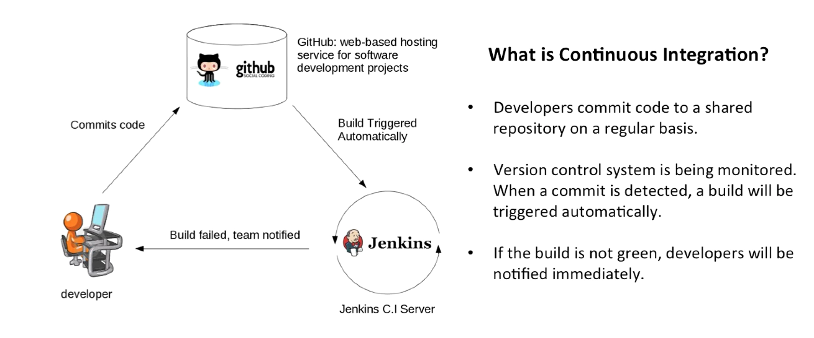

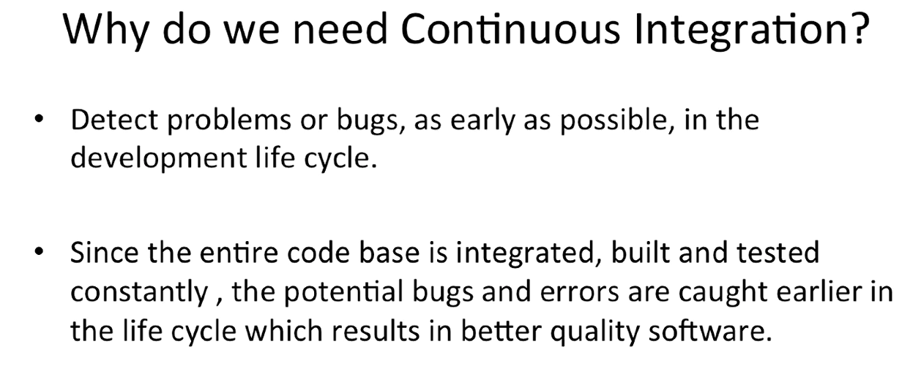

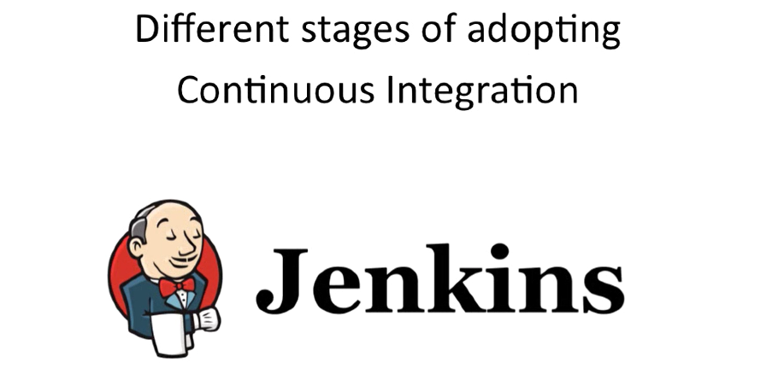

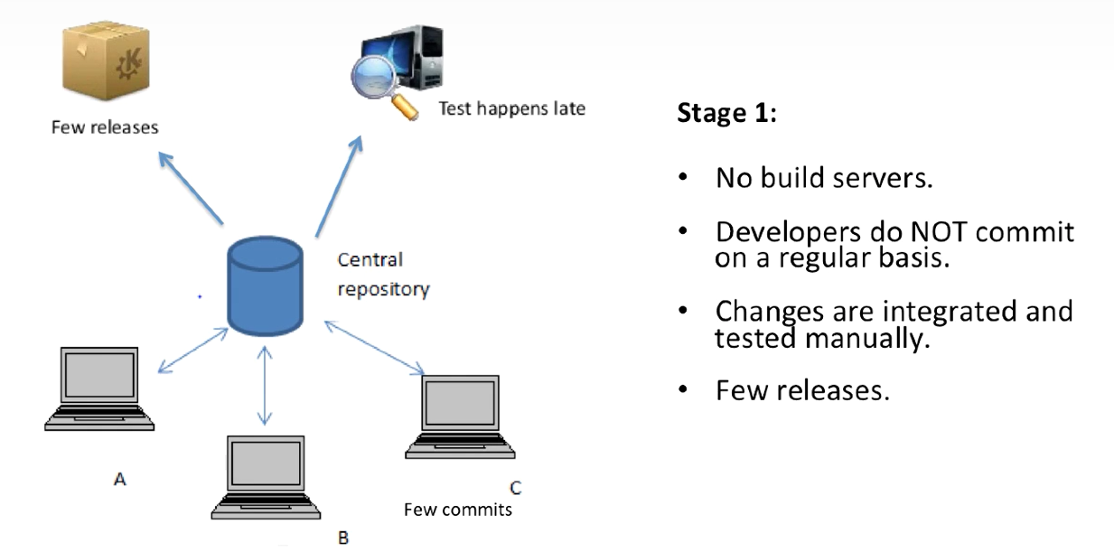

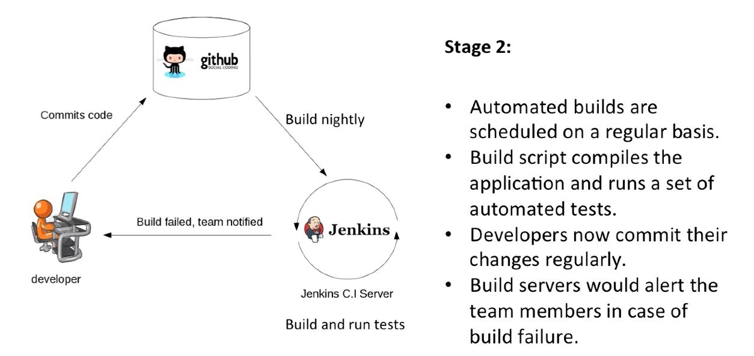

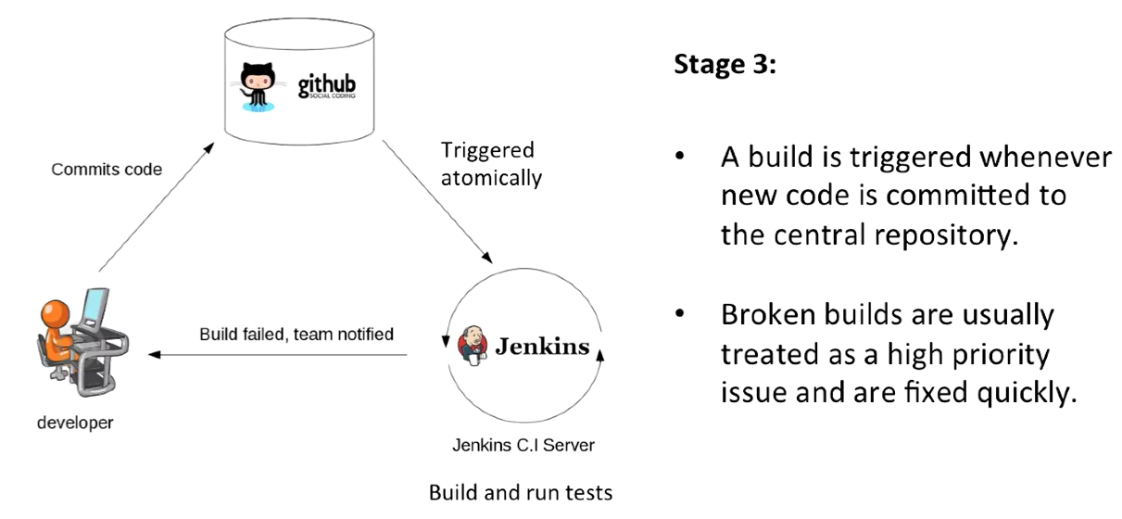

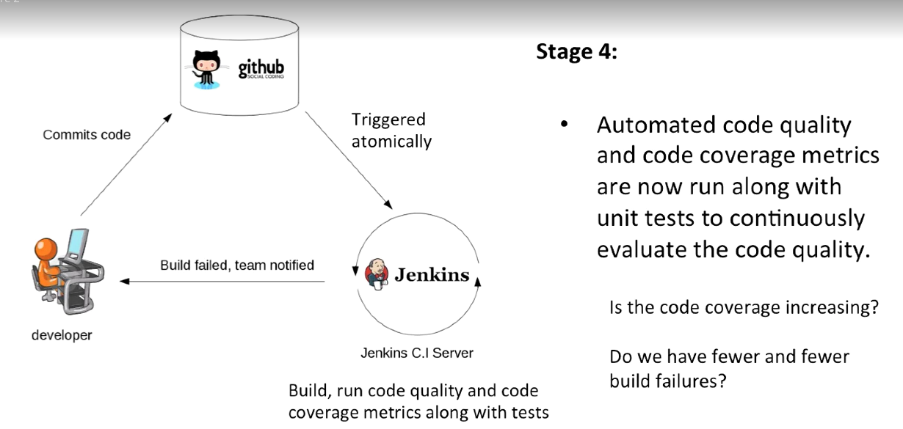

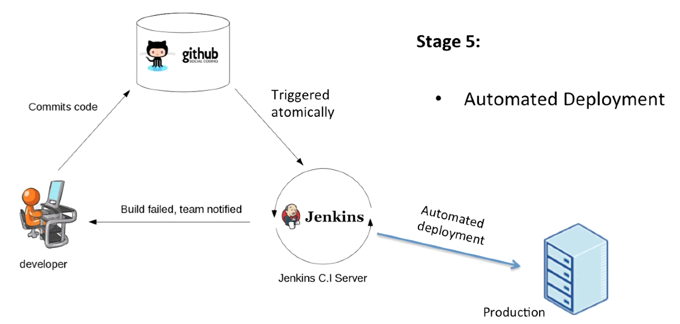

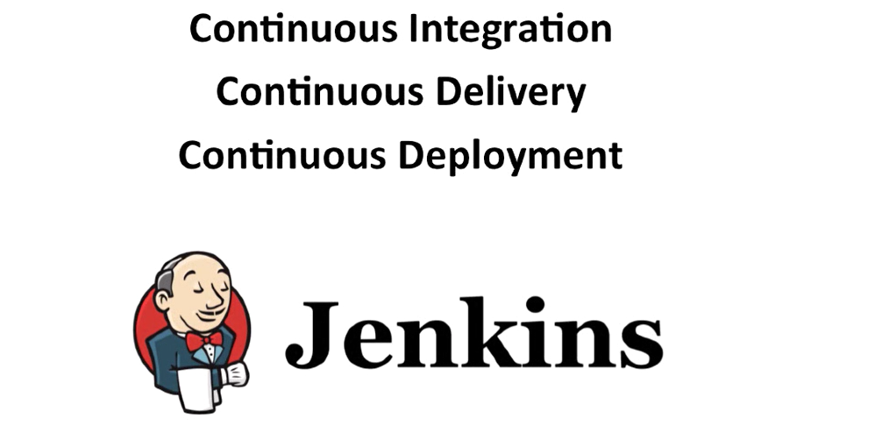

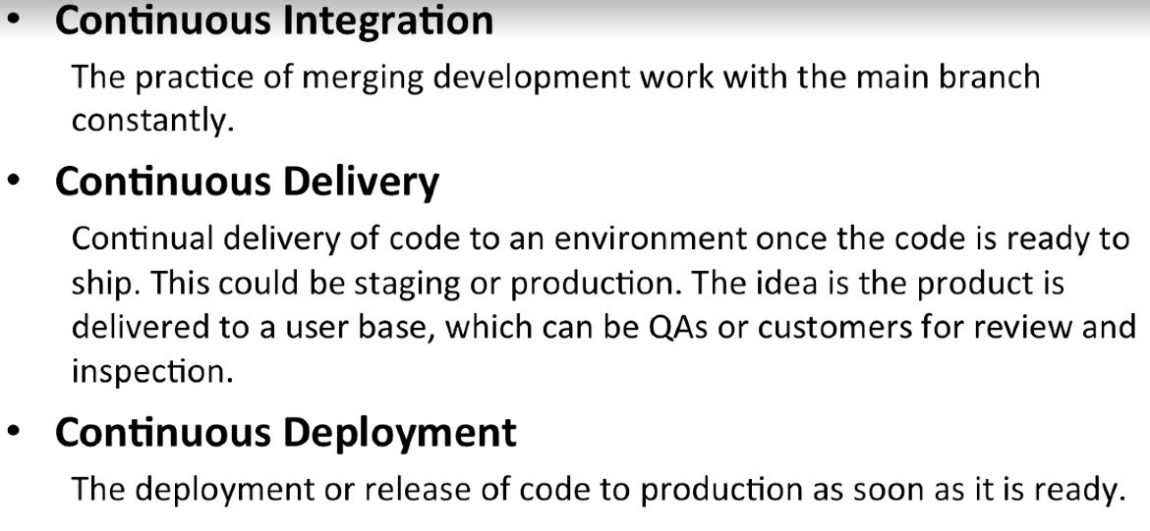

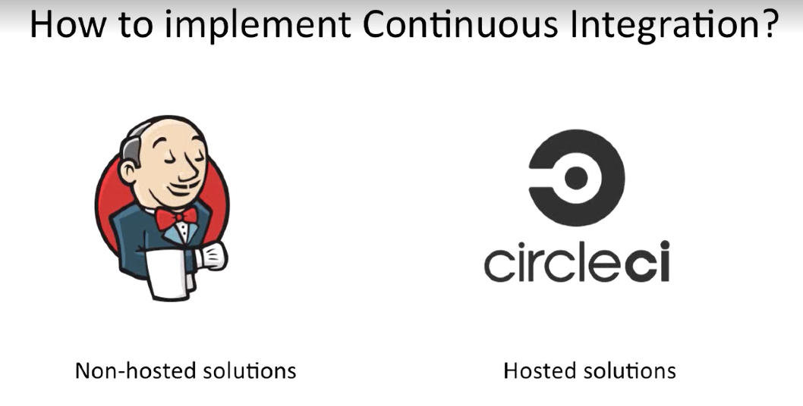

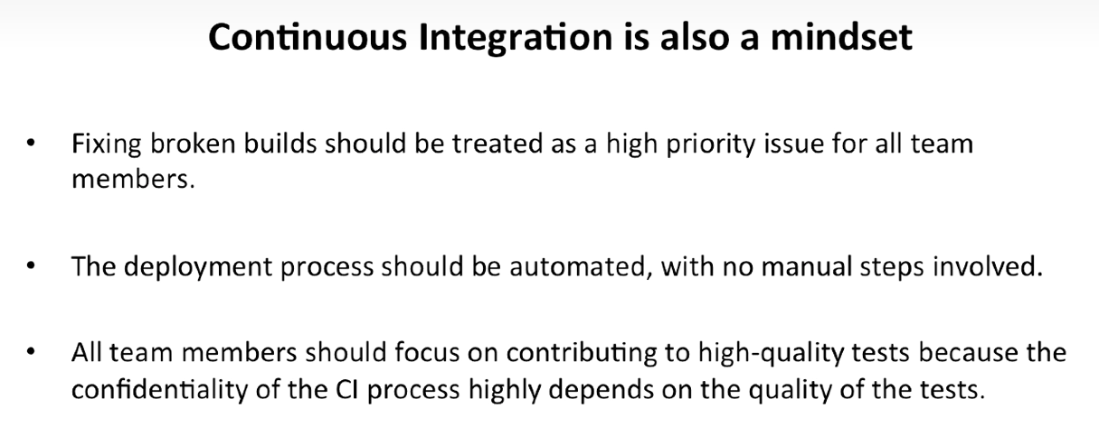

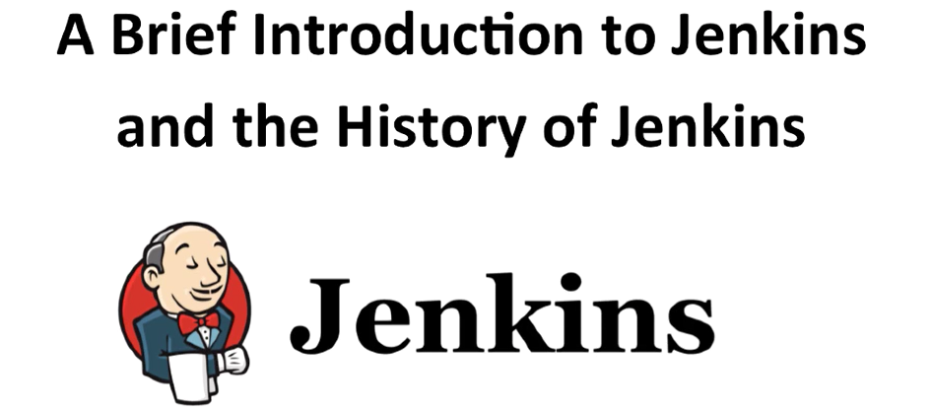

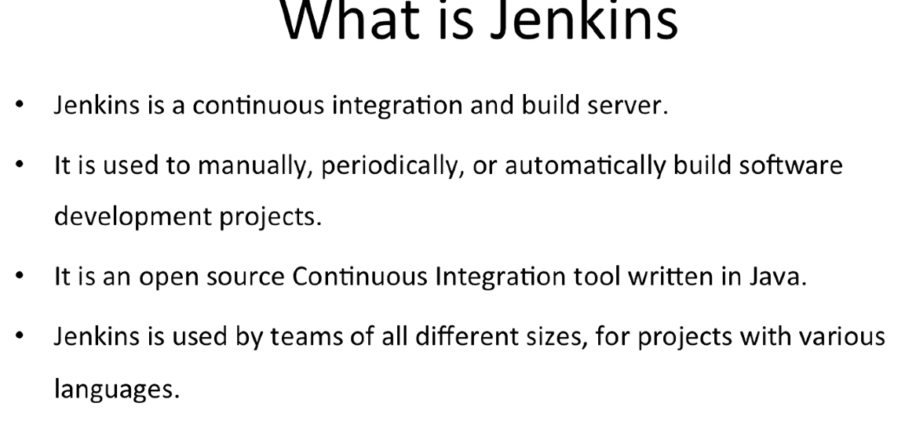

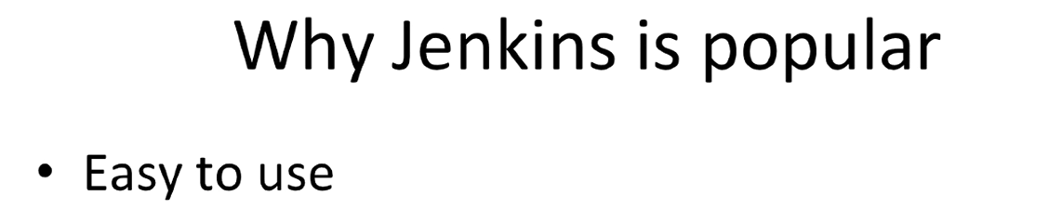

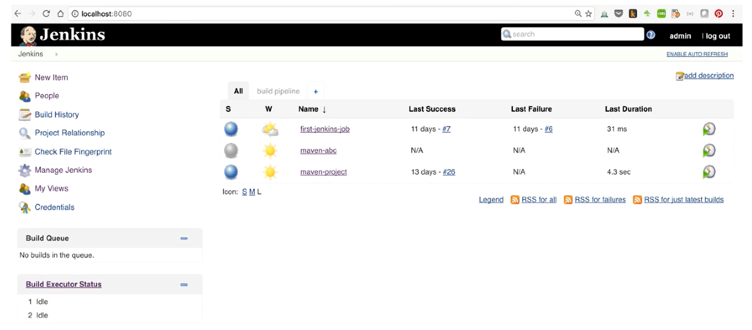

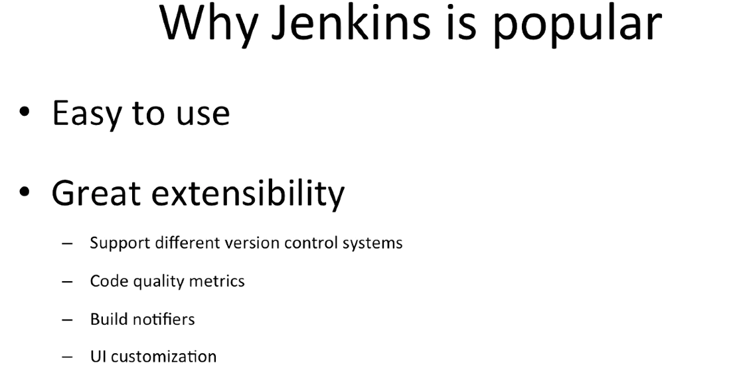

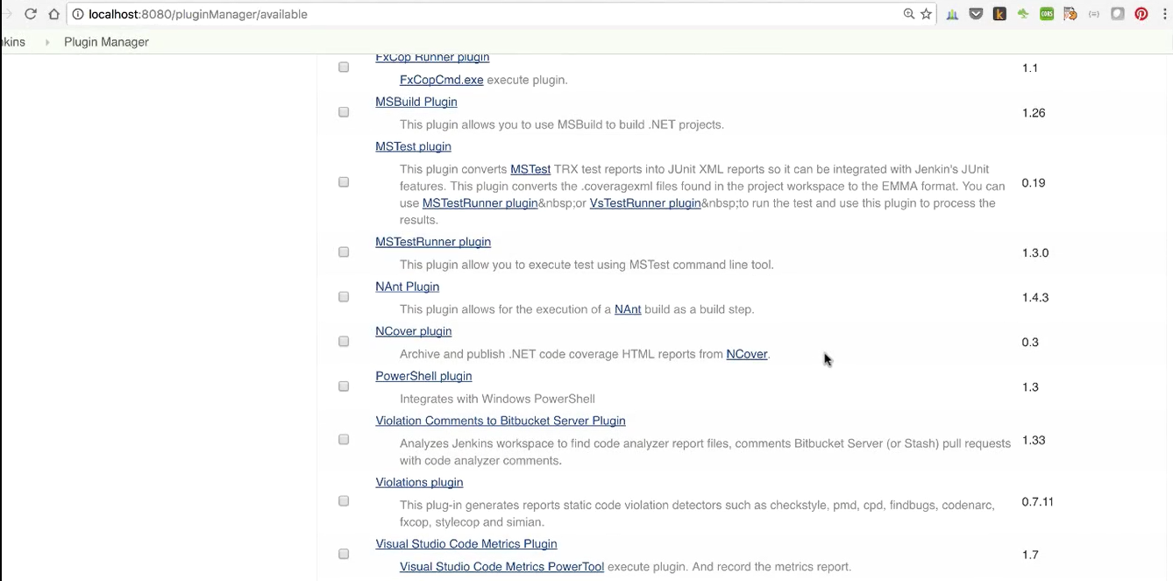

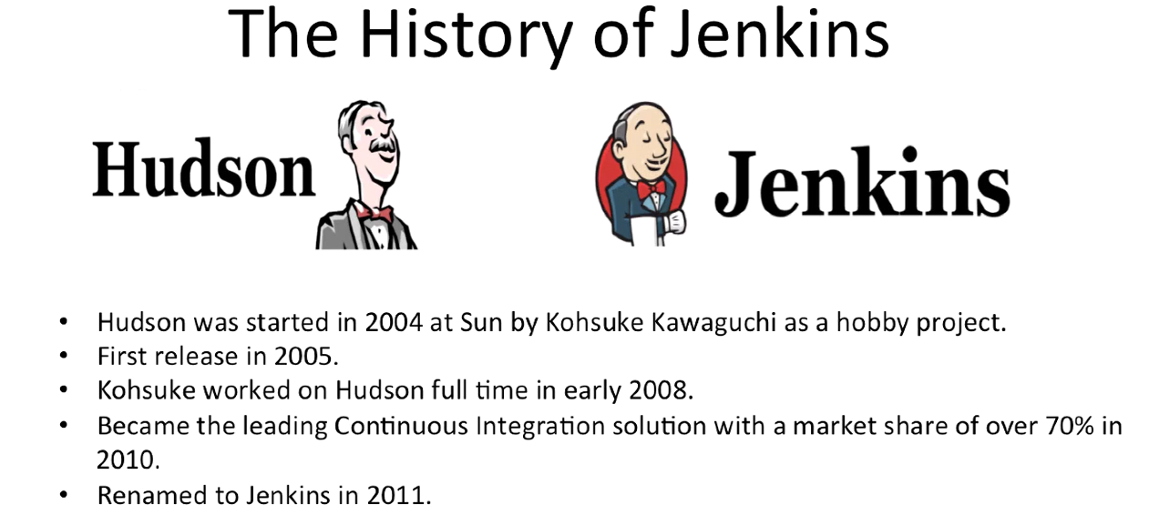

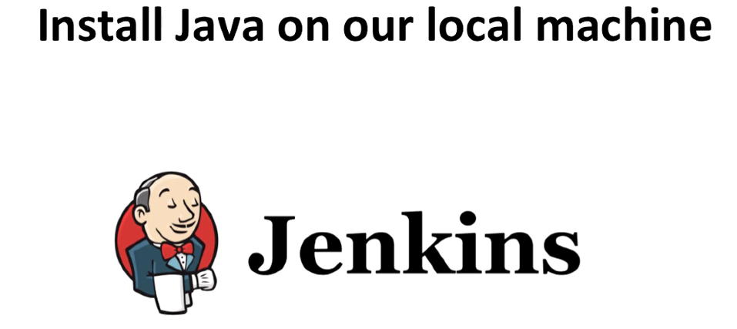

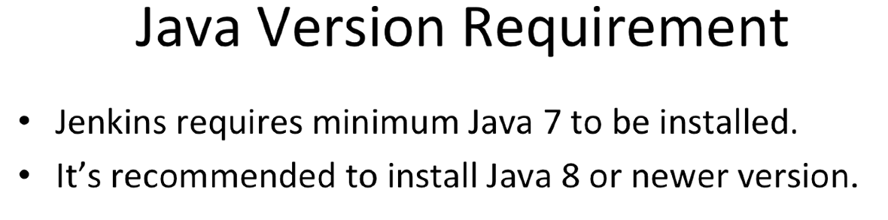

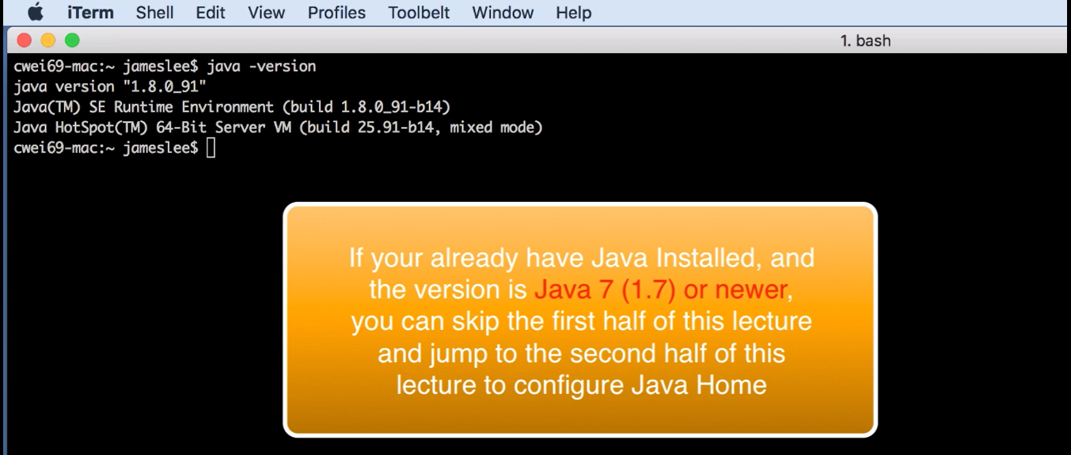

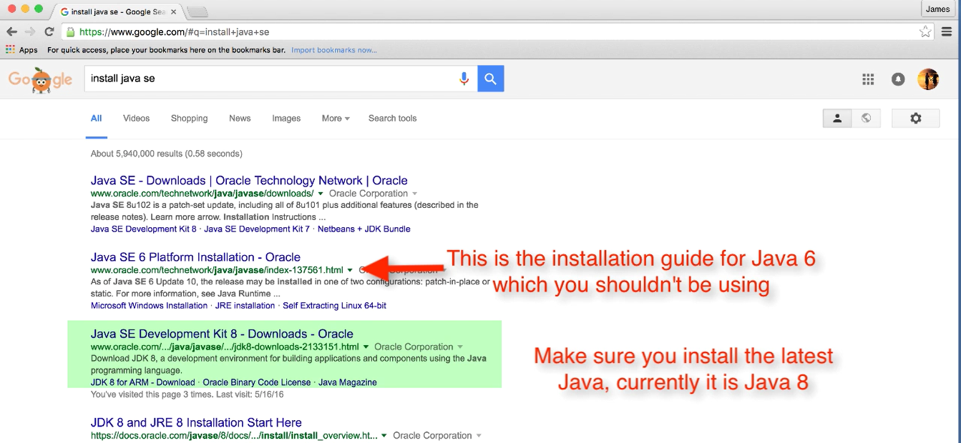

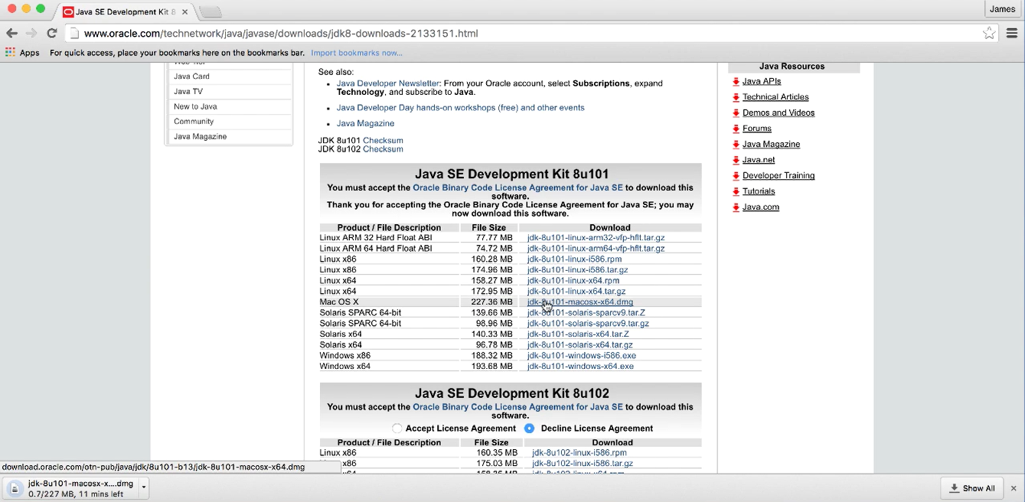

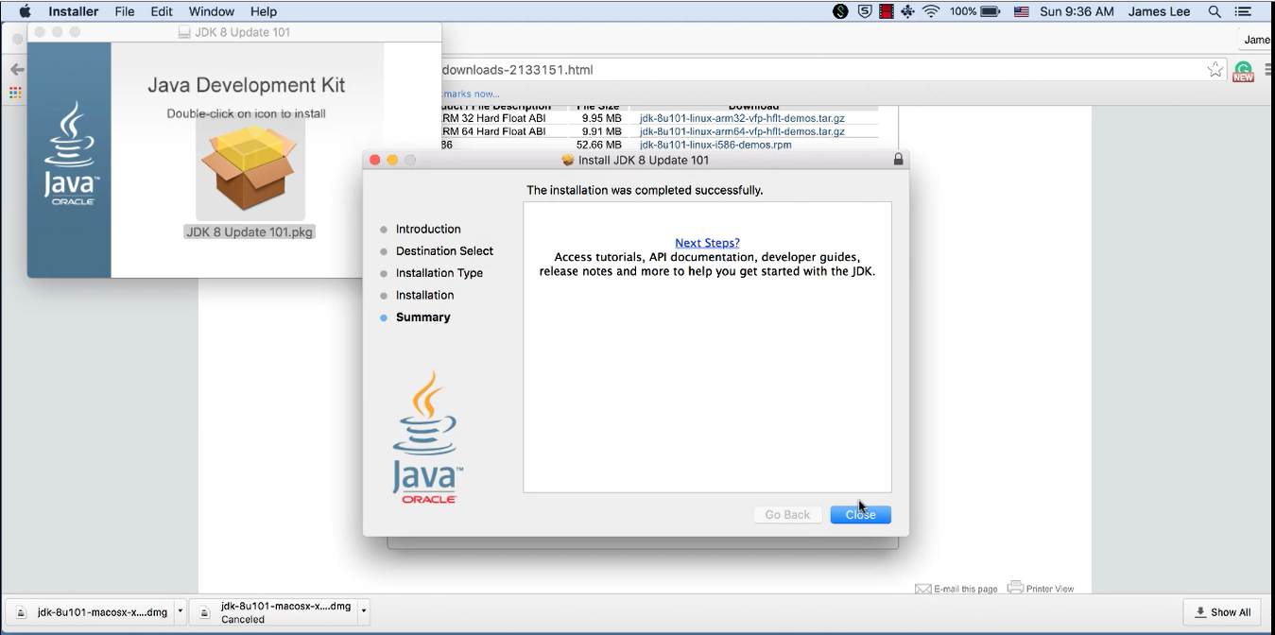

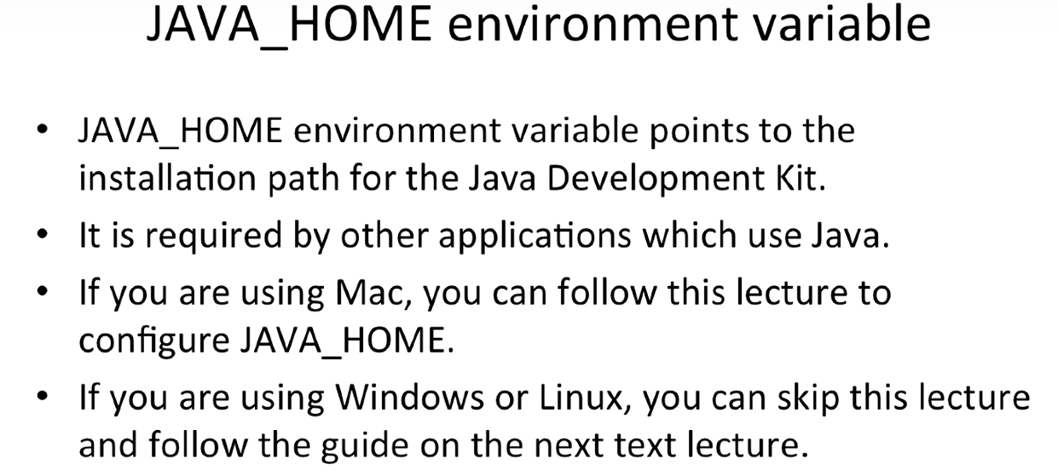

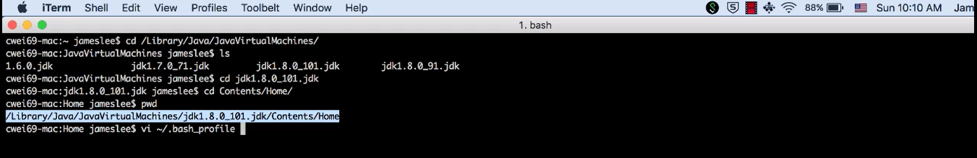

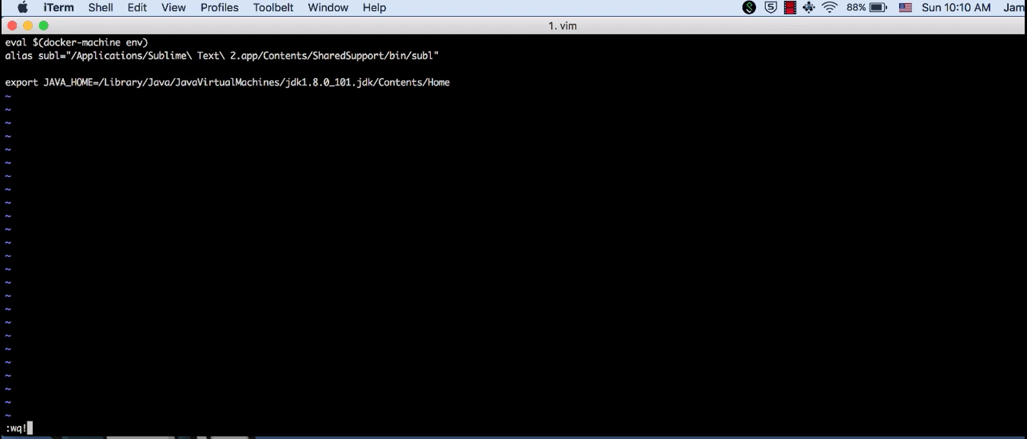

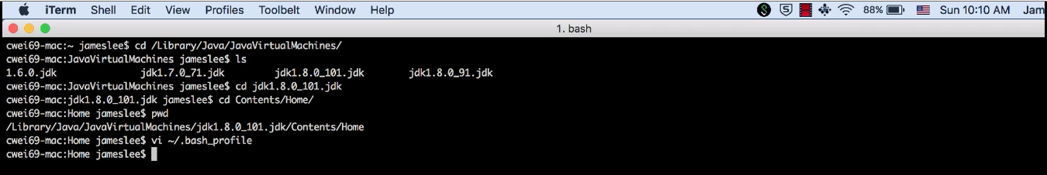

Text Direction: Install Java

Section 1, Lecture 5

**Configure Java_Home on Windows:**

* Right click My Computer and select Properties.
* On the Advanced tab, select Environment Variables, and then edit JAVA_HOME to point to where the JDK software is located, for example, C:\Program Files\Java\jdk1.6.0_02

**Configure Java_Home on Linux:**

* Login to your account and open the startup script file which is usually ~/.bash_profile  file (or can be .bashrc depending on your envrionment settings)

$ vi ~/.bash_profile

* In the startup script, set JAVA_HOME  and PATH
  + Korn and bash shells:
    1. export JAVA_HOME=jdk-install-dir
    2. export PATH=$JAVA_HOME/bin:$PATH
  + Bourne shell:
    1. JAVA_HOME=jdk-install-dir
    2. export JAVA_HOME
    3. PATH=$JAVA_HOME/bin:$PATH
    4. export PATH
  + C shell:
    1. setenv JAVA_HOME jdk-install-dir
    2. setenv PATH $JAVA_HOME/bin:$PATH
    3. export PATH=$JAVA_HOME/bin:$PATH

jdk-install-dir  is the JDK installation director, which should be something similar to /usr/java/jdk1.5.0_07/bin/java

* Type the following command to activate the new path settings immediately:

$ source ~/.bash_profile

* Verify new settings:  
  $ echo $JAVA_HOME<br>$ echo $PATH

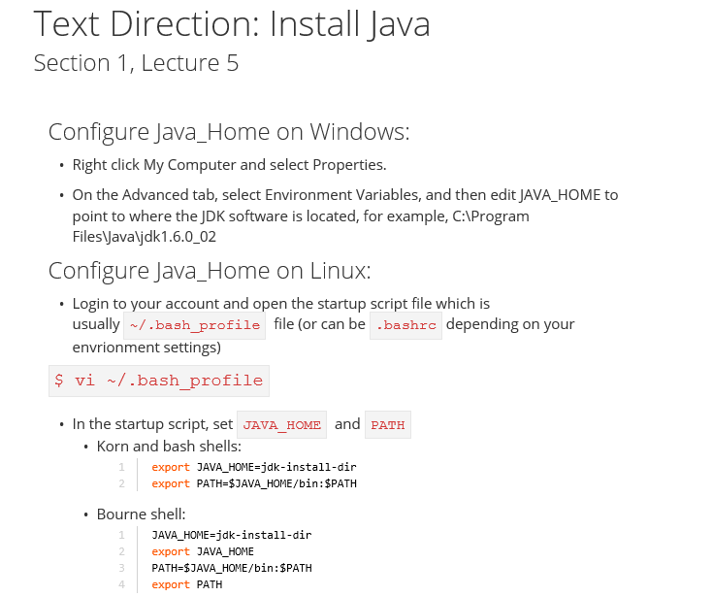

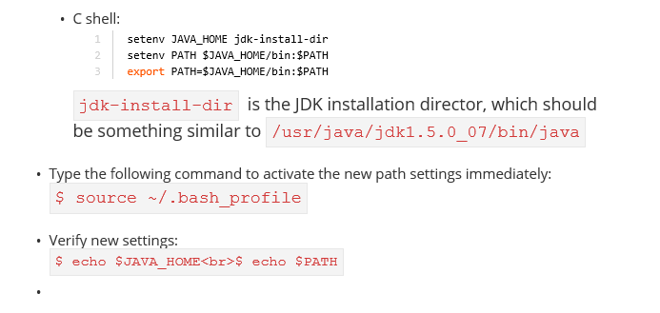

**Note:** To find the java path in linux.

ubuntu@ip-172-31-16-54:/usr/bin$ readlink -f /usr/bin/javac

/usr/lib/jvm/java-7-openjdk-amd64/bin/javac

ubuntu@ip-172-31-16-54:/usr/bin$

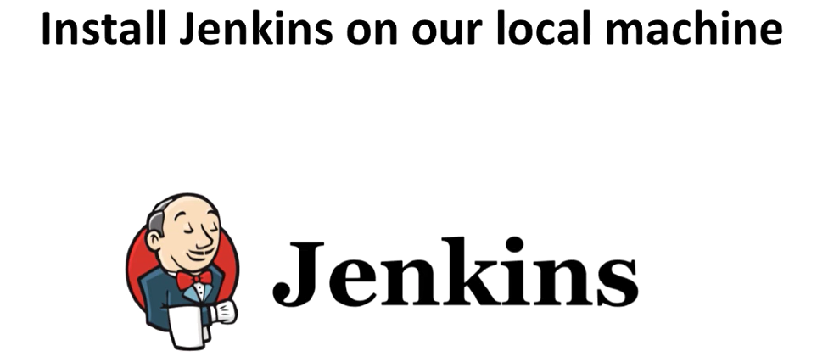

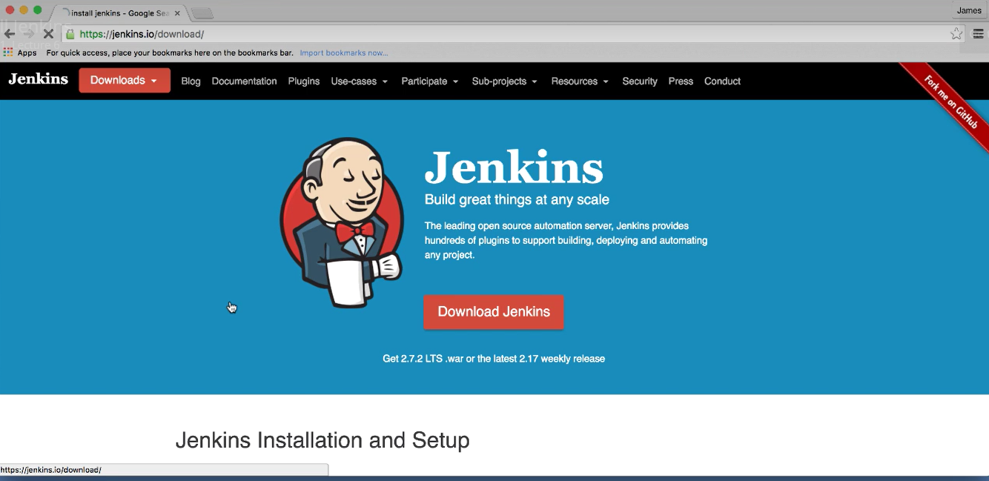

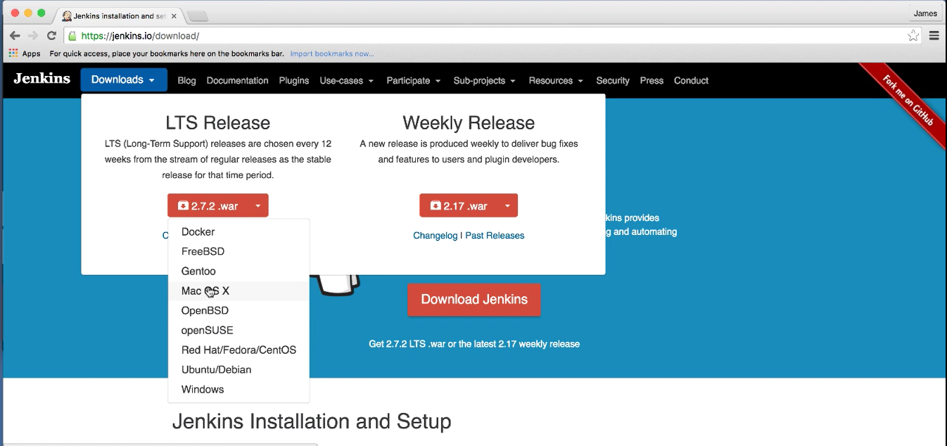

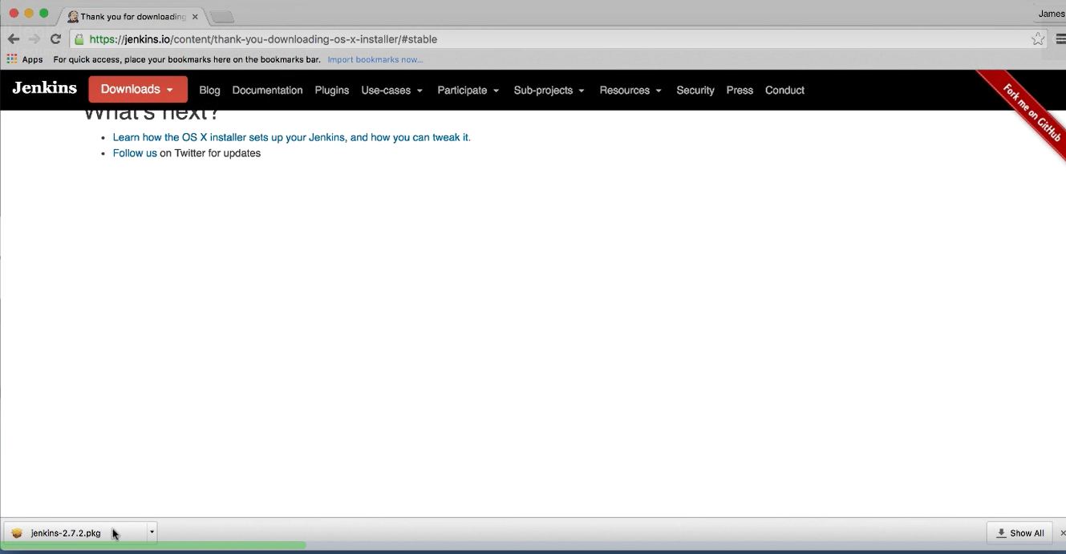

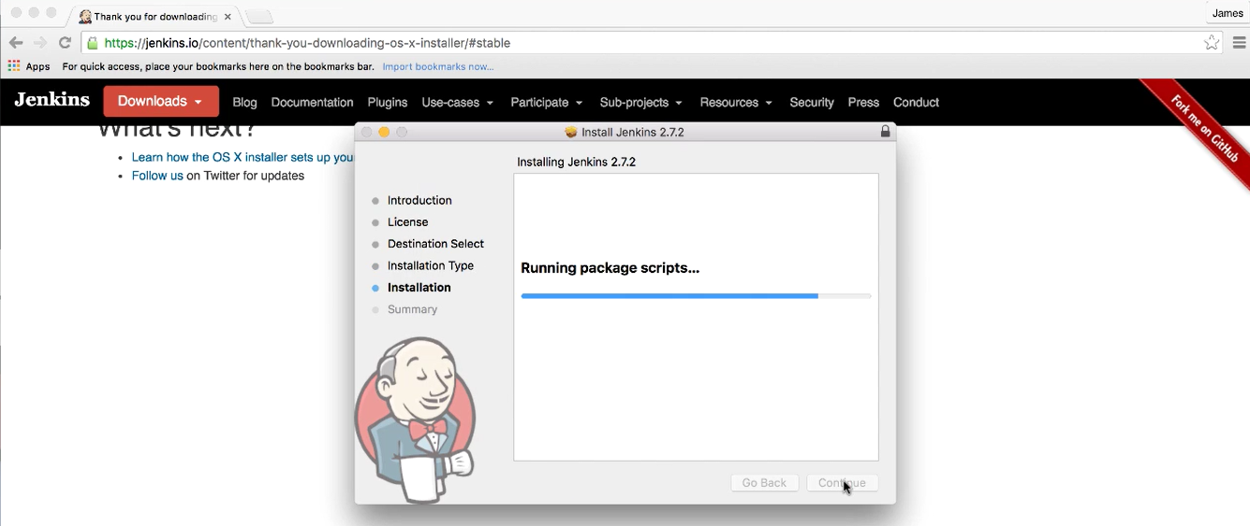

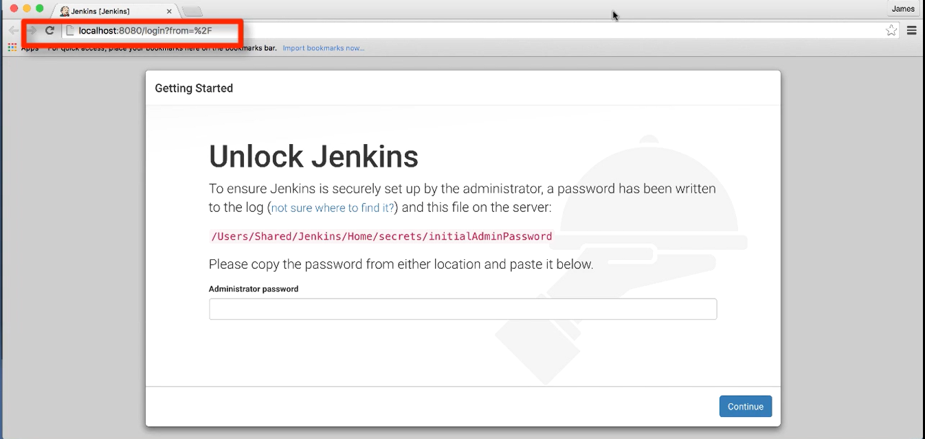

**Note**: Jenkins run port 8080 by default

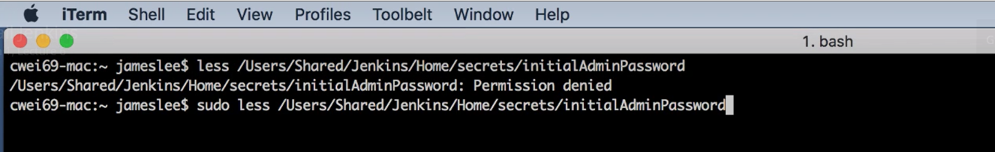

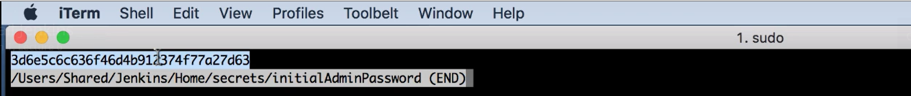

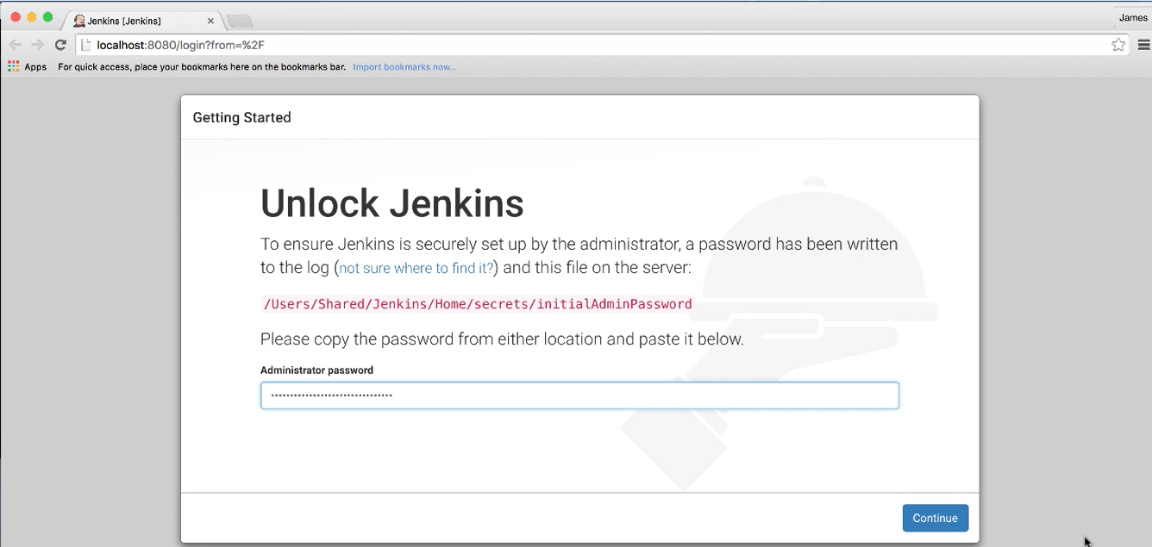

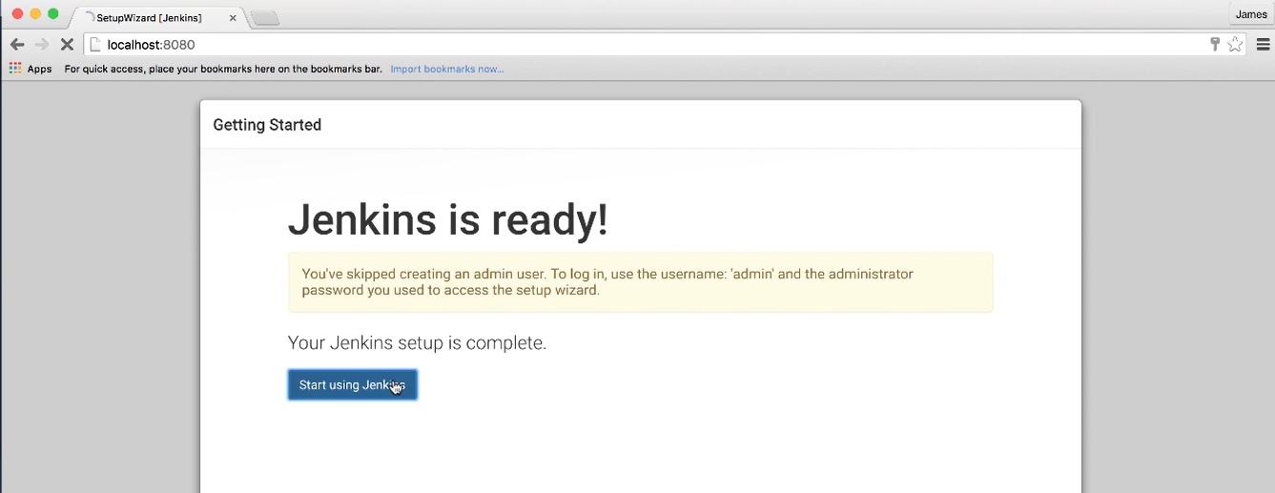

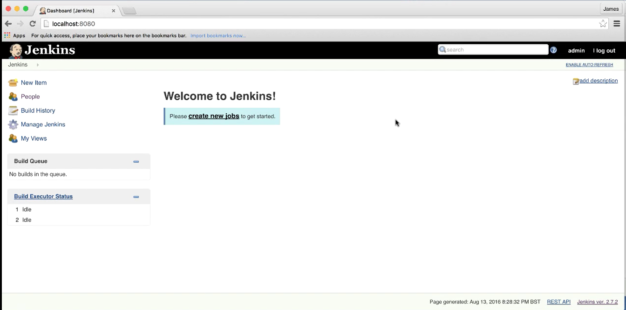

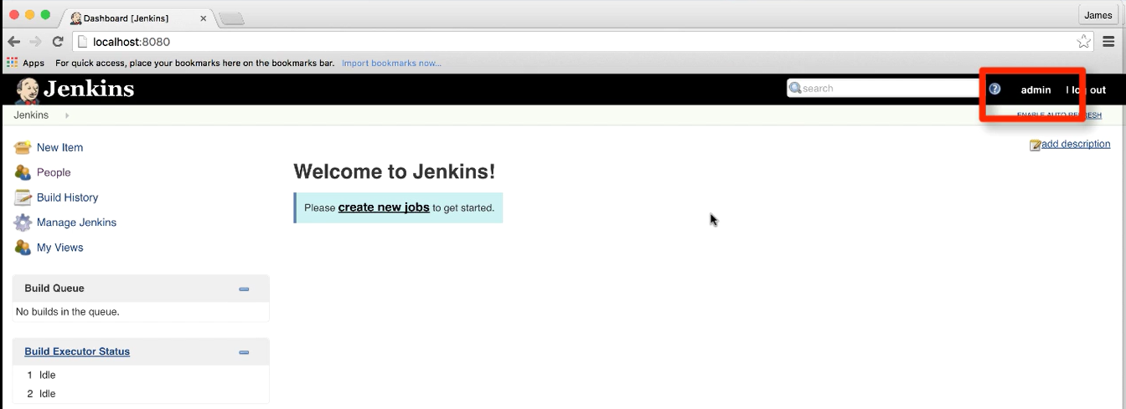

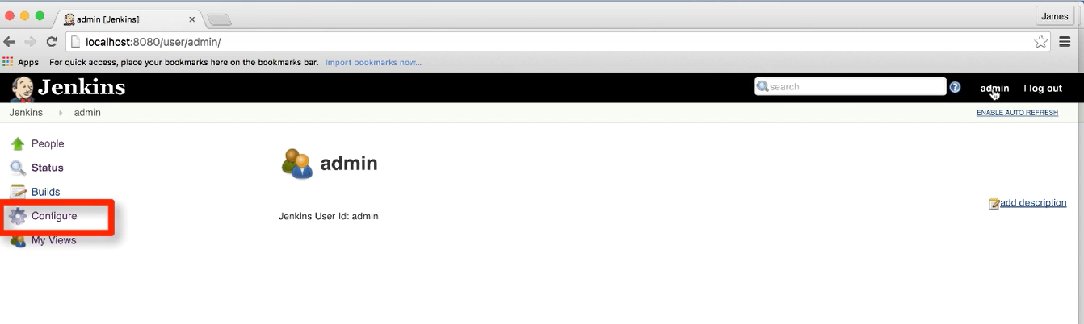

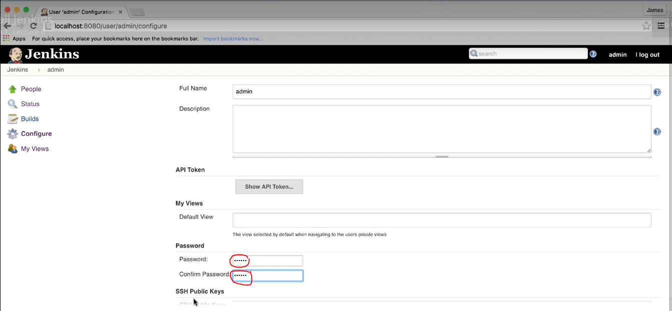

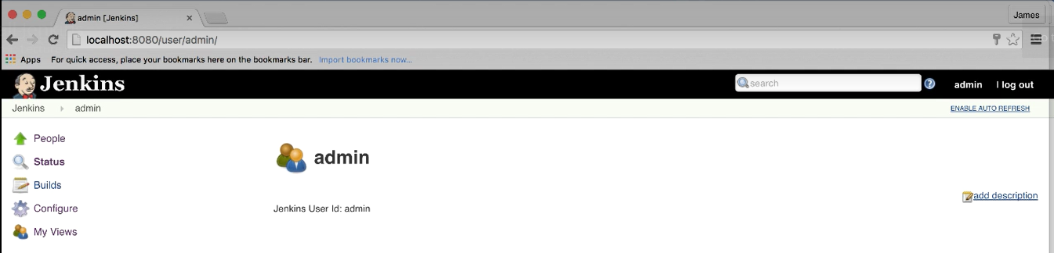

In my **AWS instance**: installation of Jenkins. In the below its already installed, hence it is showing as done.

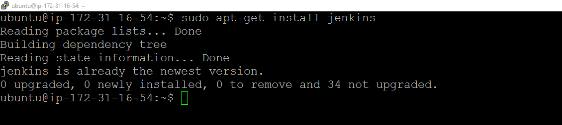

Apache2 default port 80. Jenkins default port 8080

To configure the apache2 proxy the requests from port 80 to 8080. You have to create and update VirtualHost details in **Jenkins.conf**

$ sudo vim /etc/apache2/sites-available/jenkins.conf

Update the **ServerName** in the below path as per the current instance Public DNS where Jenkins installed. This step is required to start the Jenkins in browser.

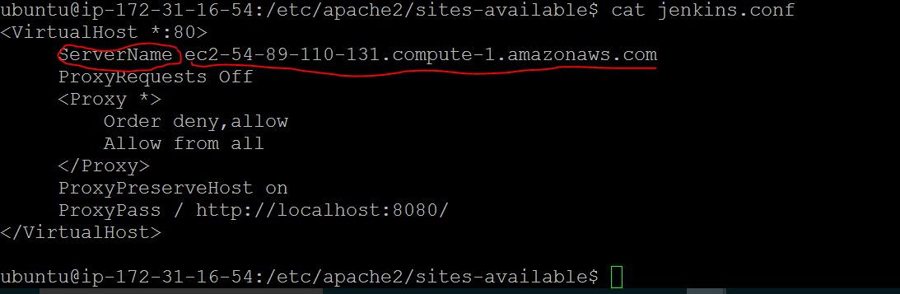

ubuntu@ip-172-31-16-54:/etc/apache2/sites-available$ sudo a2enmod proxy

Module proxy already enabled

ubuntu@ip-172-31-16-54:/etc/apache2/sites-available$ sudo a2enmod proxy_http

Considering dependency proxy for proxy_http:

Module proxy already enabled

Module proxy_http already enabled

ubuntu@ip-172-31-16-54:/etc/apache2/sites-available$ sudo a2ensite jenkins

Site jenkins already enabled

ubuntu@ip-172-31-16-54:/etc/apache2/sites-available$ service apache2 reload

* Reloading web server apache2 *

**NOTE**: a2enmod is apache2 modules to enable the proxy, proxy_http

A2ensite used to enable the Jenkins

Then reload the apache2

**To start the Jenkins:**

ubuntu@ip-172-31-16-54:/var/lib/jenkins$ sudo service jenkins start

* Starting Jenkins Continuous Integration Server jenkins [ OK ]

ubuntu@ip-172-31-16-54:/var/lib/jenkins$

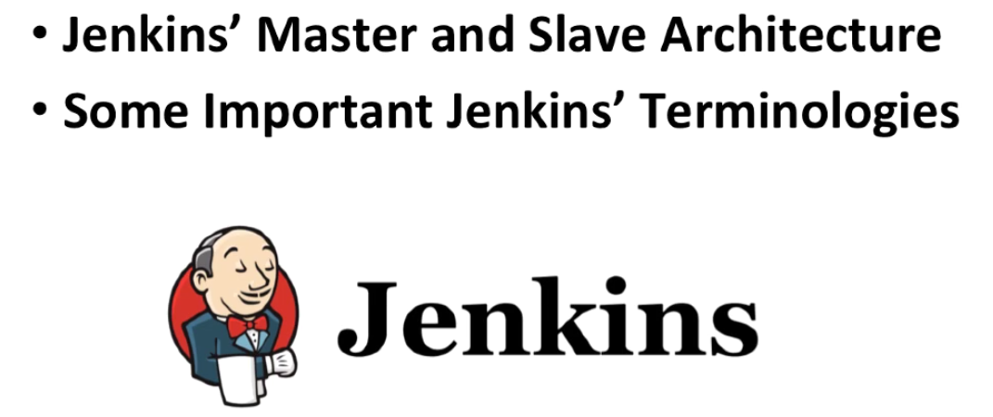

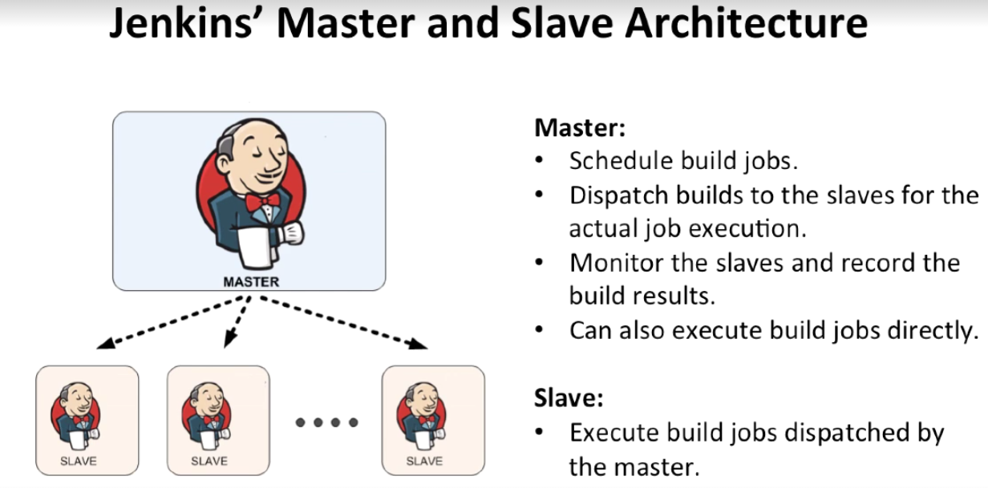

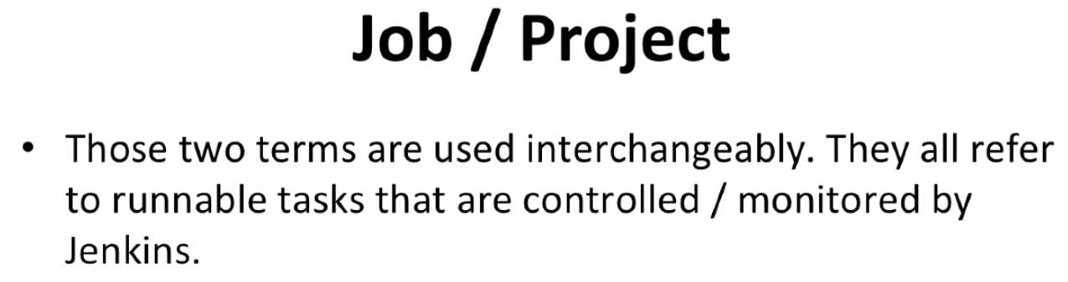

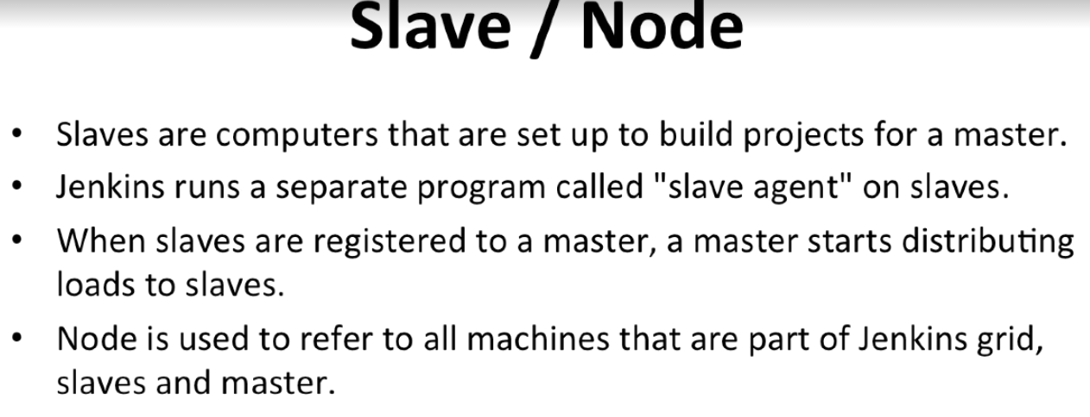

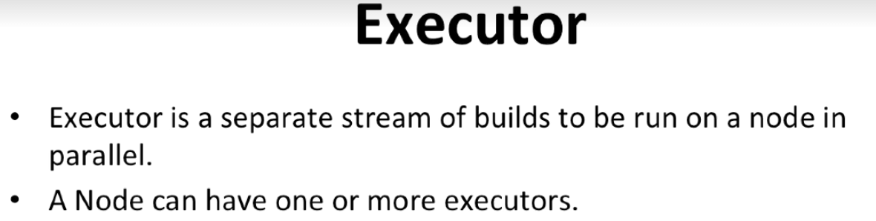

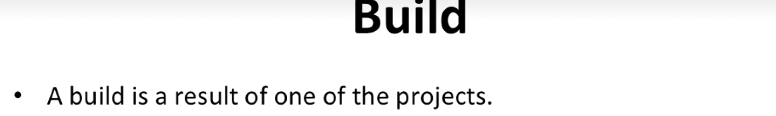

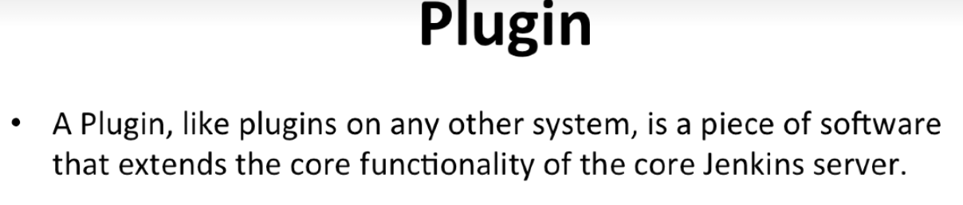

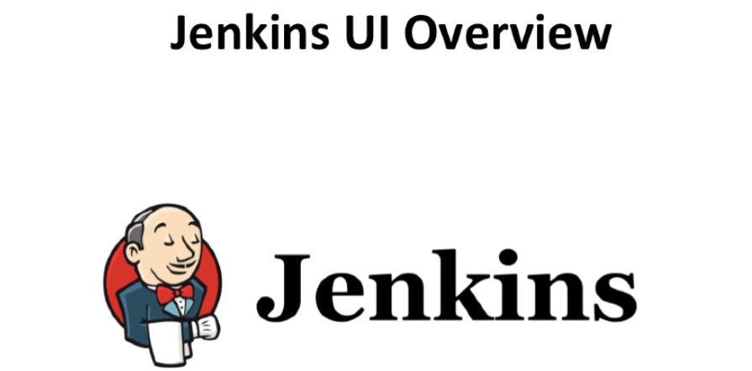

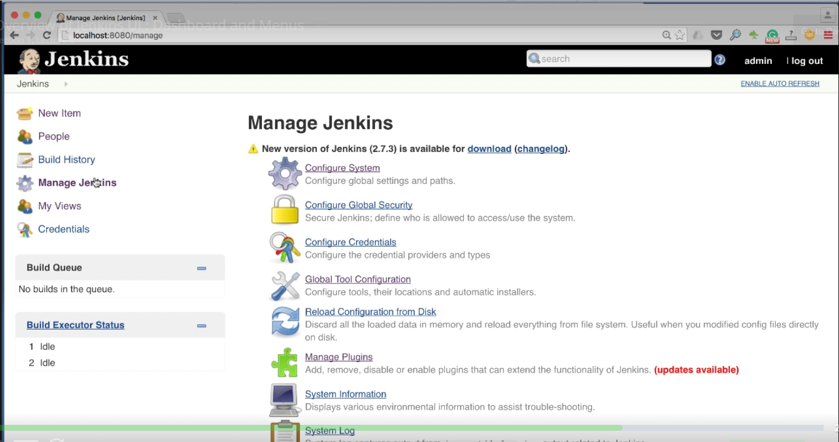

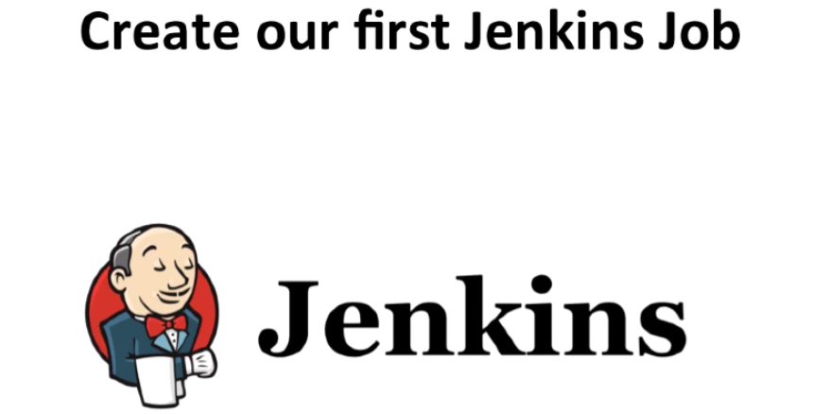

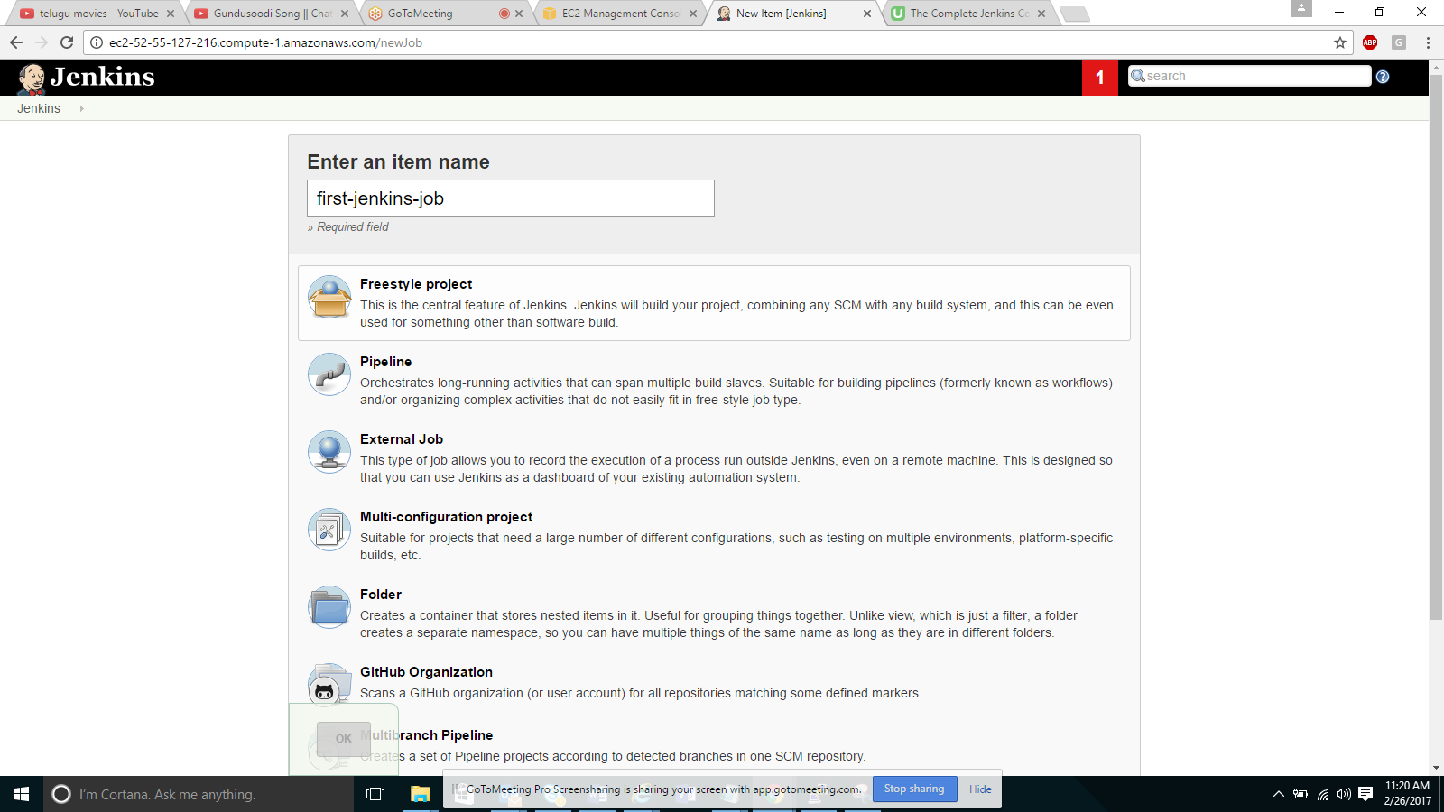

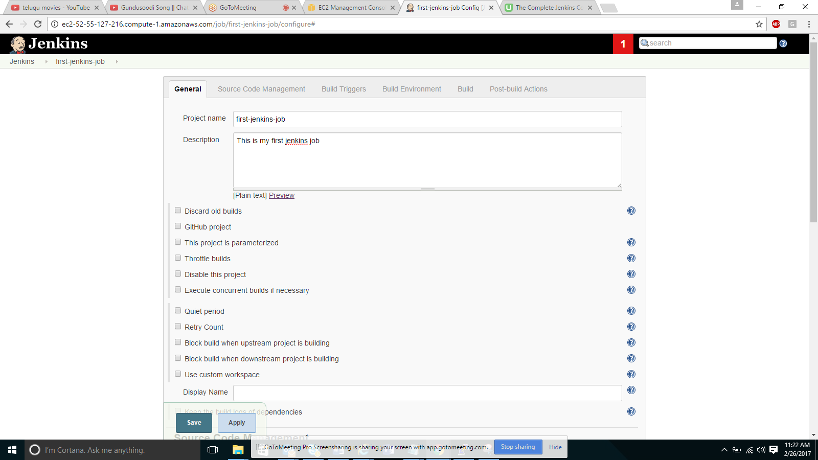

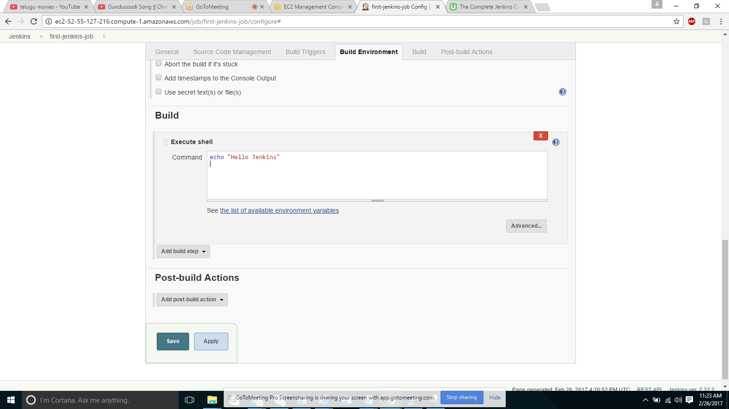

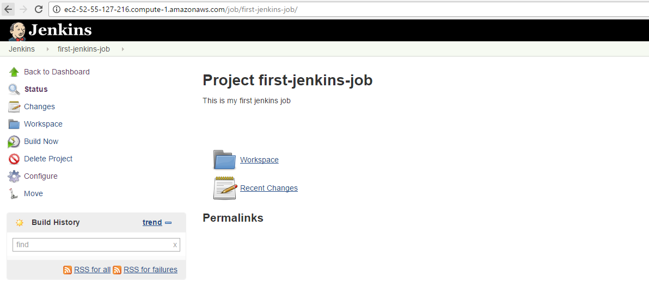

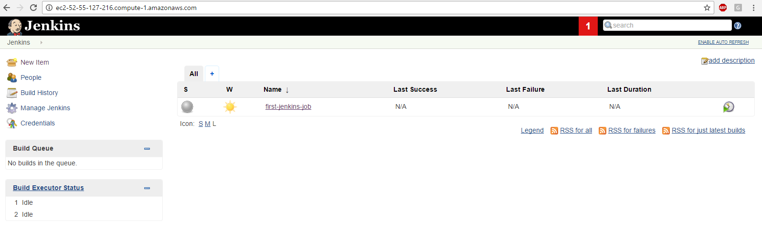

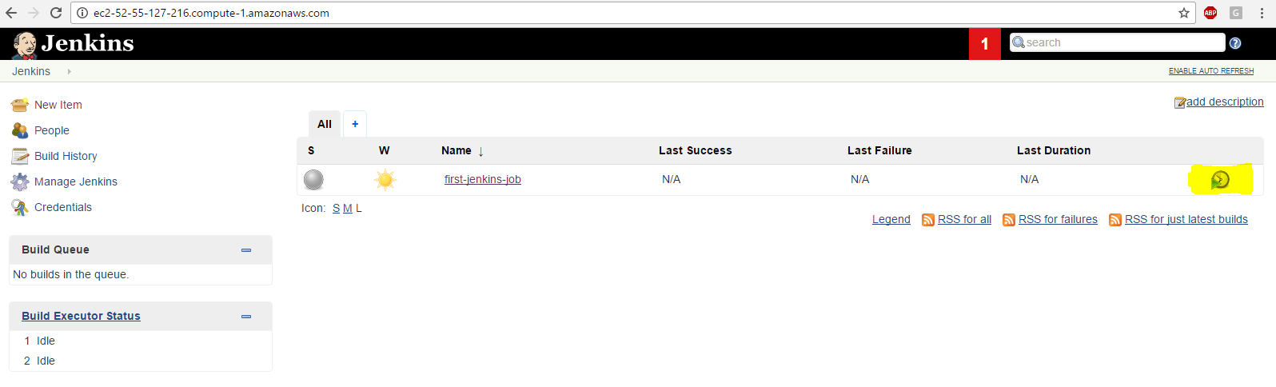

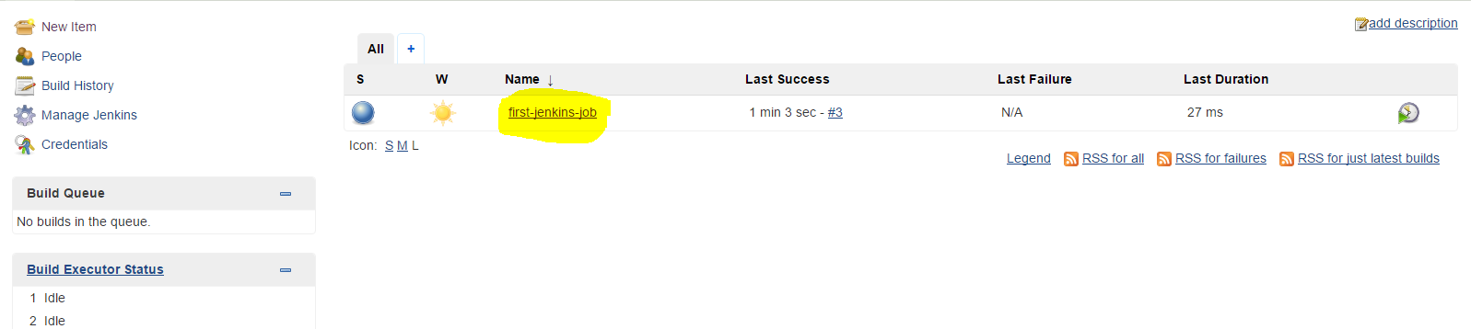

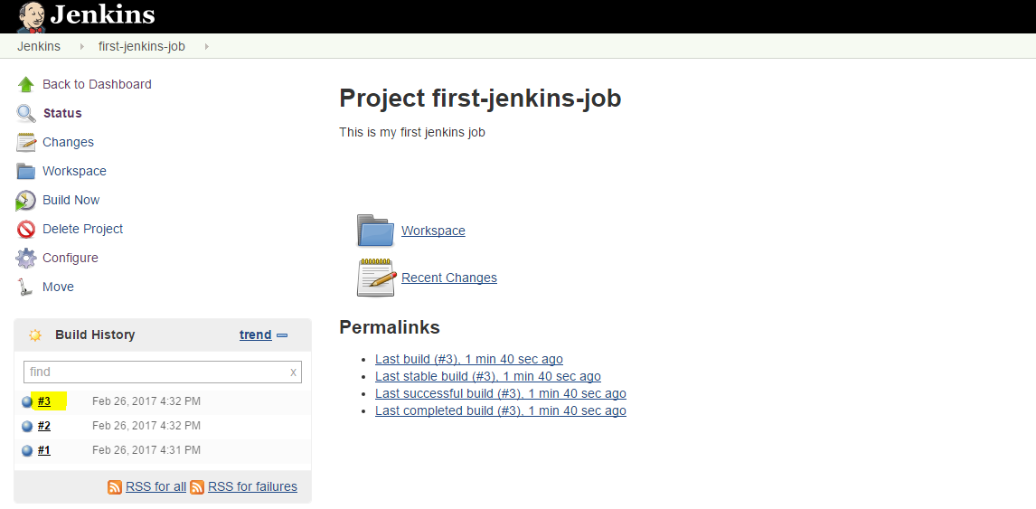

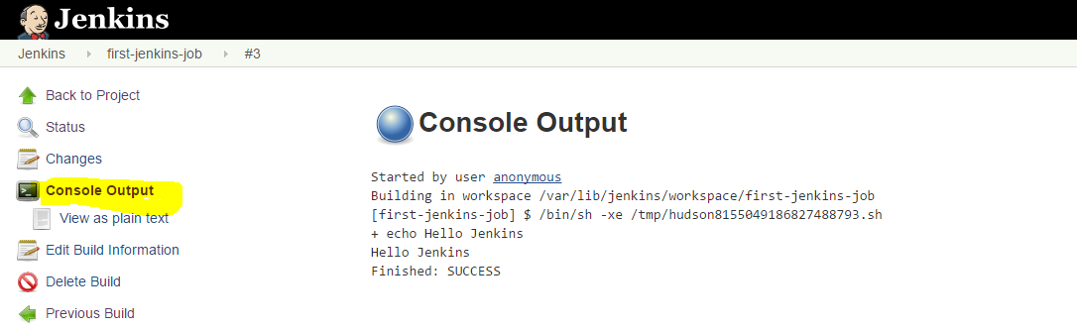

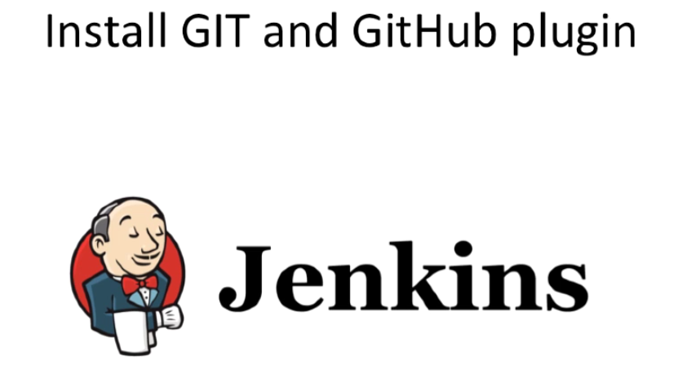

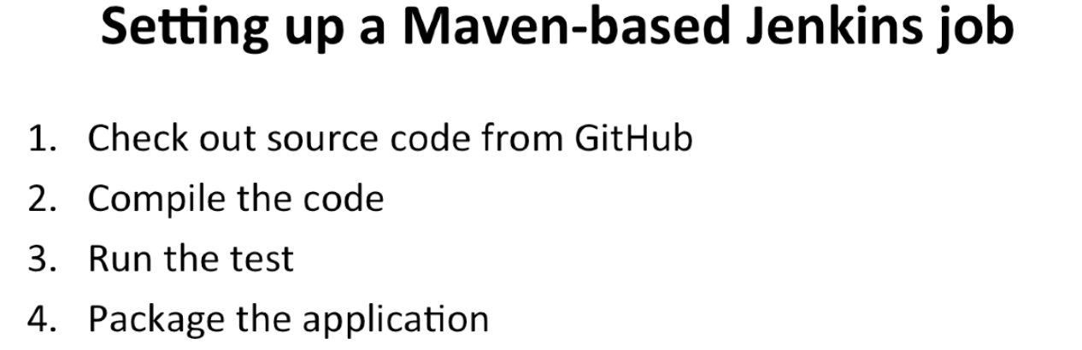

**Exercise:**

We are using GitHub project to execute Jenkins job. For that we need to install Github plugin in Jenkins.

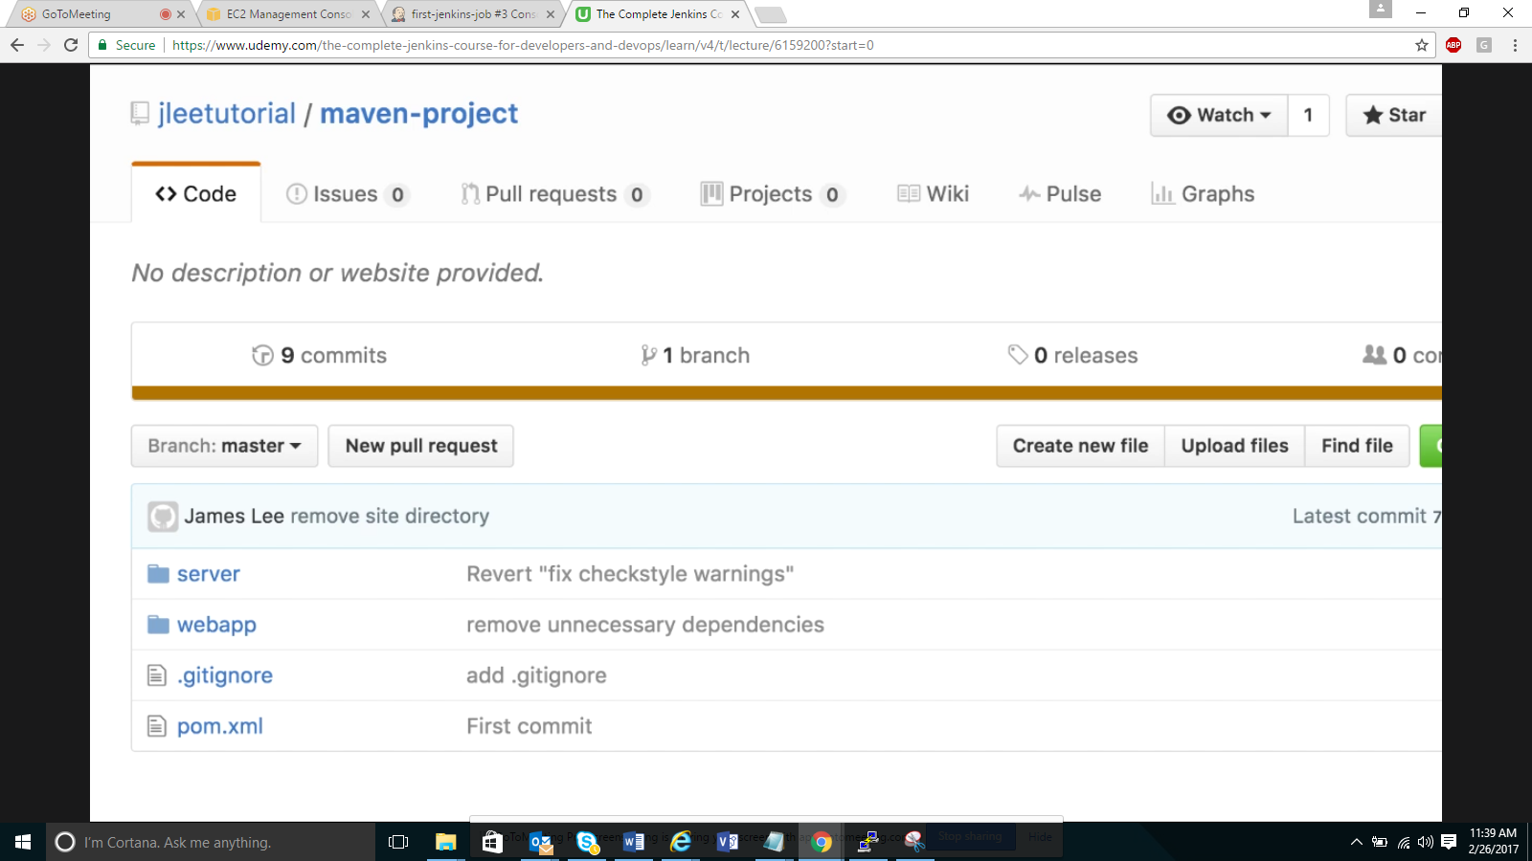

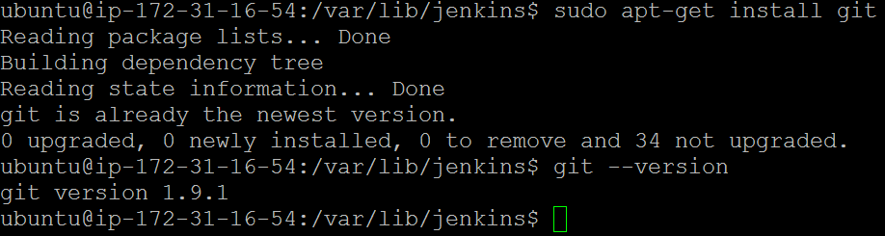

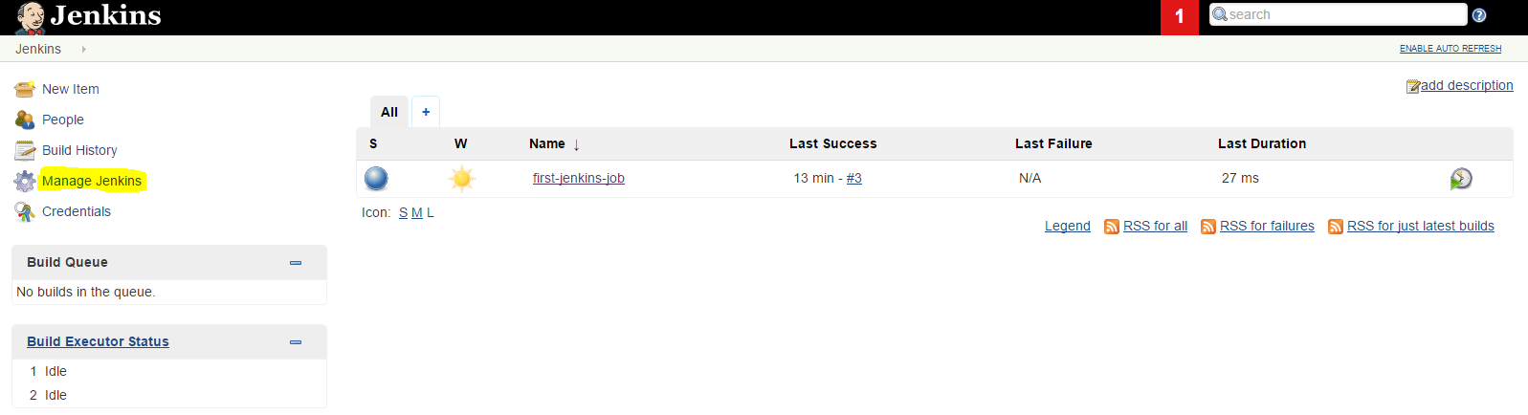

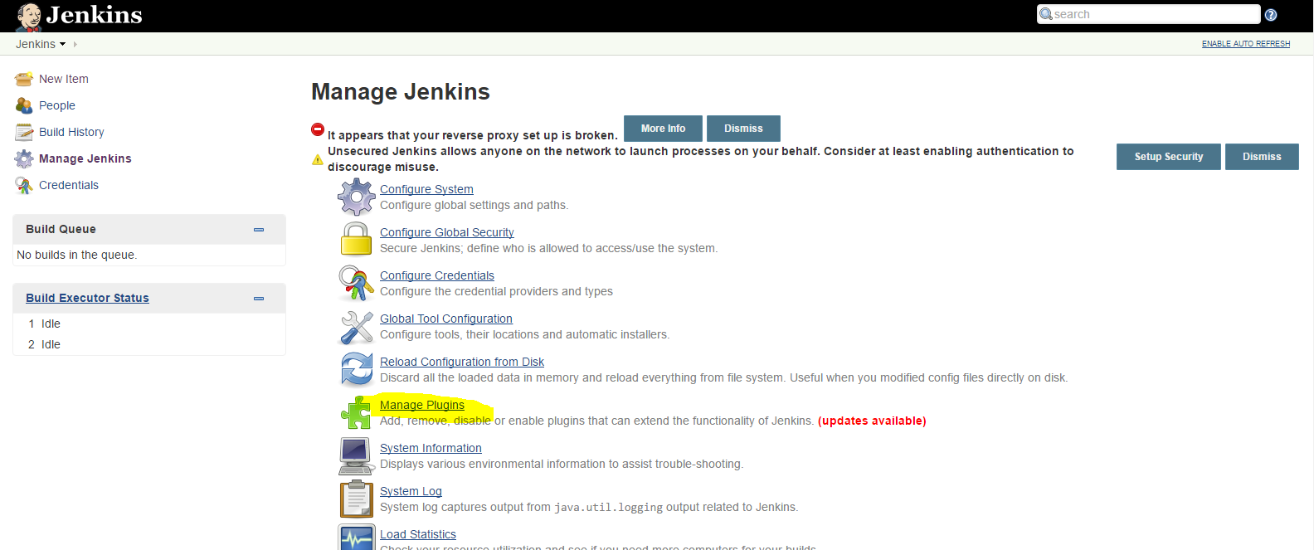

If you want to install go to Available tab and search filter with github plugin and install, select install without restart

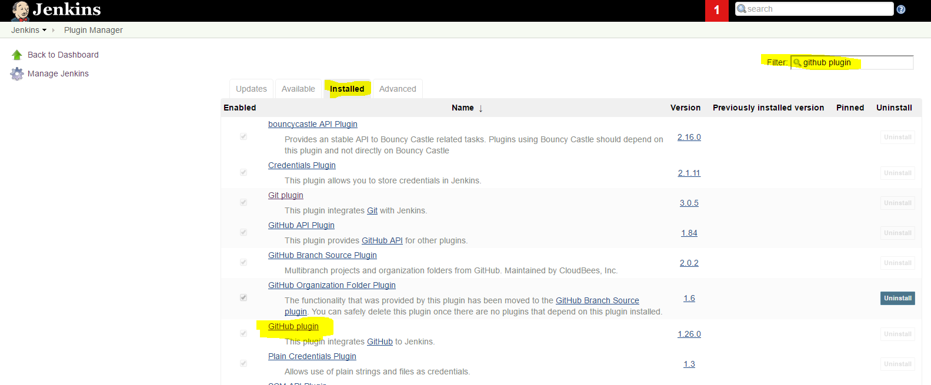

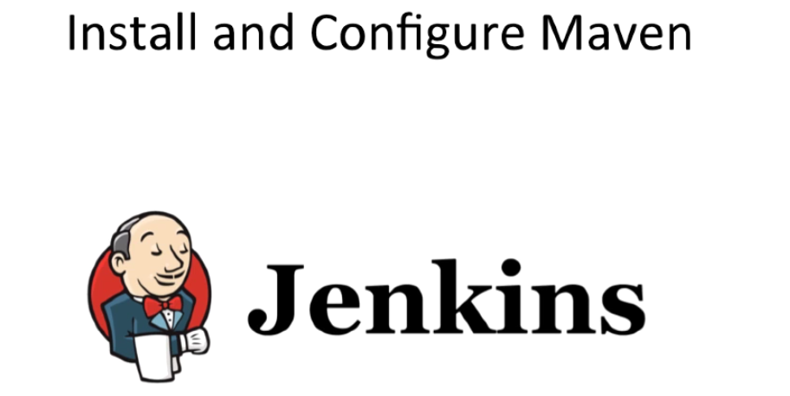

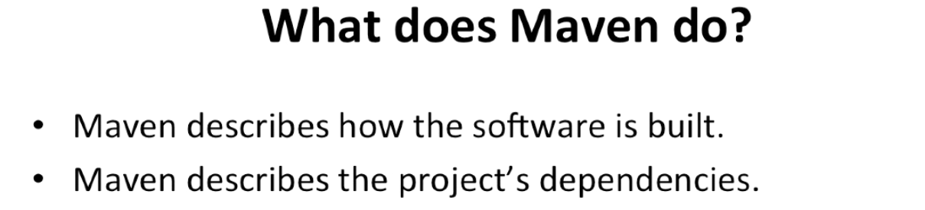

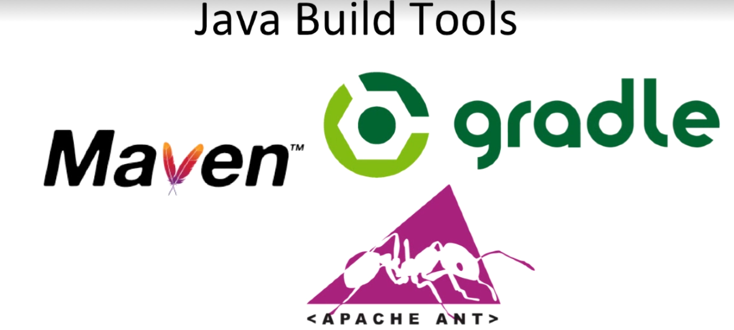

Install Maven

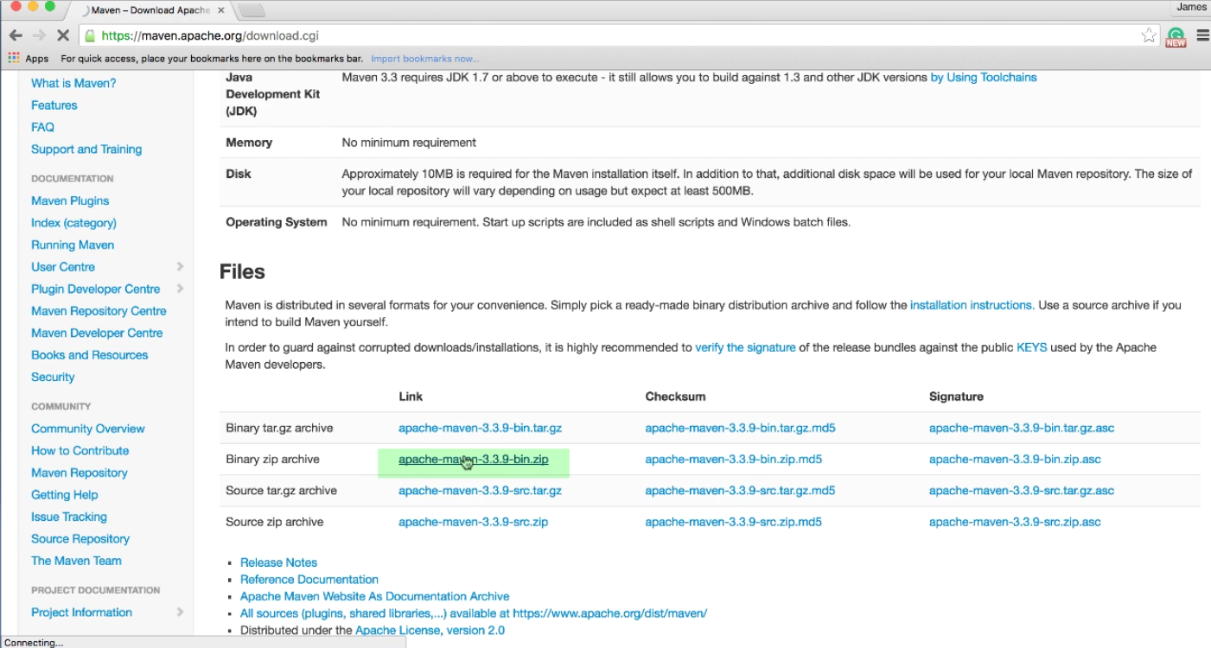

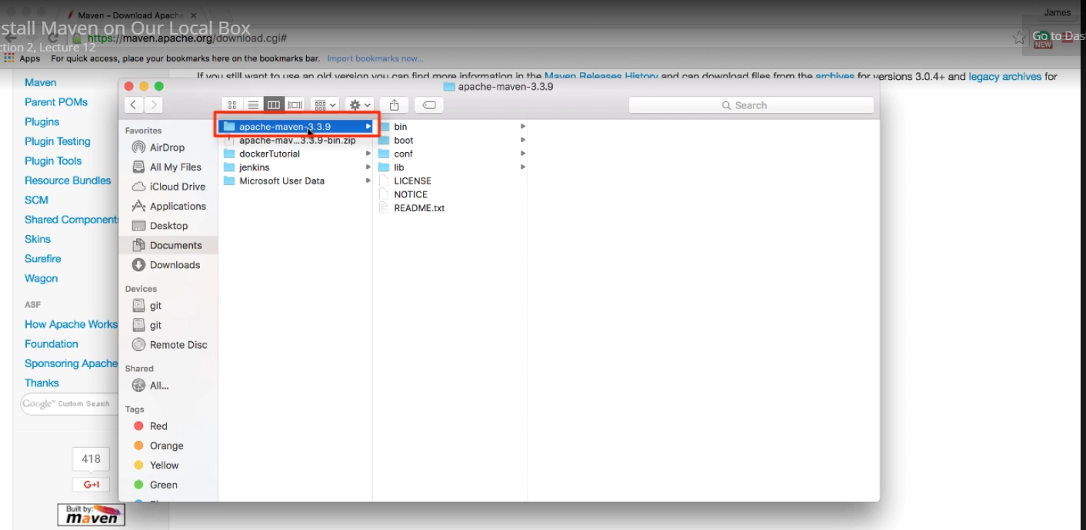

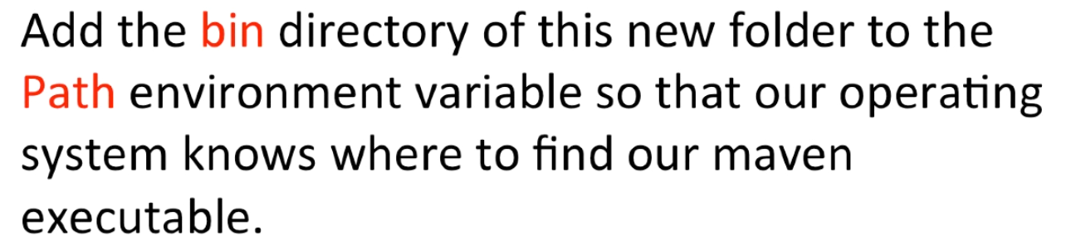

The above step may be vary depending upon the OS.

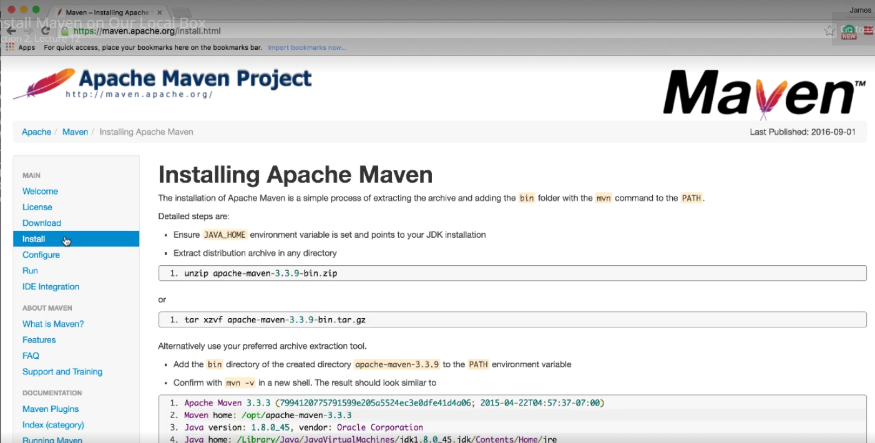

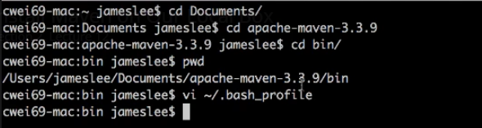

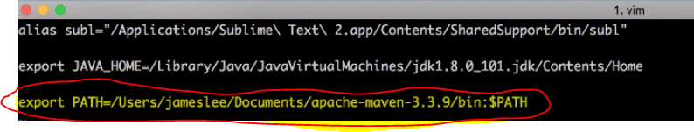

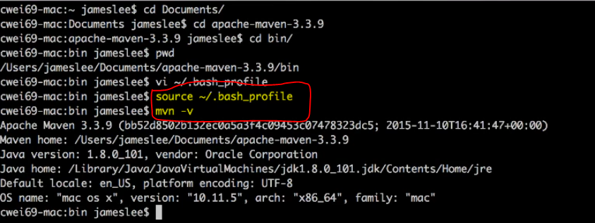

Install Maven:

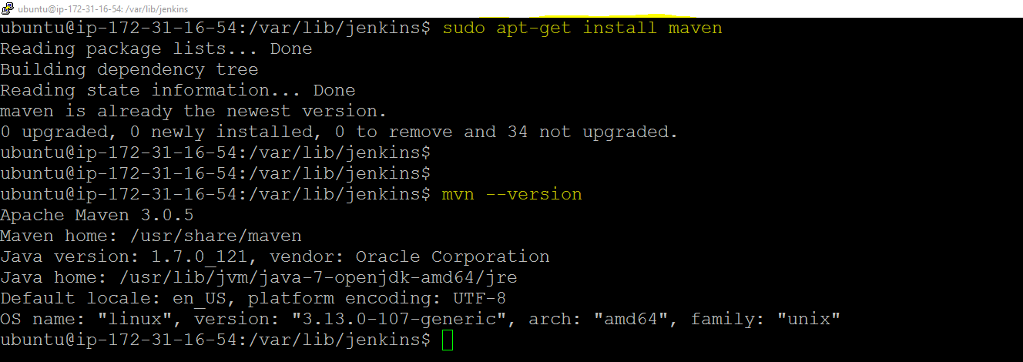

**readlink** used to find the path of a software. Always use the parameter as /usr/bin/<software-name>

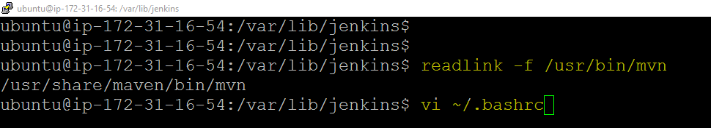

Add the path in **.bashrc** and user **source** command to apply the path changes.

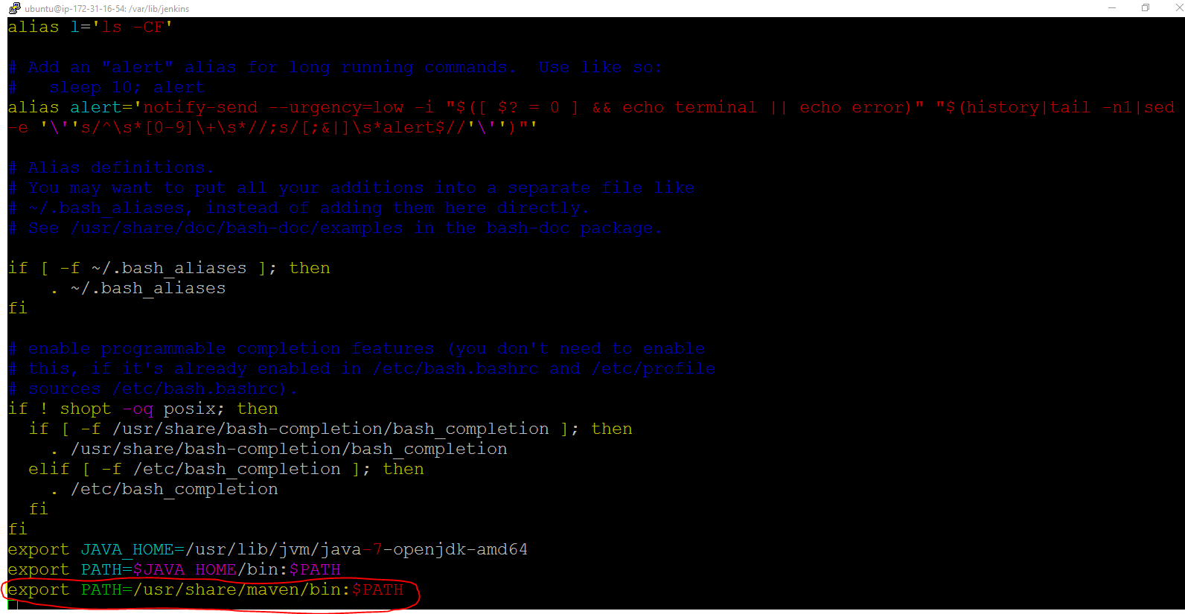

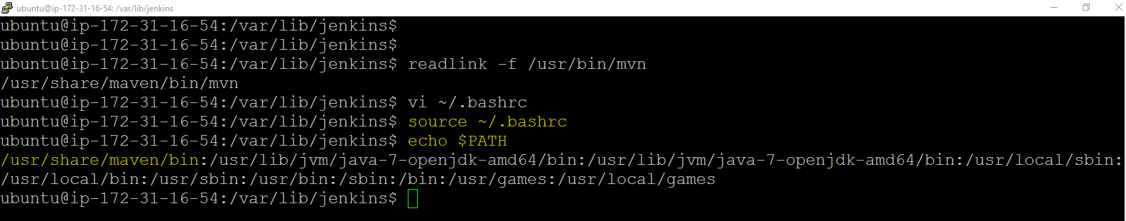

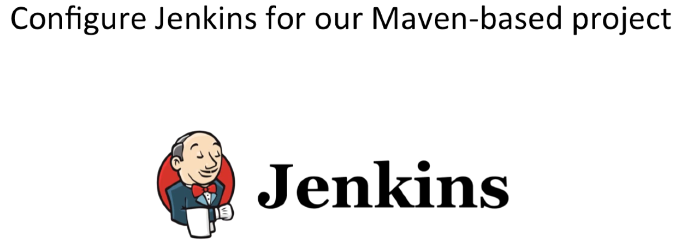

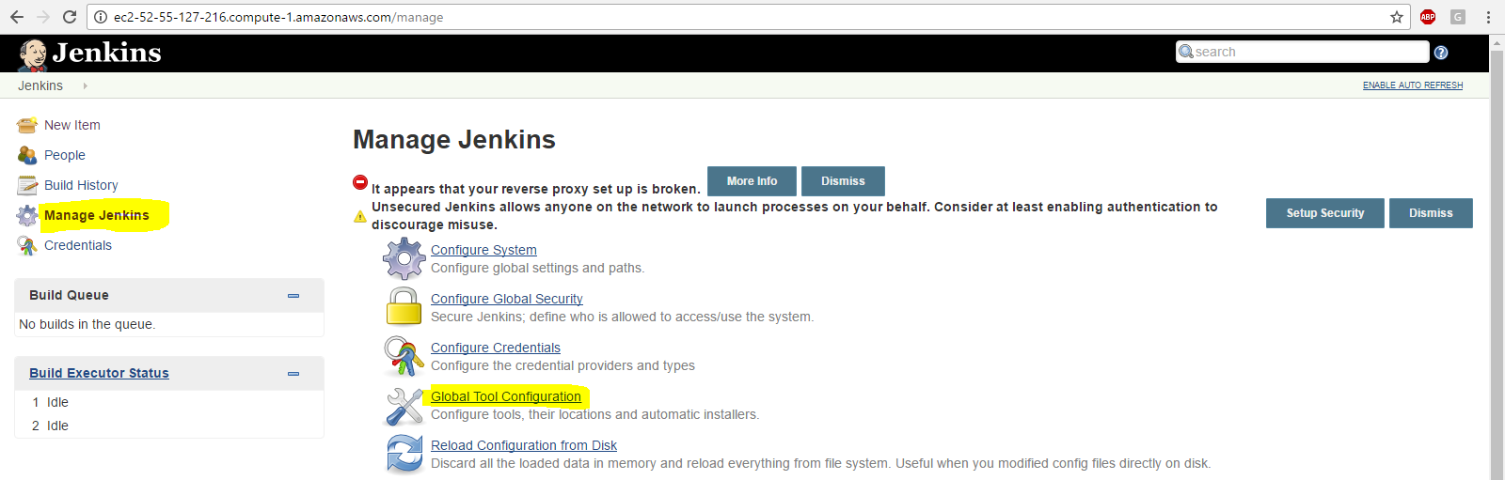

Configure Java, Git, Maven

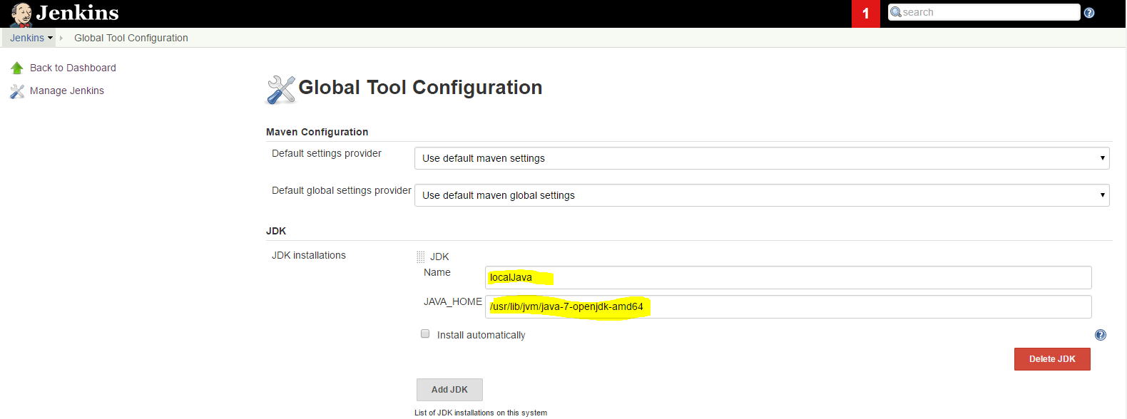

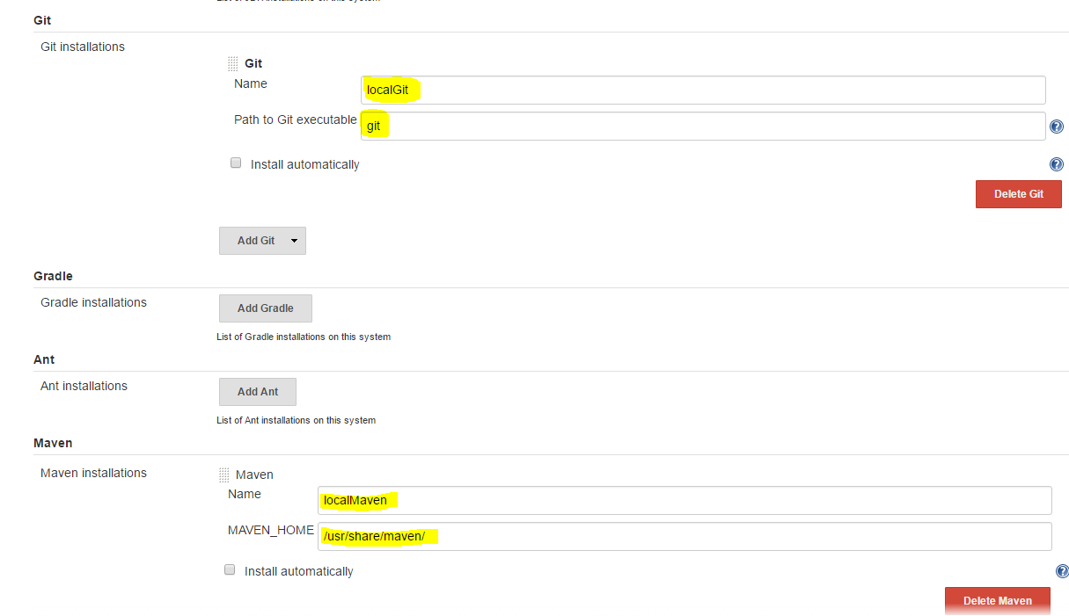

Click on SAVE

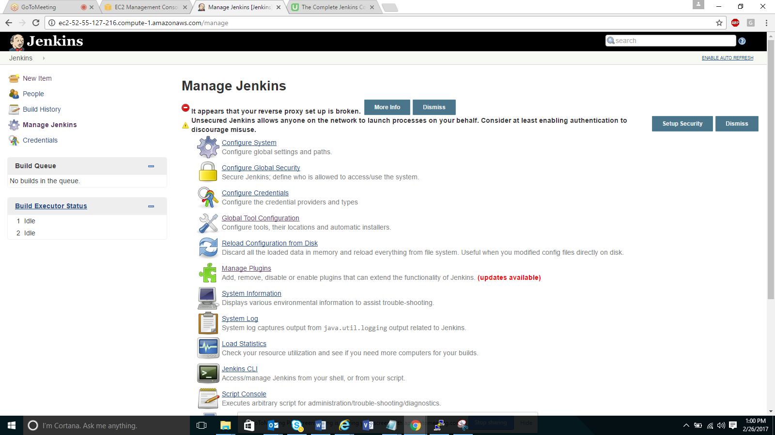

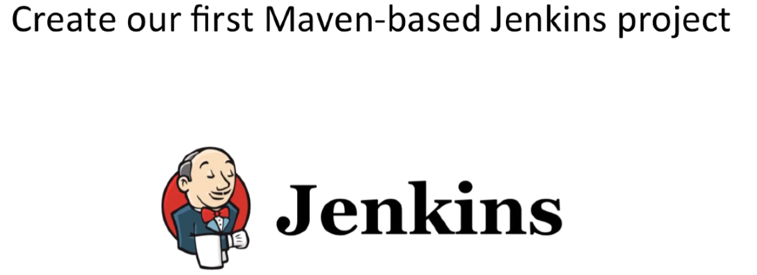

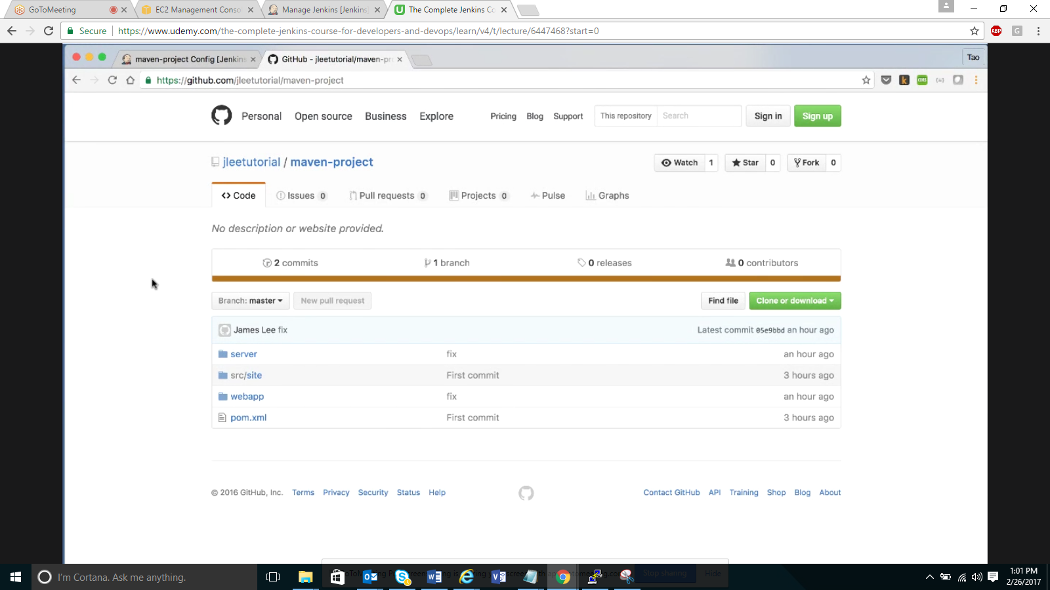

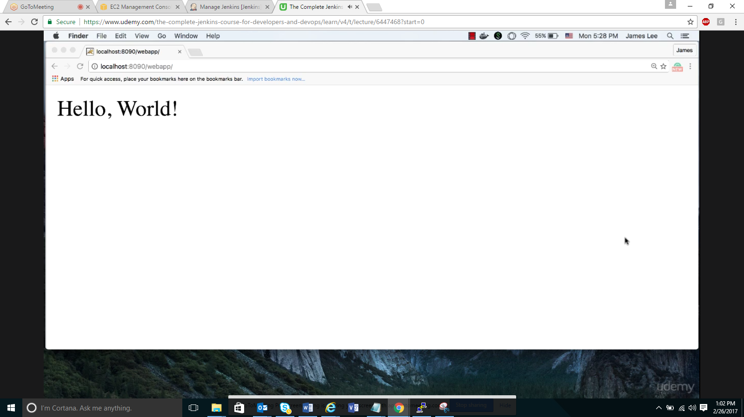

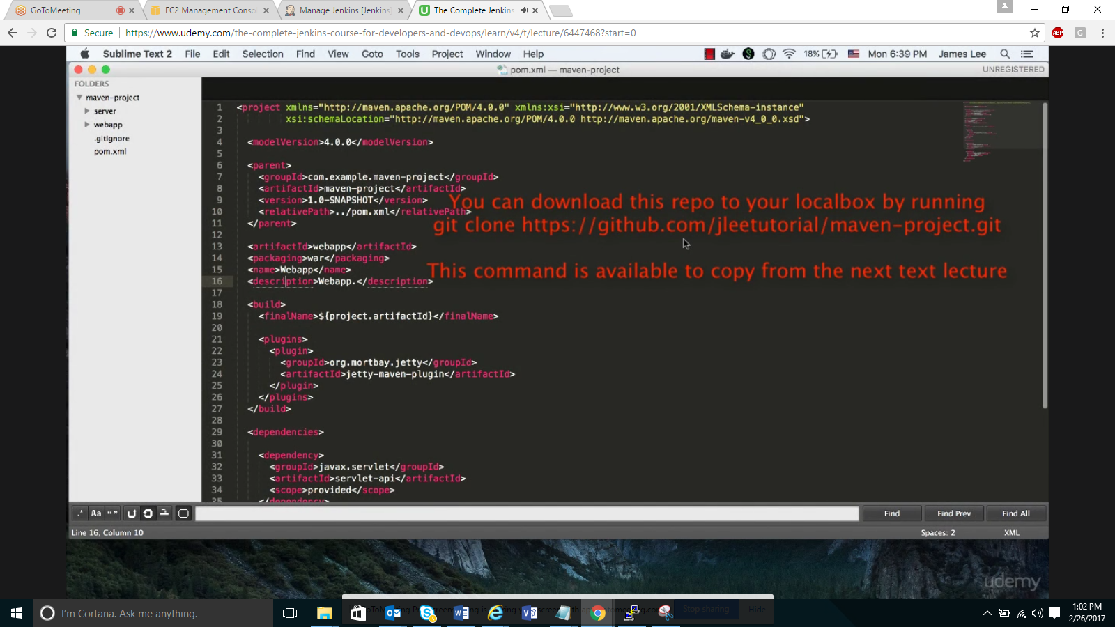

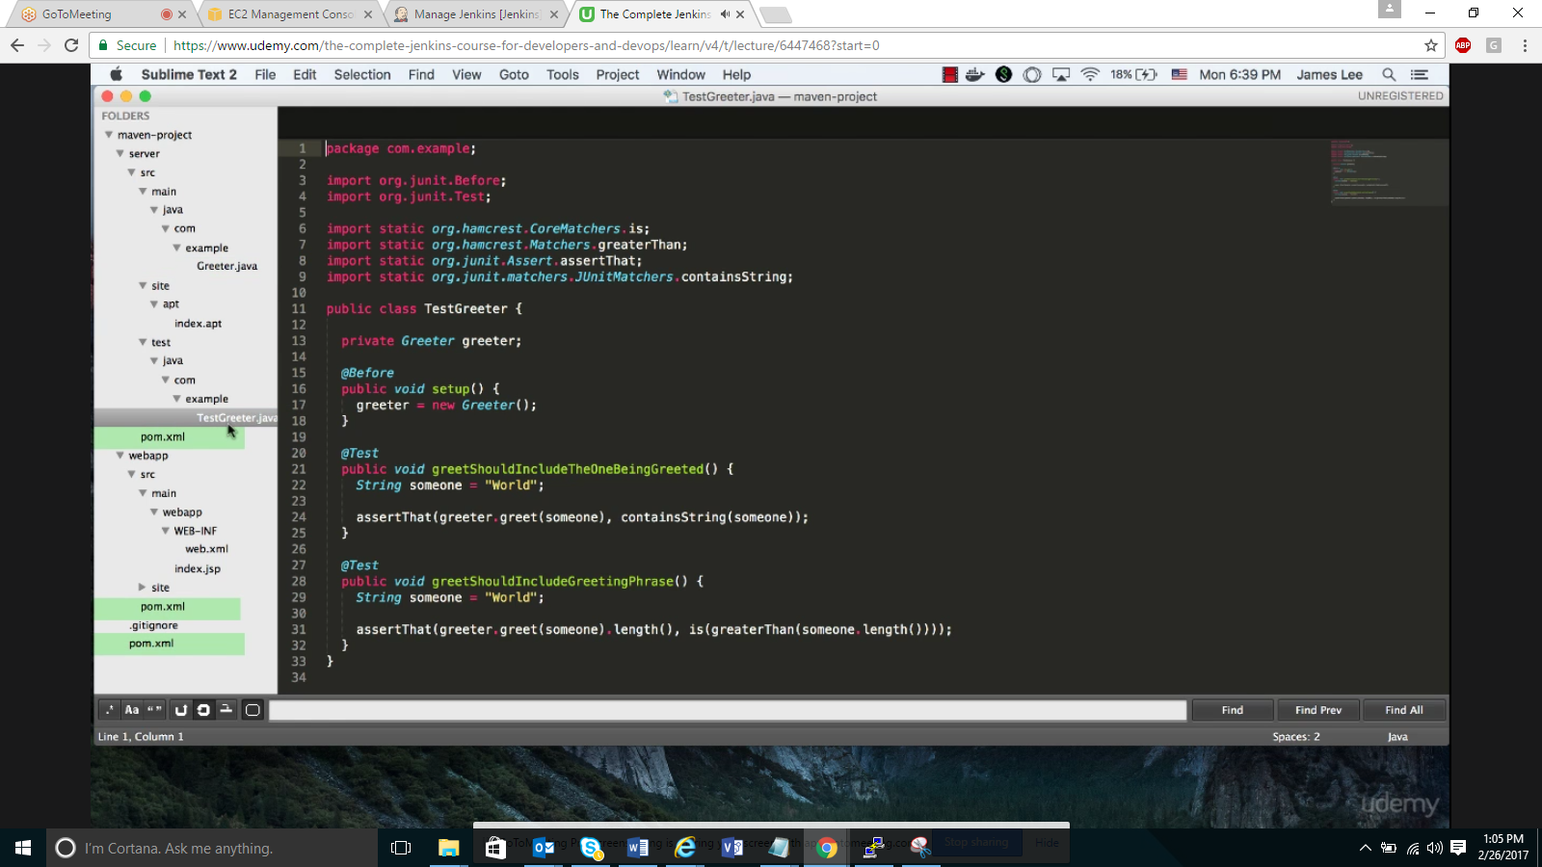

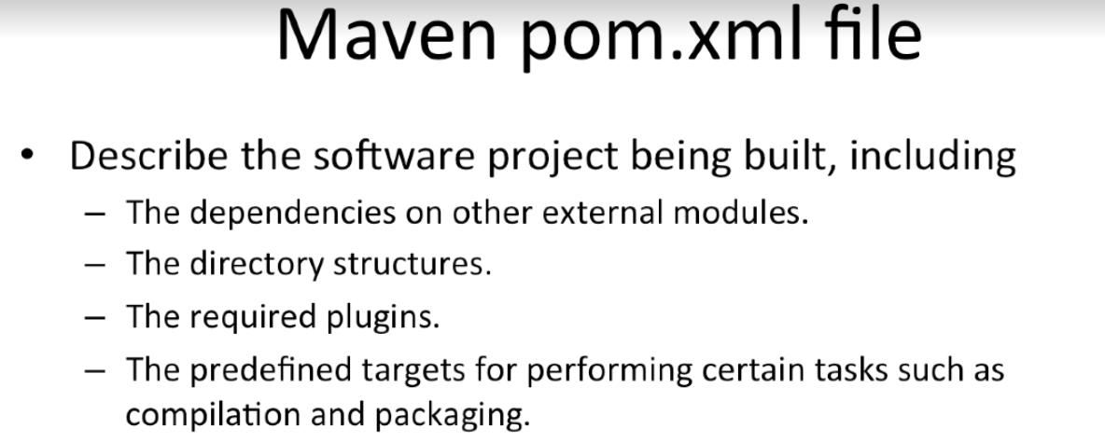

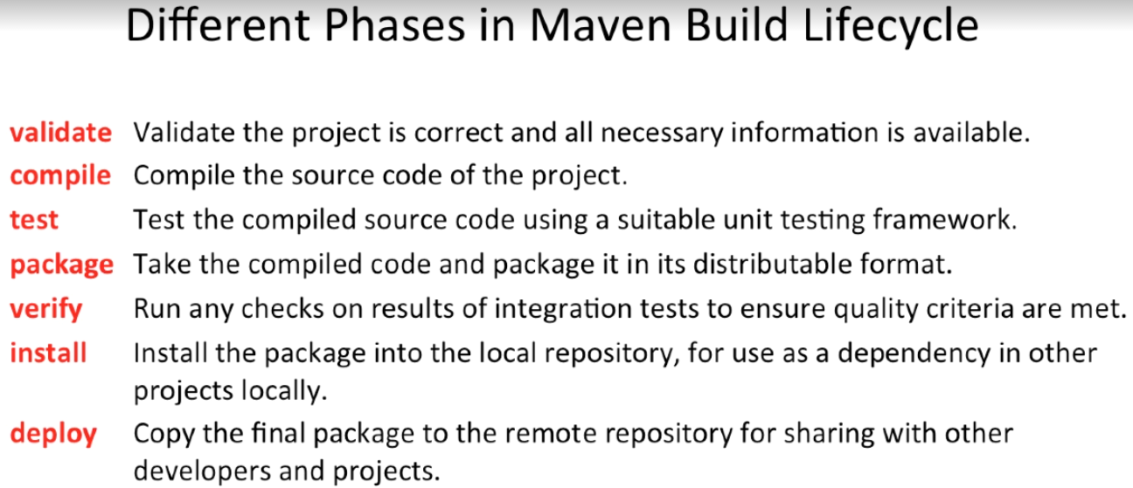

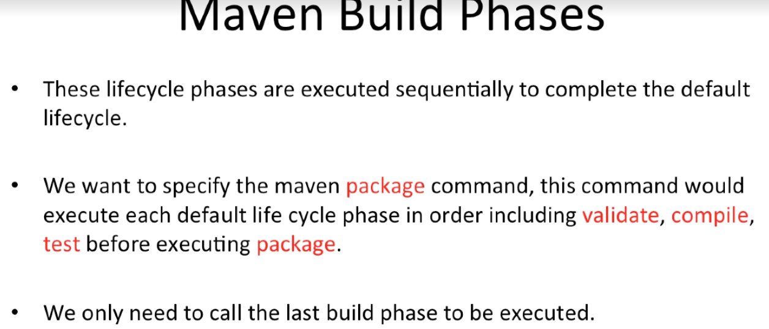

Creating new Maven project in Jenkins:

* + 1. Click on “NEW ITEM” on Jenkins landing page
    2. Give project name as “maven-project”
    3. Select “free style” project
    4. Click OK

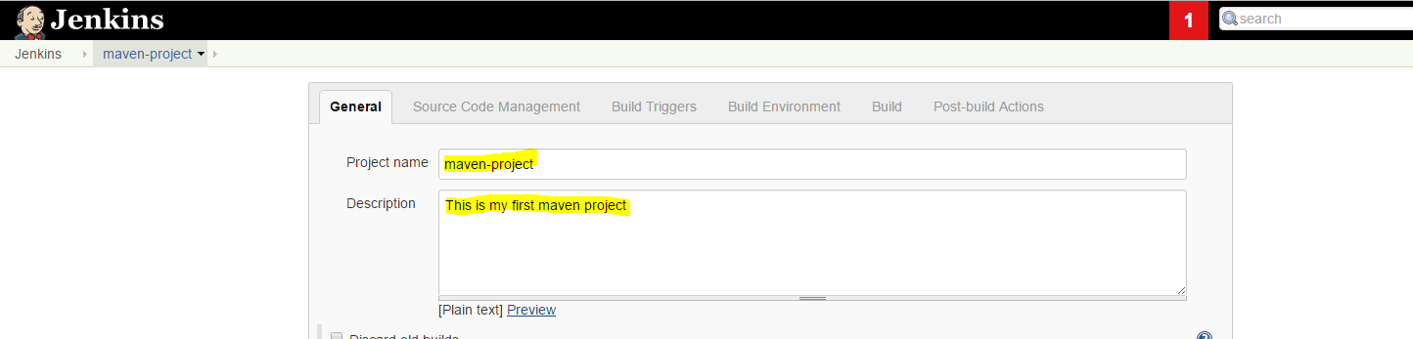

Project Location:

https://github.com/jleetutorial/maven-project

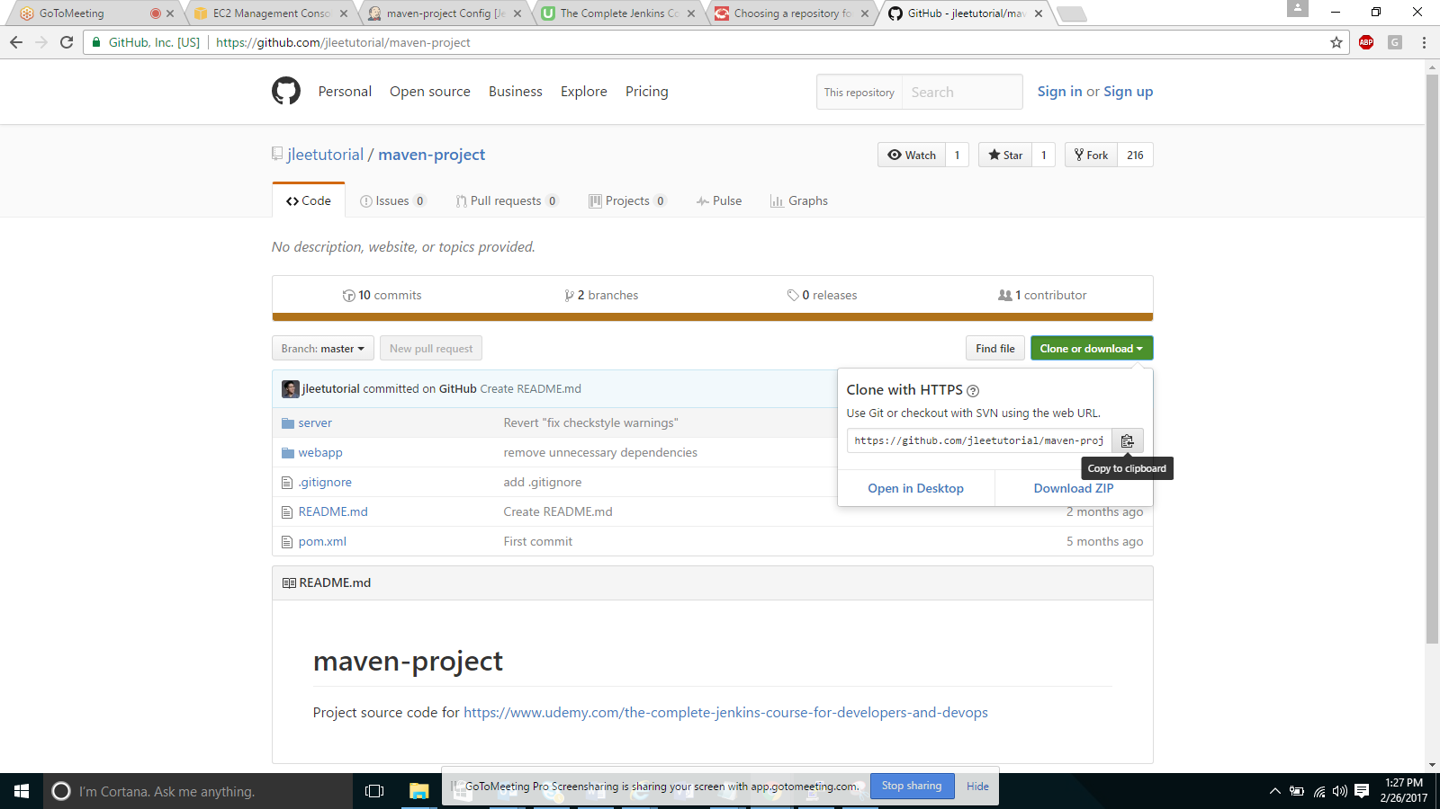

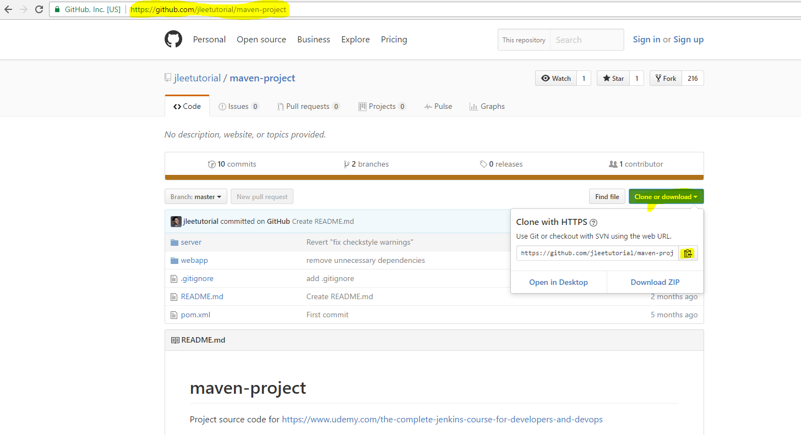

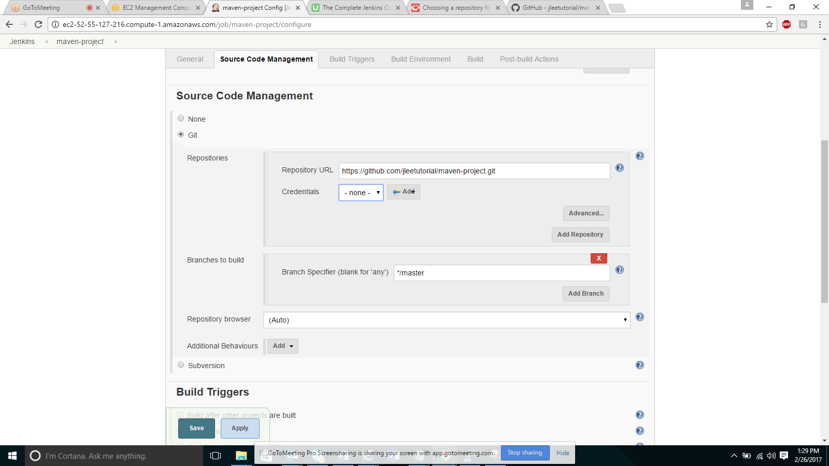

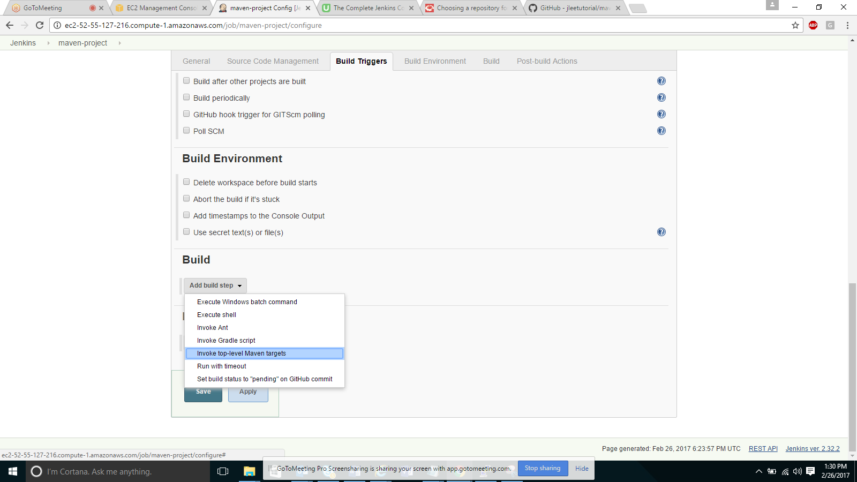

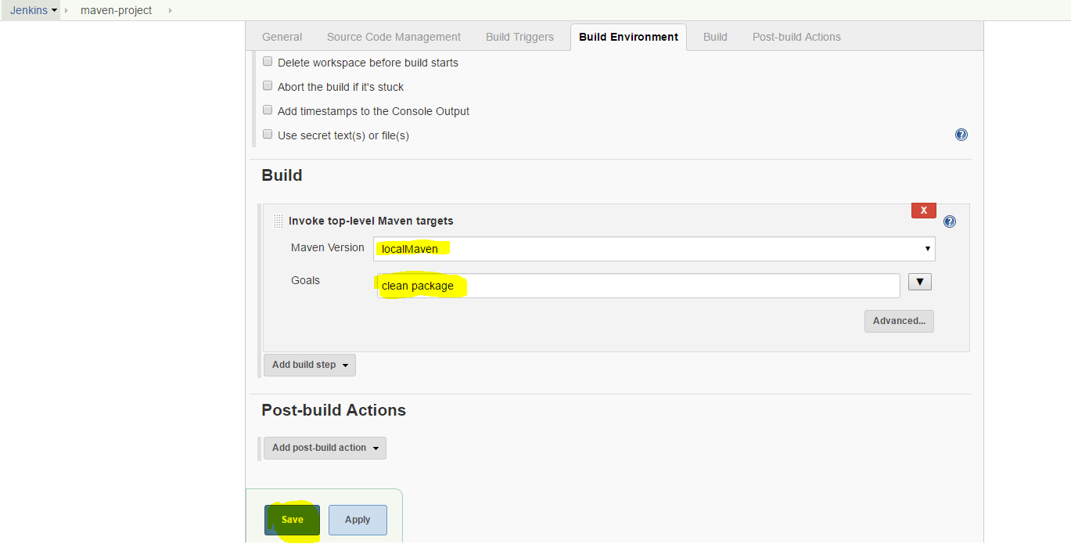

Goals are basically phases of the Maven build

clean – ensure we have clean environment before we are executing any further maven build steps

Text Direction: Create our First Maven-based Jenkins Project

Section 2, Lecture 15

#### Command to clone the repo:

git clone https://github.com/jleetutorial/maven-project.git

#### Git repo webpage:

https://github.com/jleetutorial/maven-project

#### URL of the Git repo (the one that Jenkins needs):

https://github.com/jleetutorial/maven-project.git

#### Maven Project type

In this lecture you might NOT see the Maven Project  type available to choose from when you click the New Item  button.

In order to have the Maven Project  type, you will need to install the Maven Project Plugin.

https://wiki.jenkins-ci.org/display/JENKINS/Maven+Project+Plugin If you are building a complicated maven project, definitely pick the maven project type here, this is a project template that Jenkins has reserved specifically for Maven-based projects.

Jenkins understands the pom dot XML file format and would take advantage of it which can greatly reduce the manual configuration.

But considering our maven project is a very simple one and the free style project would suffice, so here we just go with the free style project.

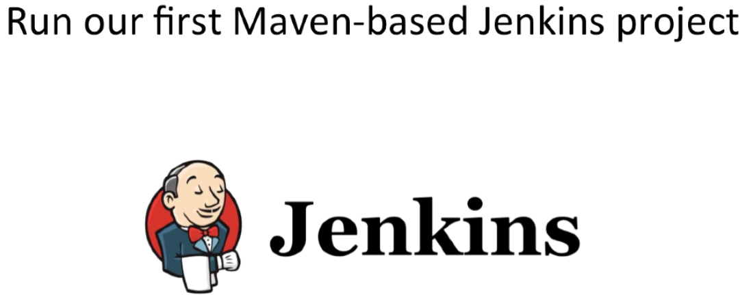

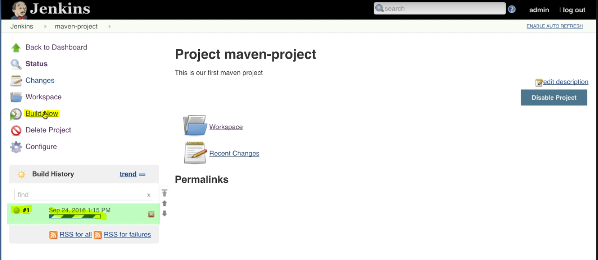

First it checks out the source code from github

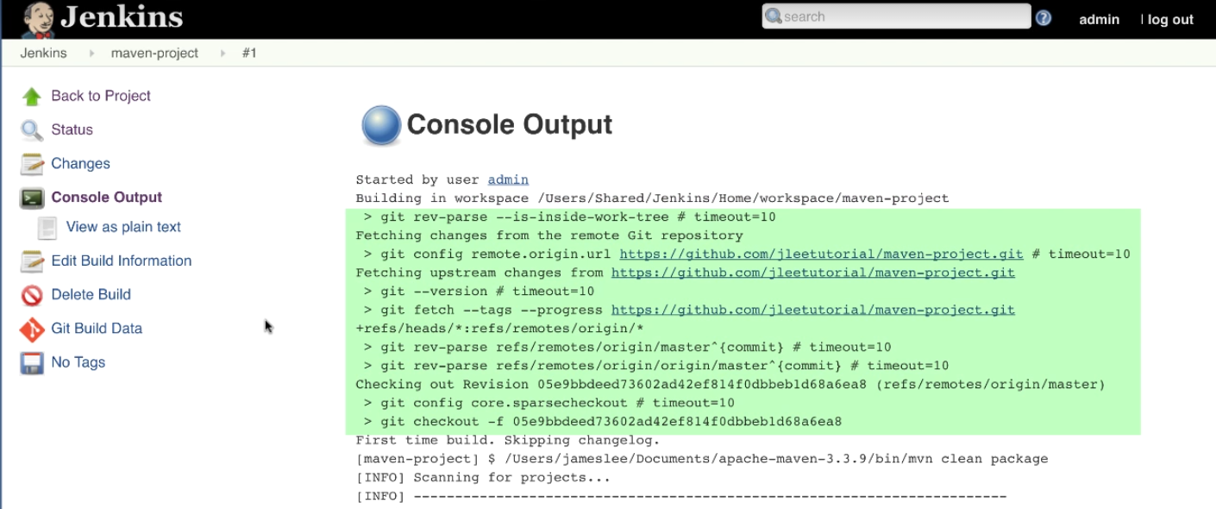

Then it is going to execute maven clean and package commands

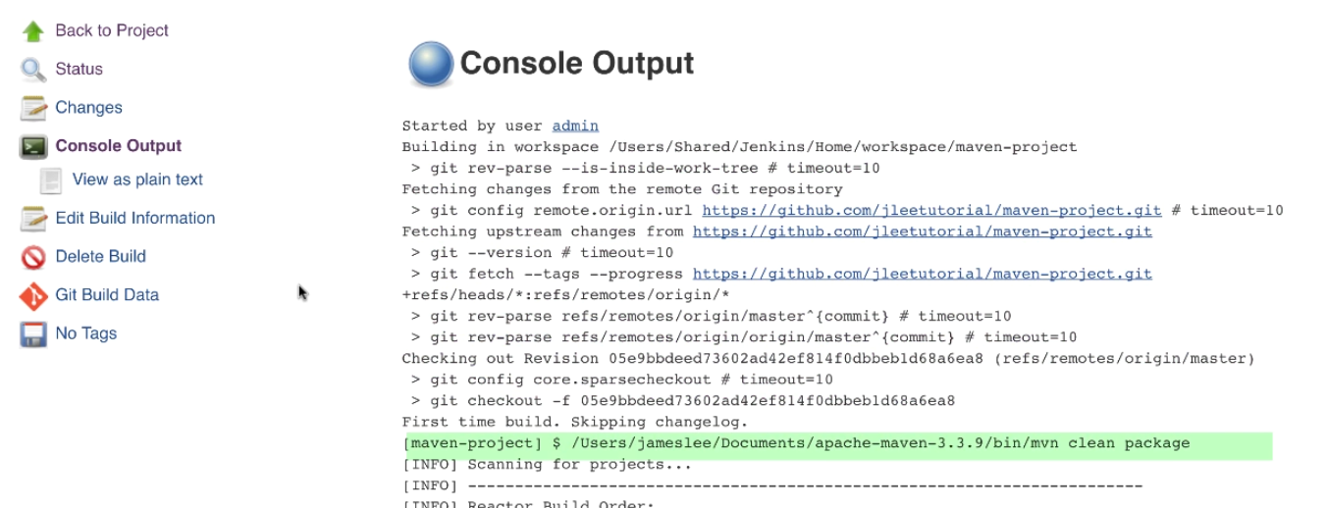

Maven figure out the right order of creating all the modules of the maven project.

First one is the root module (Maven Project), server module and webapp module.

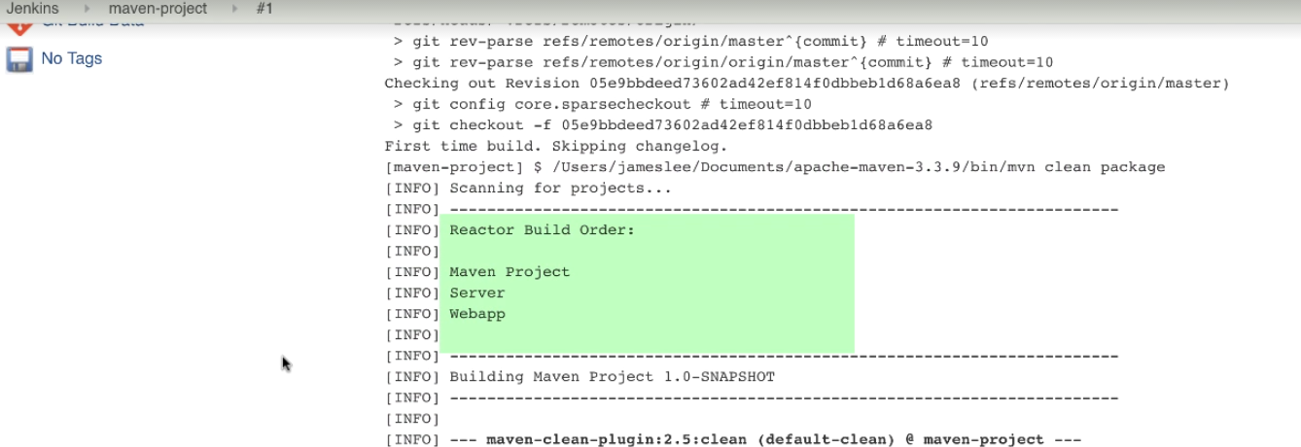

Clean command to remove any previous artifacts generated in the target directory

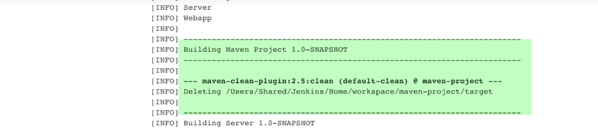

Then move to the server module, Jenkins is executing sequential maven build commands such as compile, test before packaging.

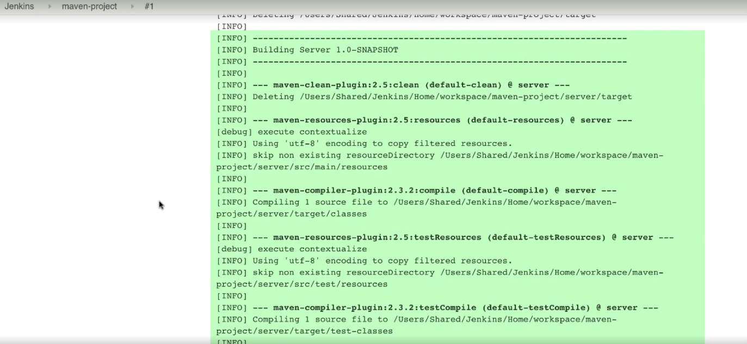

After executing all Tests, it prints out unit test reports.

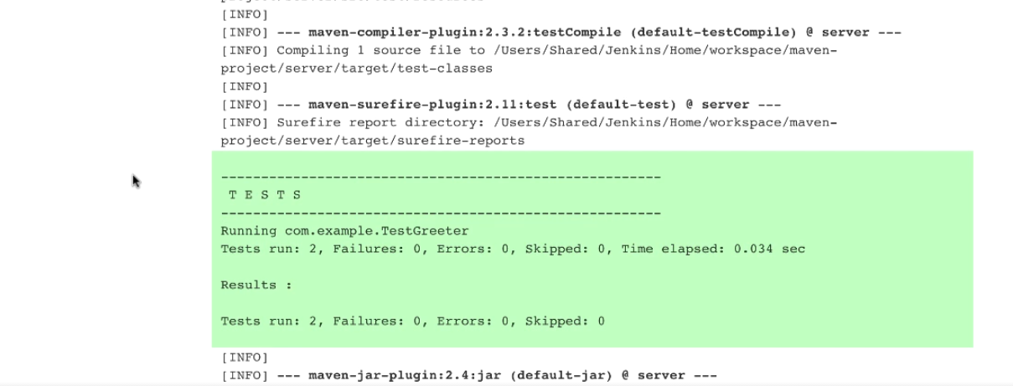

Lastly it packages the server module and produces the server.jar under the target directory in the server module.



Build starts the webapp module predecimilar to the server module cleaning, compile and test.

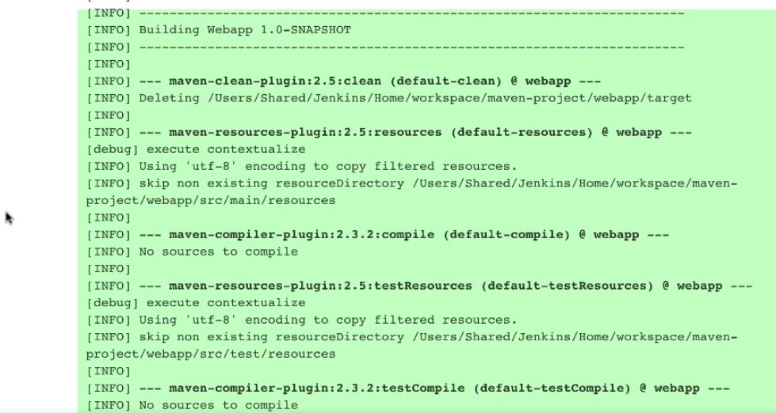

At the end it packages webapp module, and produces the webapp.war further deployed to a servlet container like tomcat.

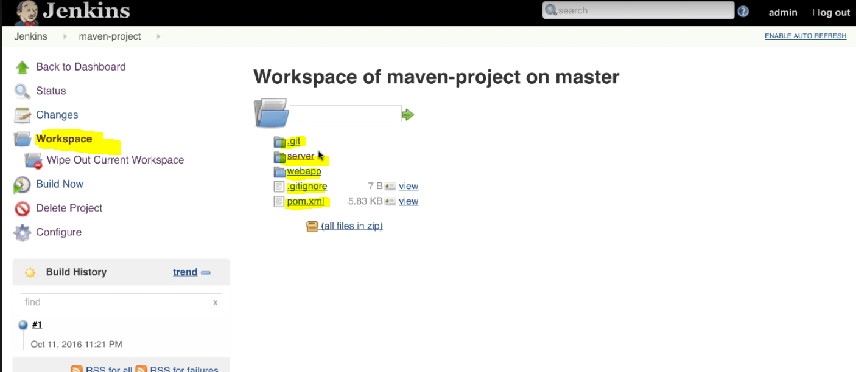

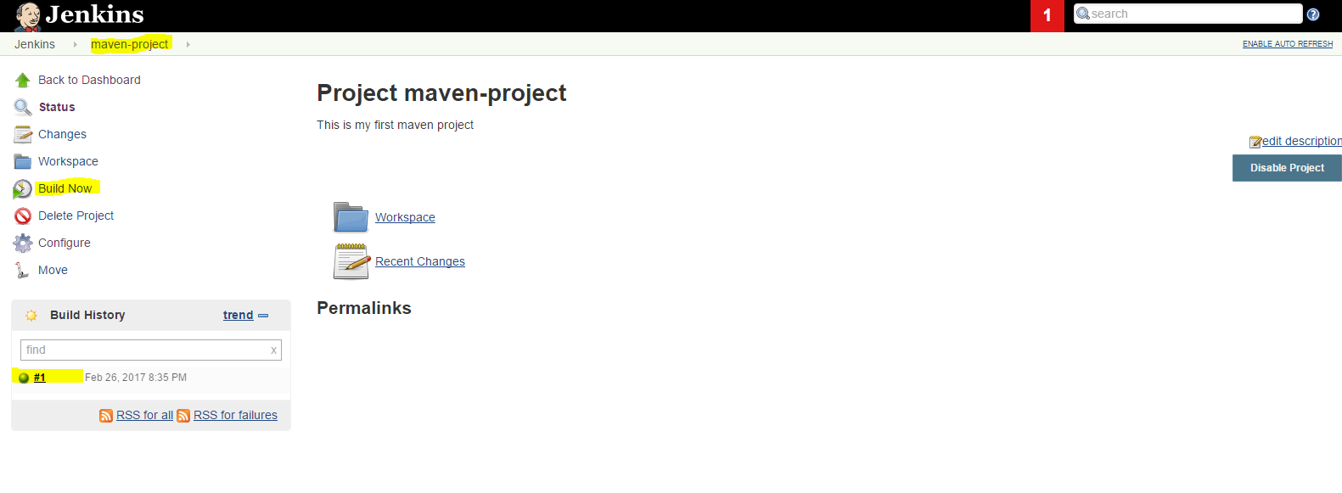

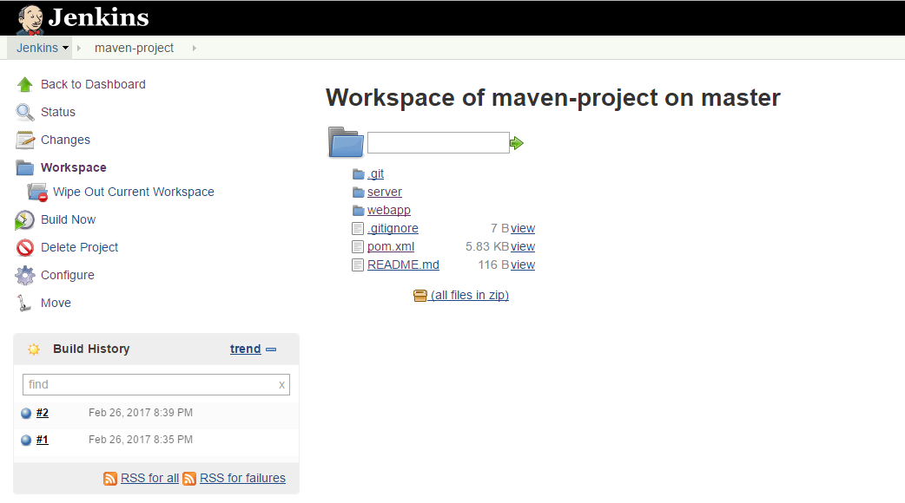

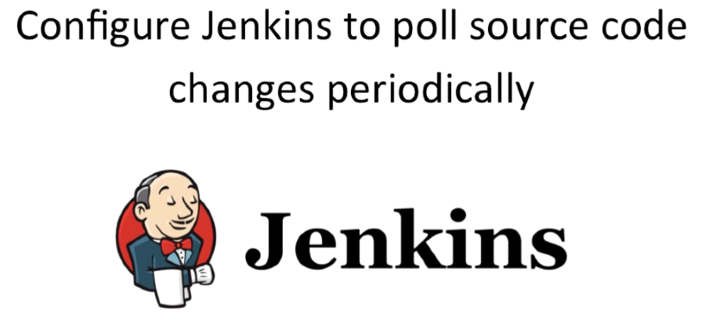

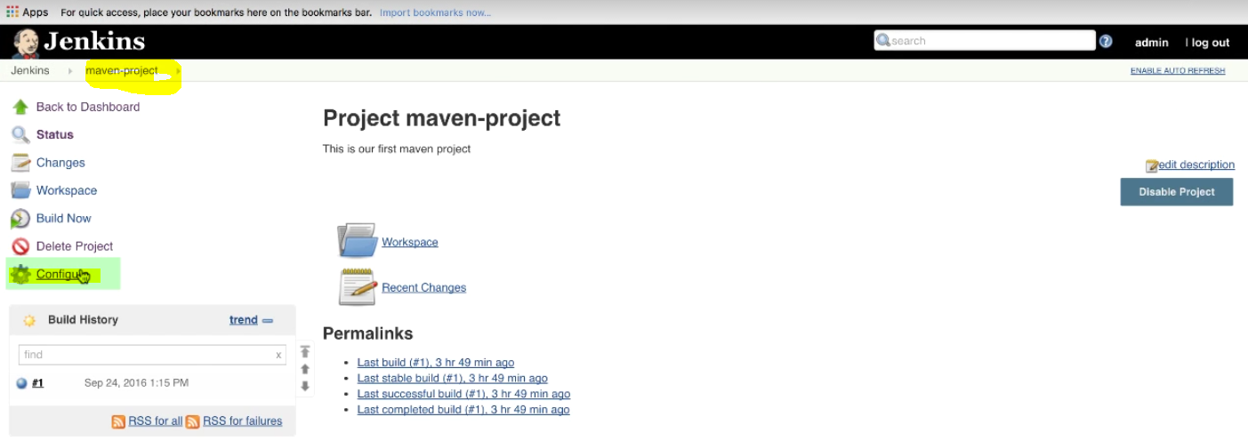

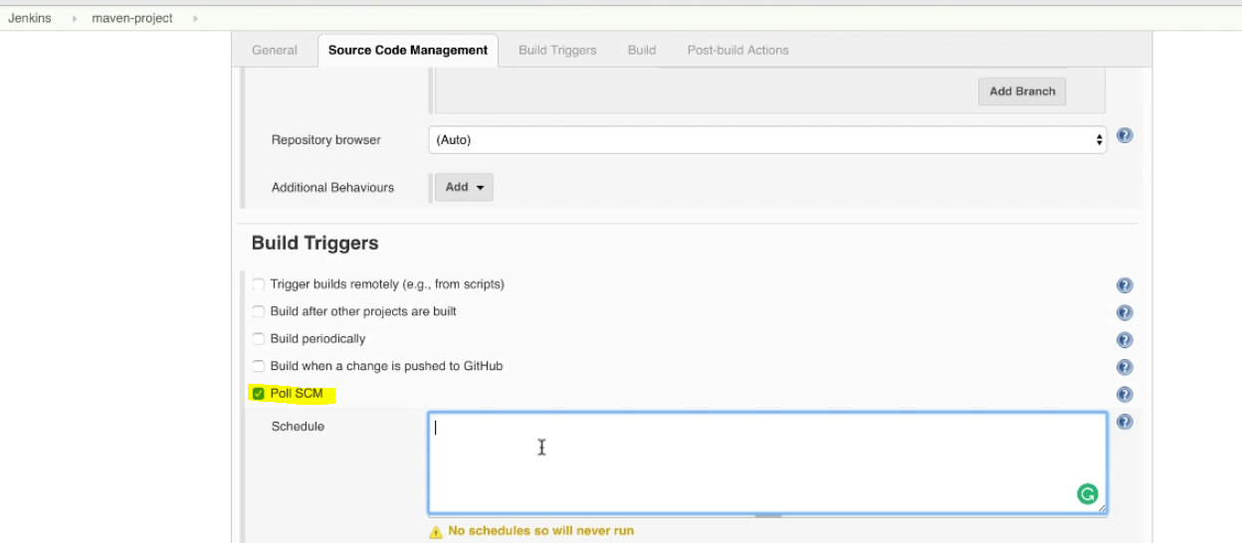

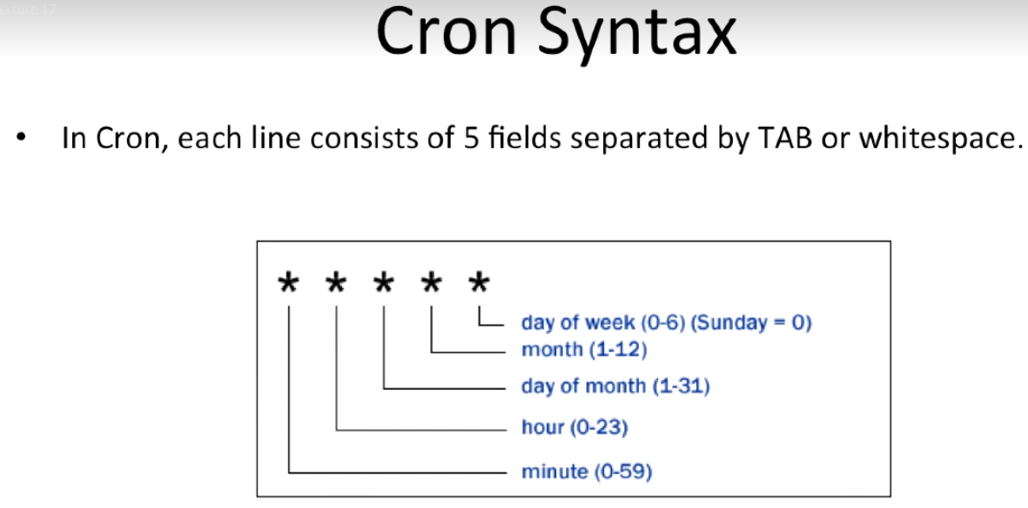

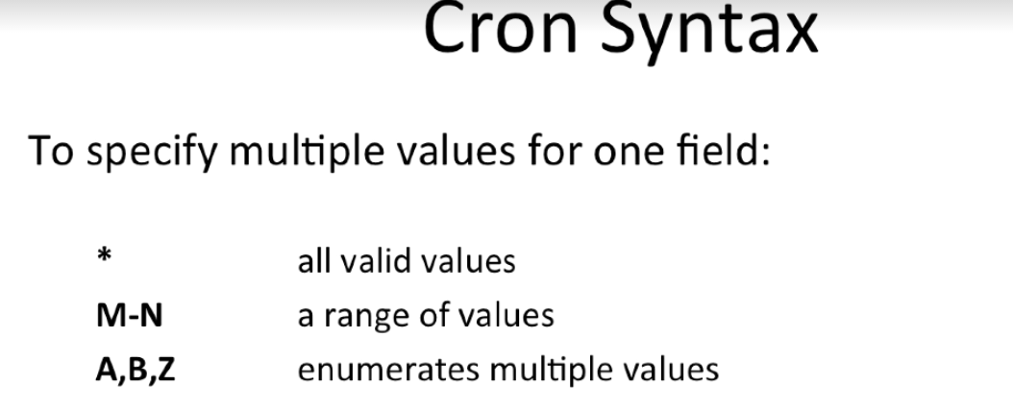

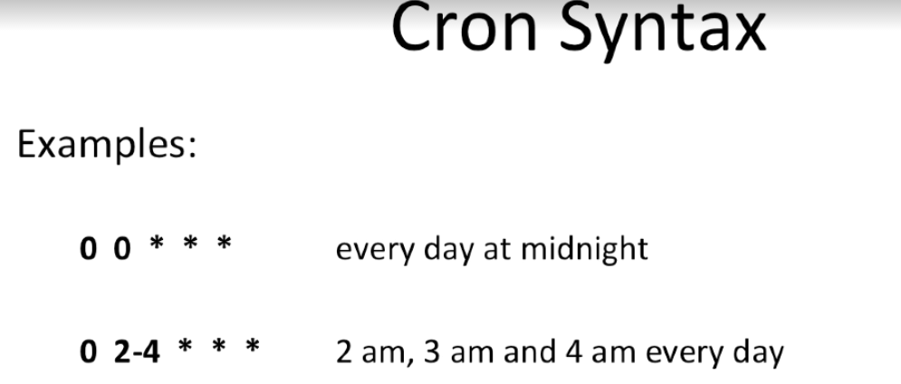

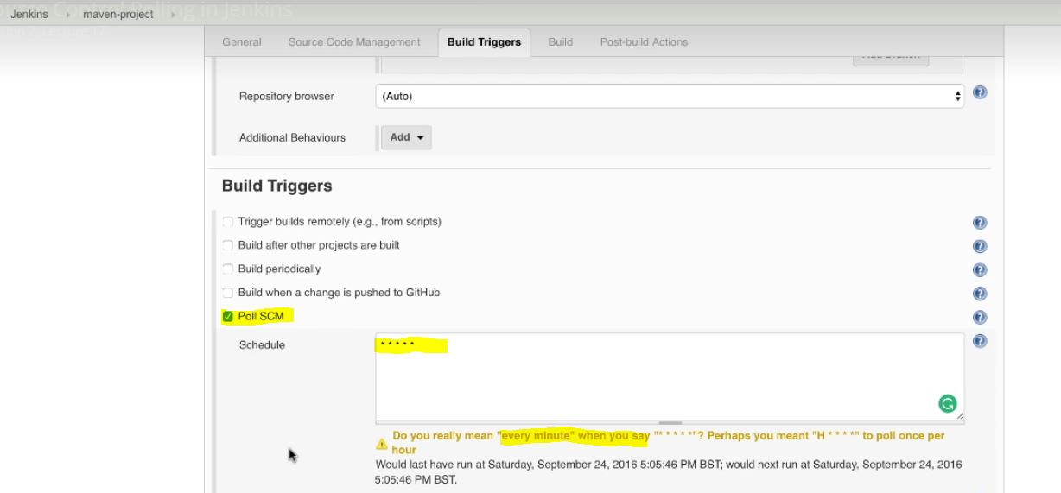

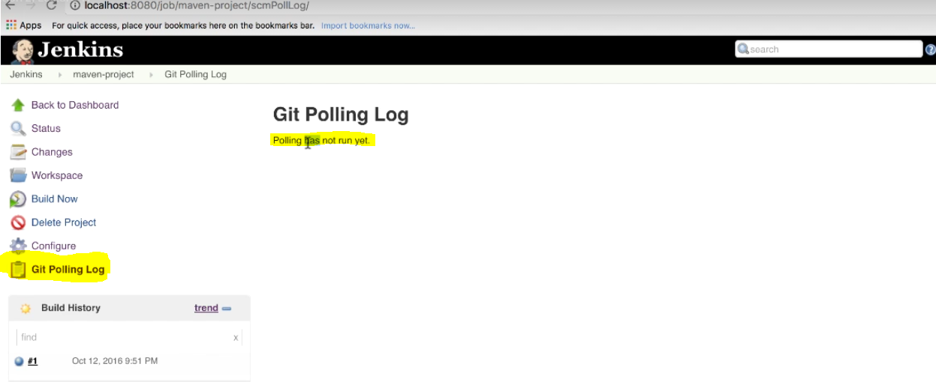

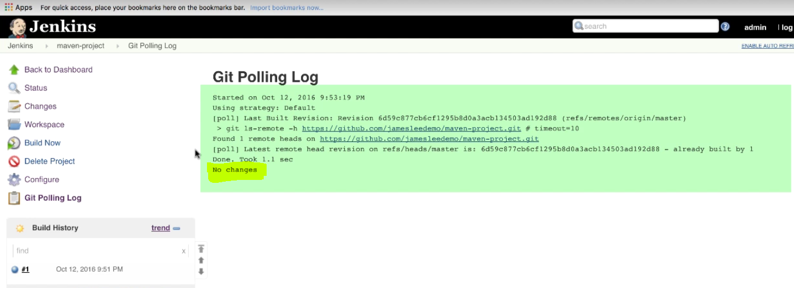

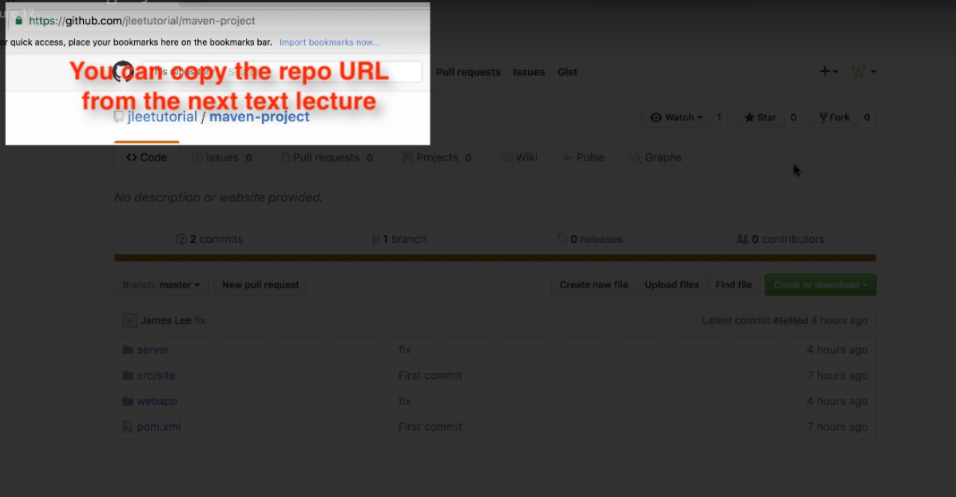

To modify the changes in the project, you need to fork the project into your github account. Then do modify the project by cloning in to your local box and push the changes to github(your github account). Then go to Jenkins (we already set the schedule every minute in Poll SCM of build triggers section) and check the build triggers as we have done the changes in the project.

When you click on Fork, it will ask to login to your github account. Give login details: kollasin@gmail.com/Greens01

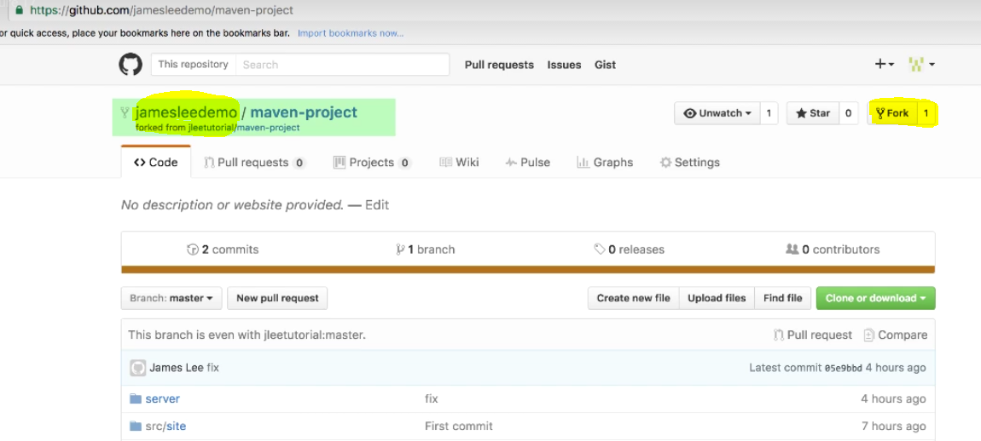

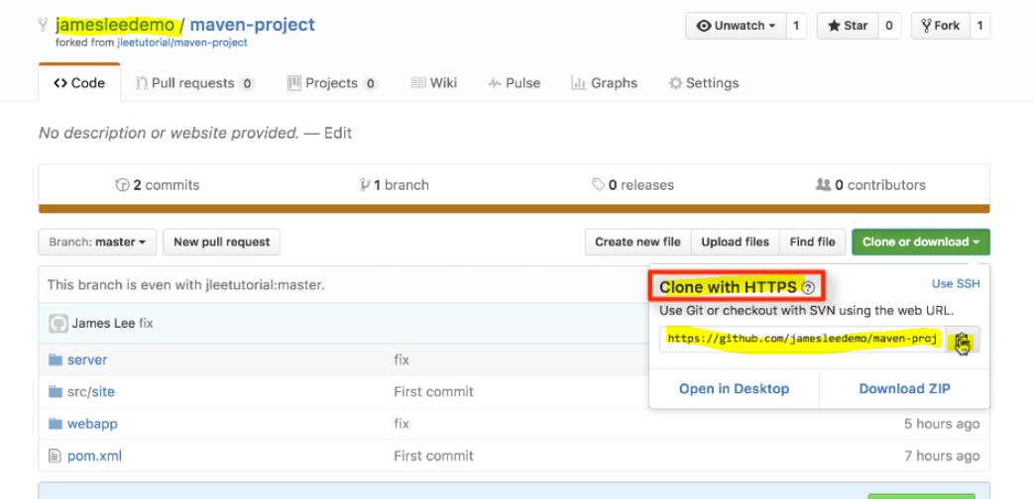

Update the Repository URL as per your forked repository in your github account. So that Jenkins will checkout the code from your github maven-project.

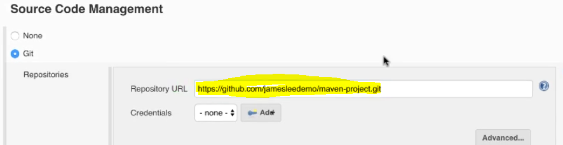

To push the changes in your github account you need to set up ssh keys

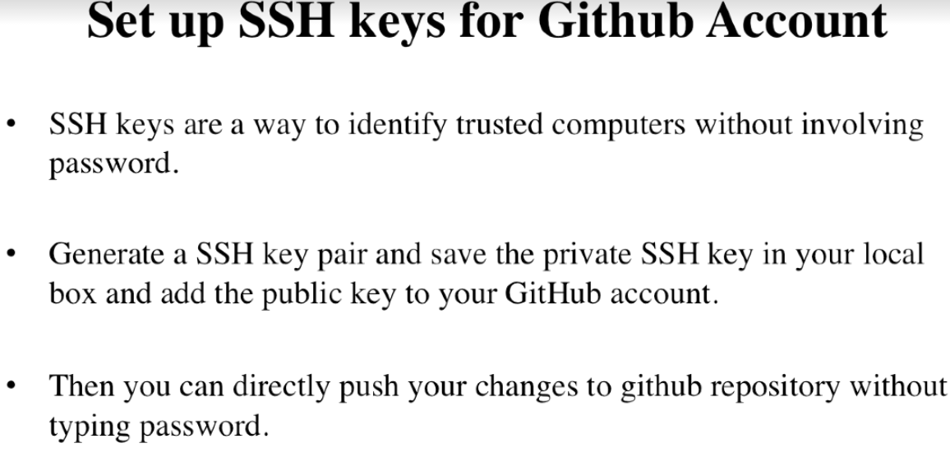

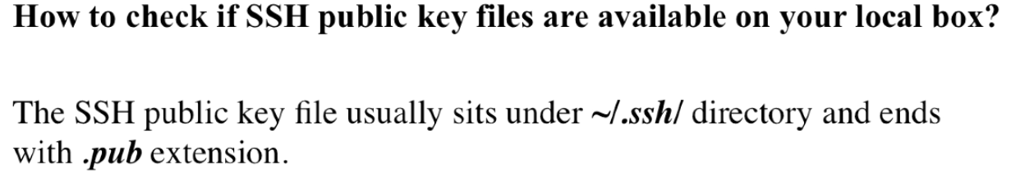

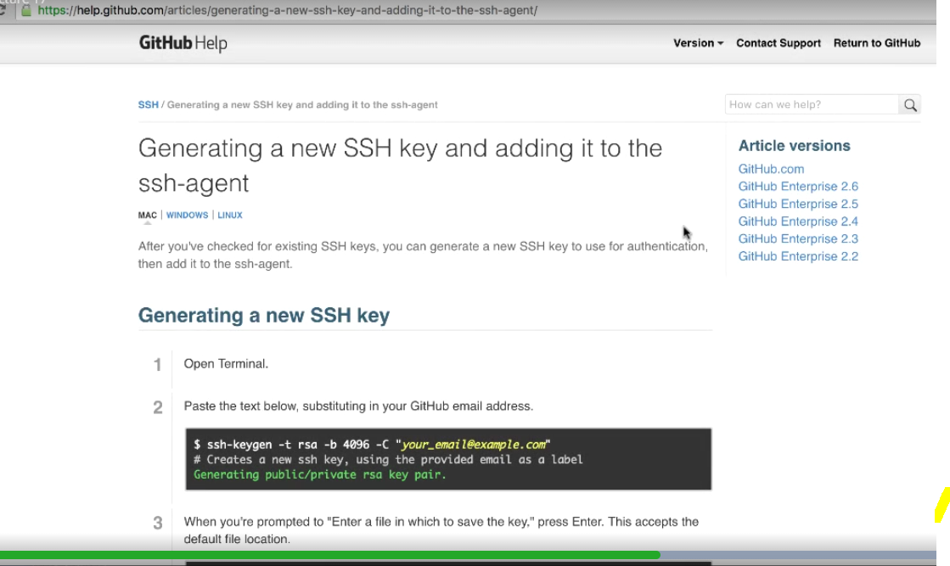

786 ssh-keygen -t rsa -C "Sudheer testing"

787 ll

788 pbcopy ~/.ssh/id_rsa.pub

Create a ssh key and copy (pbcopy copies into buffer) and paste in github settings as below

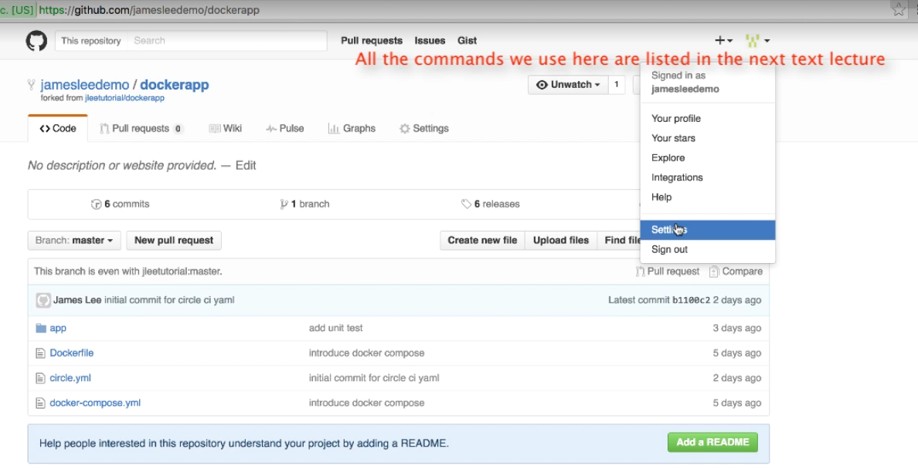

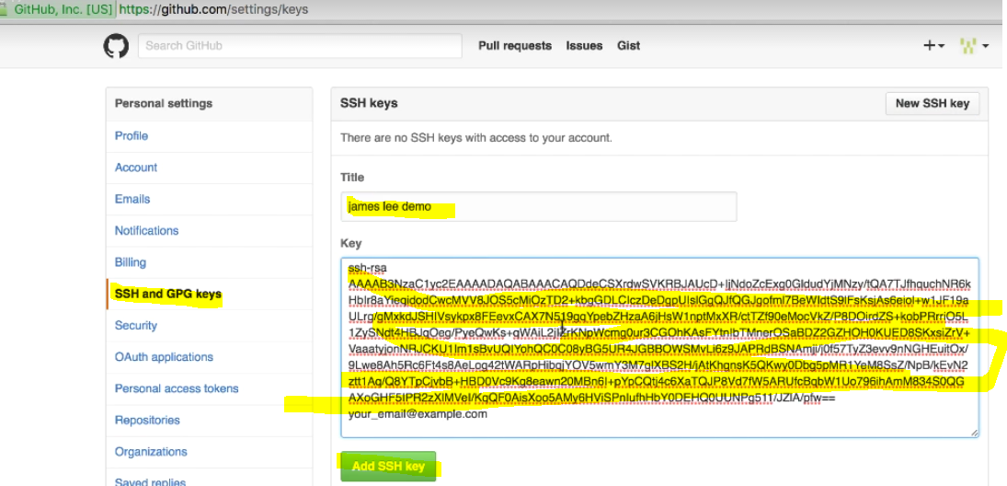

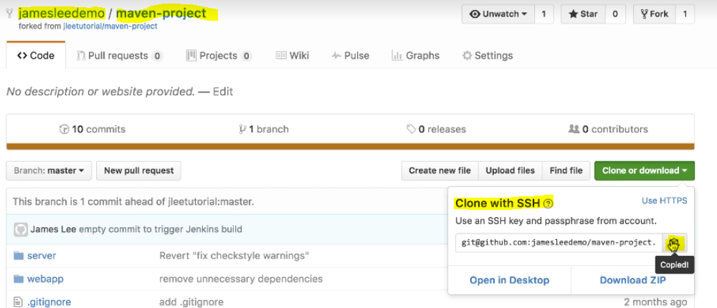

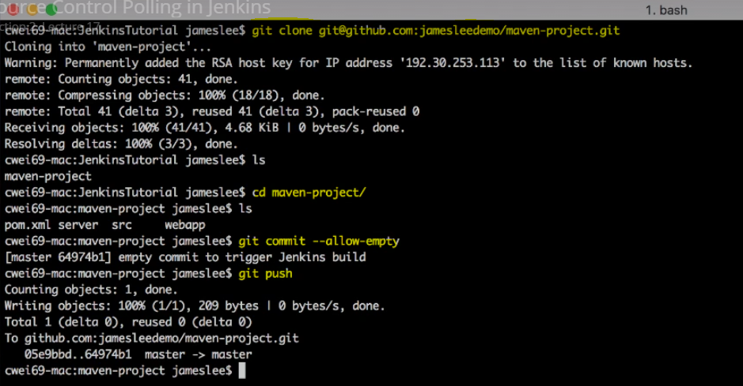

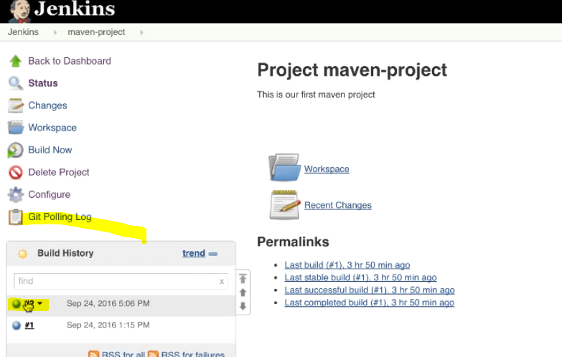

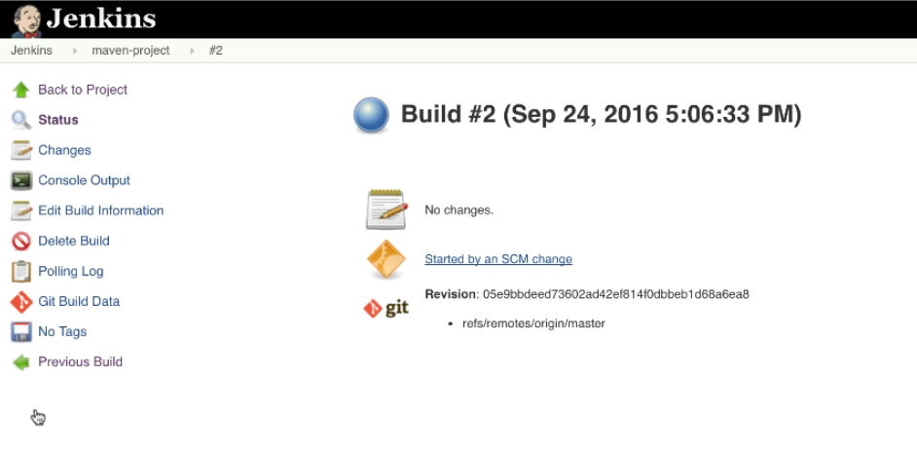

Text Direction: Source Control Polling in Jenkins

Section 2, Lecture 18

**Checking for existing SSH keys:**

https://help.github.com/articles/checking-for-existing-ssh-keys/

**Generating a new SSH key and adding it to the ssh-agent:**

https://help.github.com/articles/generating-a-new-ssh-key-and-adding-it-to-the-ssh-agent/

**Adding a new SSH key to your GitHub account:**

https://help.github.com/articles/adding-a-new-ssh-key-to-your-github-account/

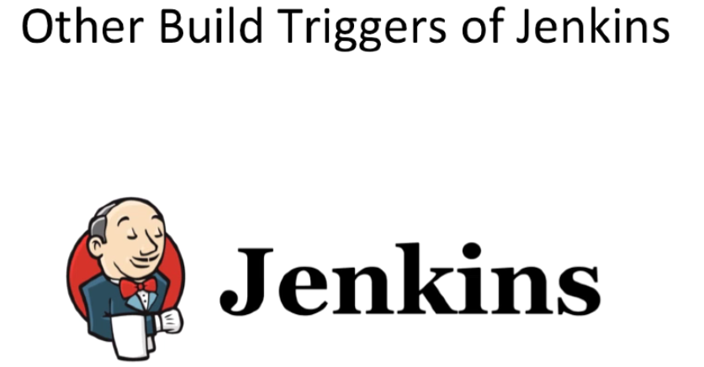

Go to the configuration page of Jenkins.

Select “Source code manaagement” tab and go to “Build Triggers” -> Trigger build Remotely (e.g., from scripts)

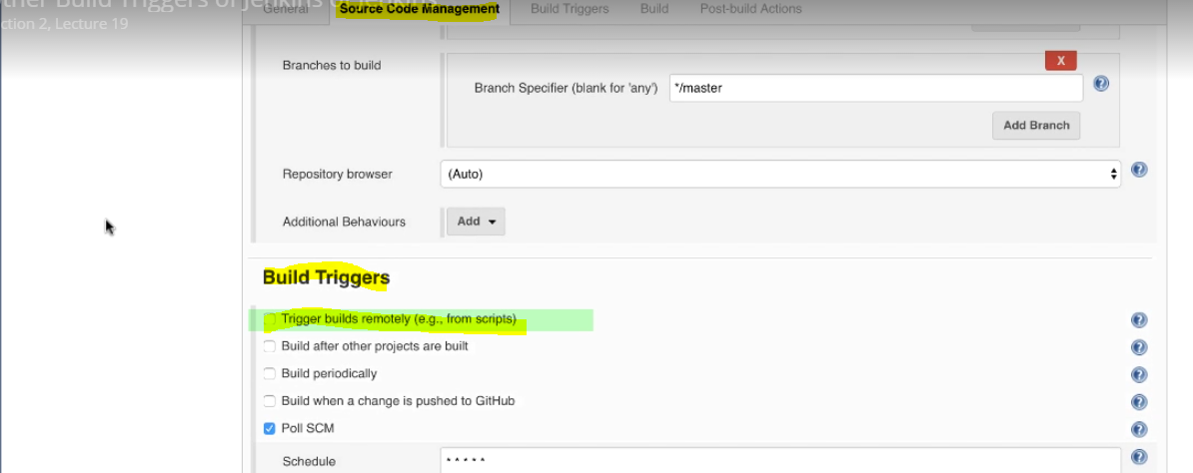

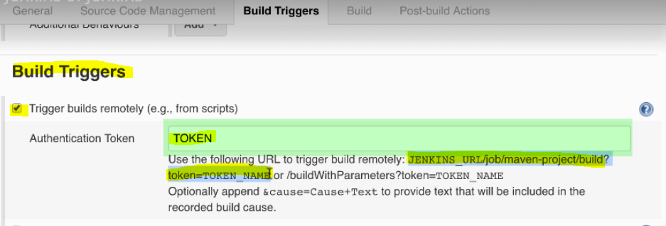

Save the configuration.

Open new browser and paste the above URL and change the JENKINS_URL with localhost:8080 and TOKEN_NAME with TOKEN and hit enter so that it trigger the build remotely.

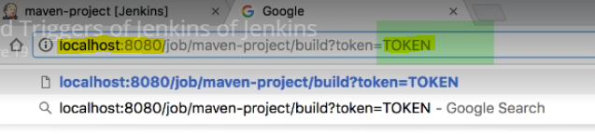

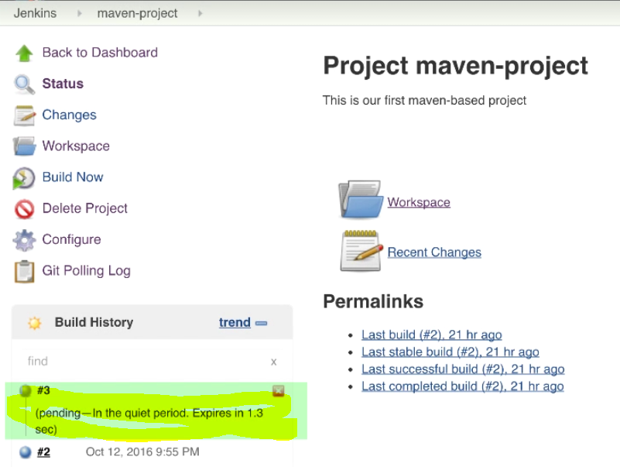

**Build after other projects are built:**

If you want to trigger a build after completion of some other build. For example, first build may be having some unit tests after successful completion of that build if you want to trigger detail testing like performance or some other full set of test to be triggered then you use this build option.

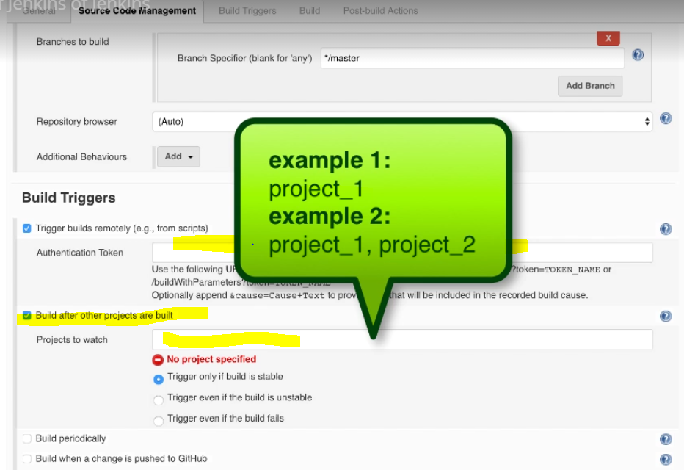

**Build periodically:**

It is not continuous integration; it is just periodically schedule the build to trigger on nightly basis.

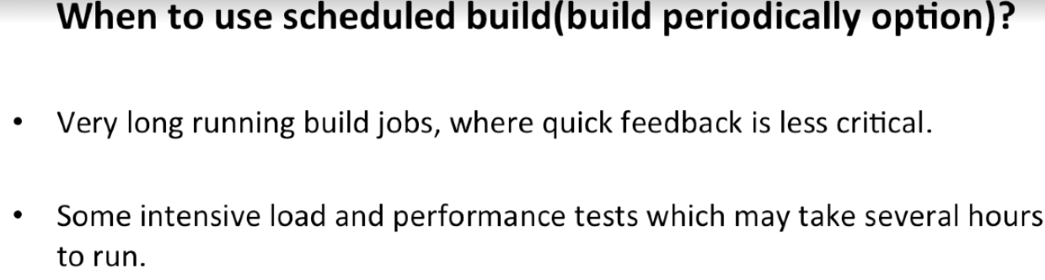

**Build when a change pushed to Github:**

It is a push model.

This trigger whenever a developer pushes the code to github a webhook trigger automatically to build.

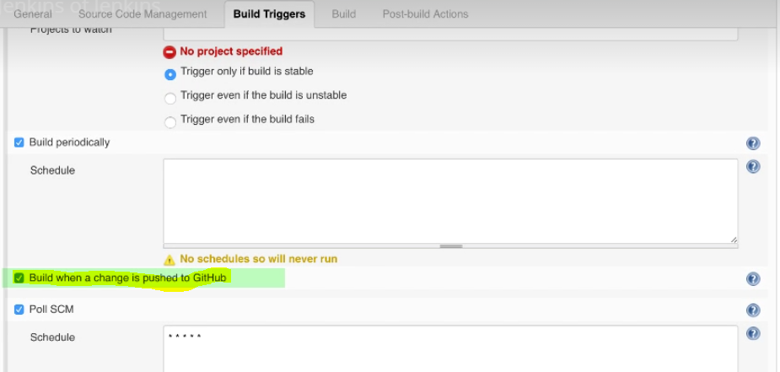

Text Direction: Other Build Triggers

Section 2, Lecture 20

#### Jenkins GitHub Plugin:

<https://wiki.jenkins-ci.org/display/JENKINS/GitHub+Plugin>

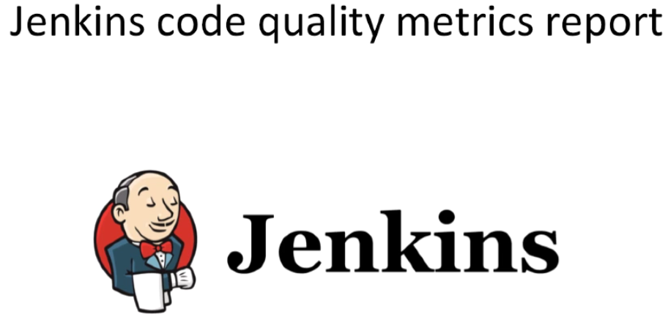

Automated Code quality and metrics checks happen along with Unit tests.

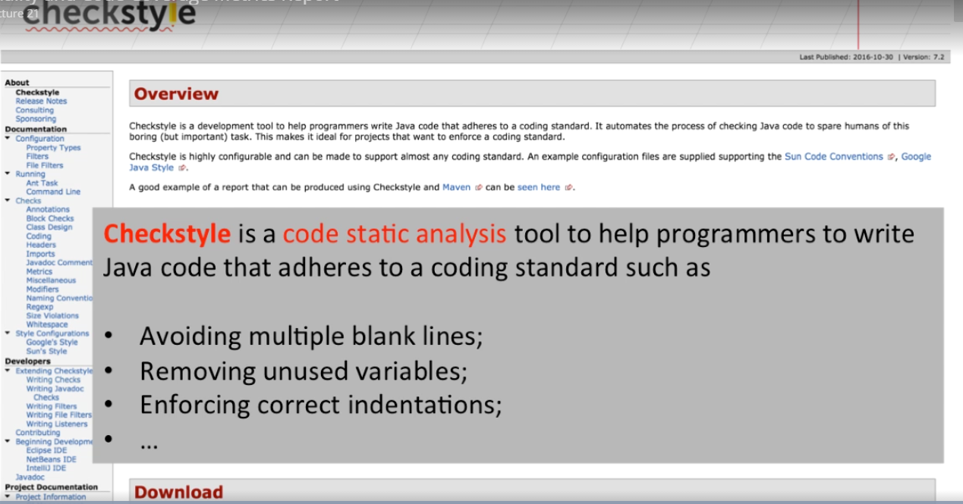

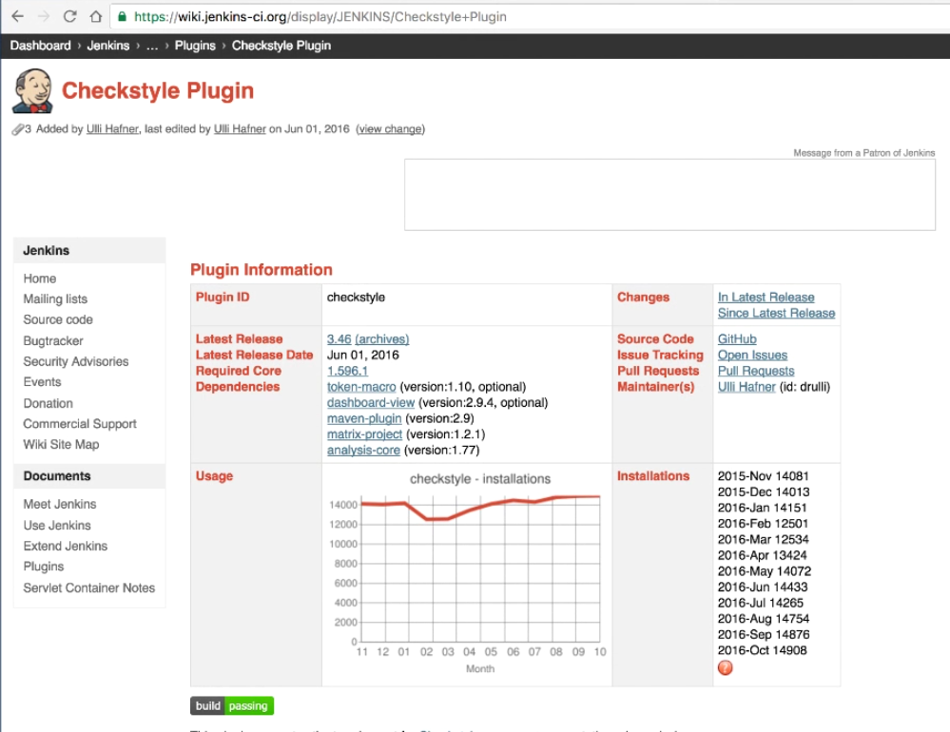

Process to install checkstyle plugin

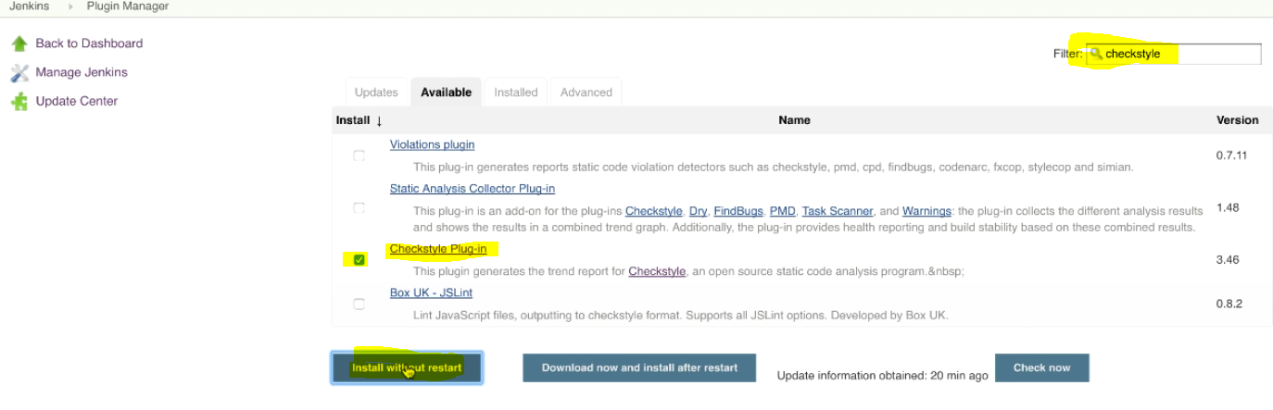

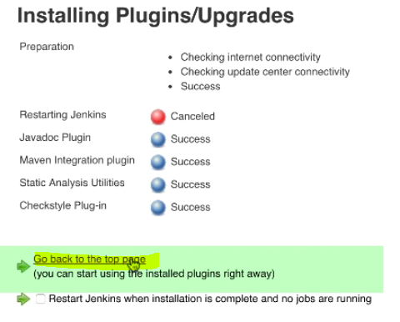

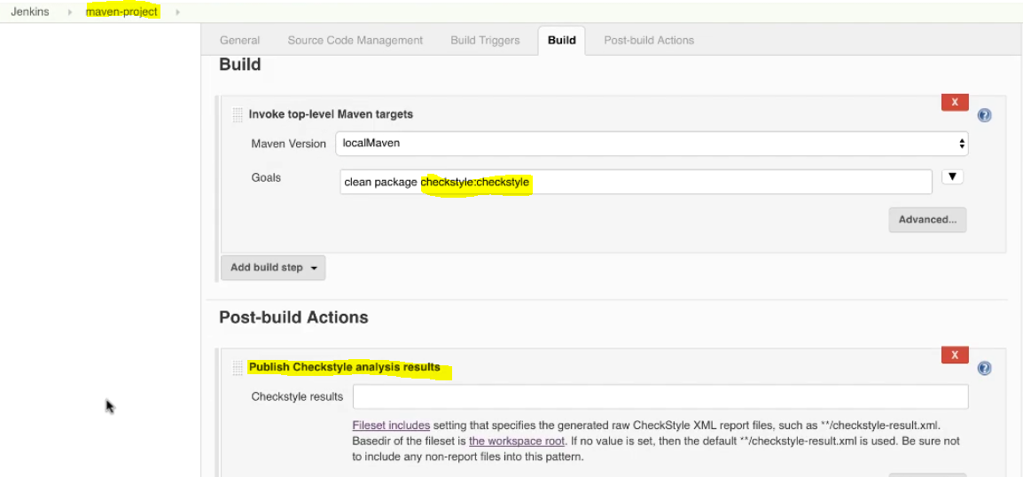

Save changes without filling Checkstyle results.

Click on build now and see the Build history and click on the build number to see the console output and checkstyle warnings

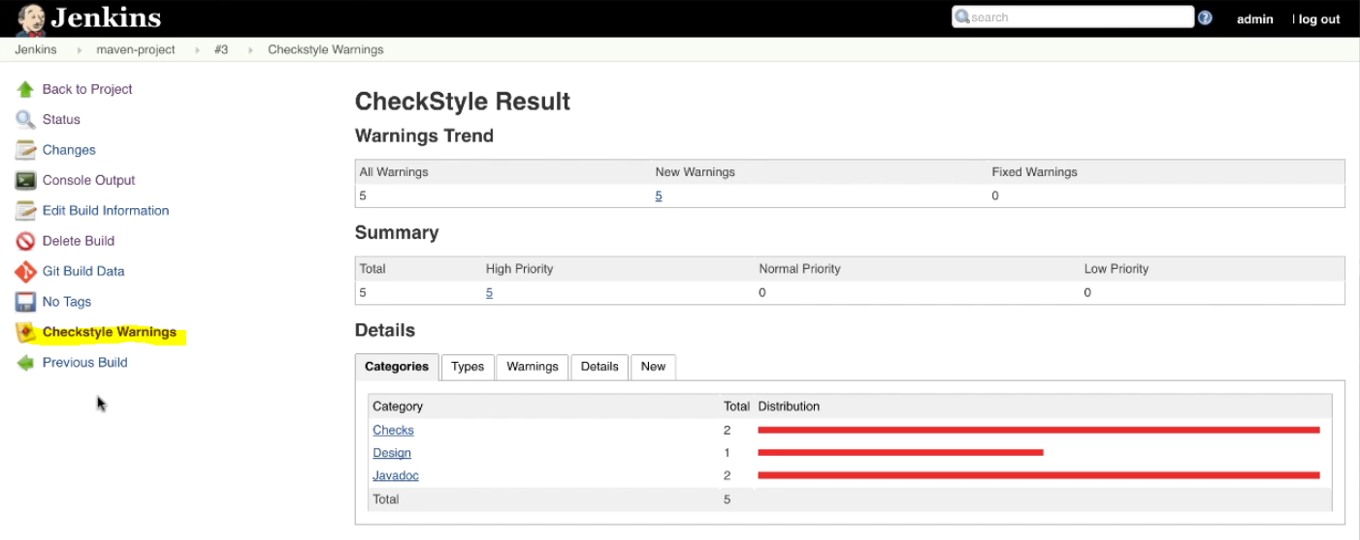

Click on each category of the warning and see the details

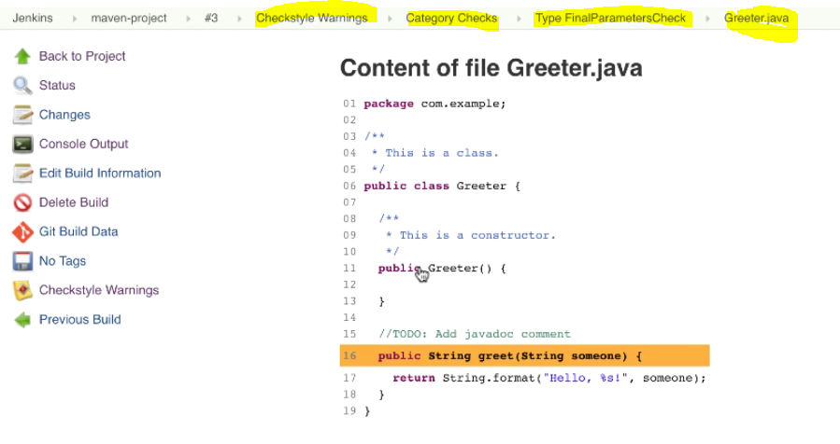

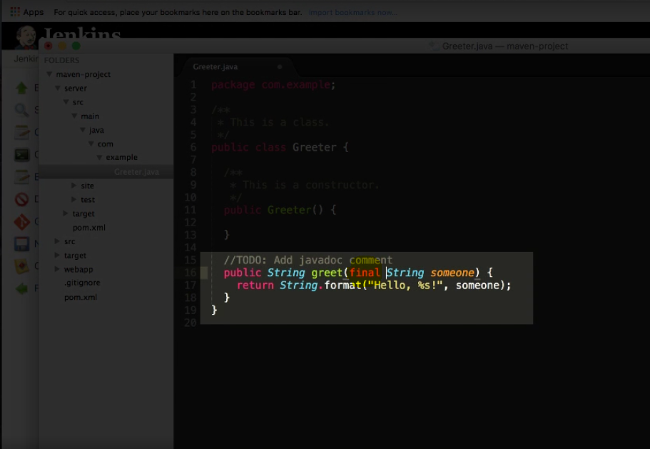

After fixing all the warning do the git commits as follows

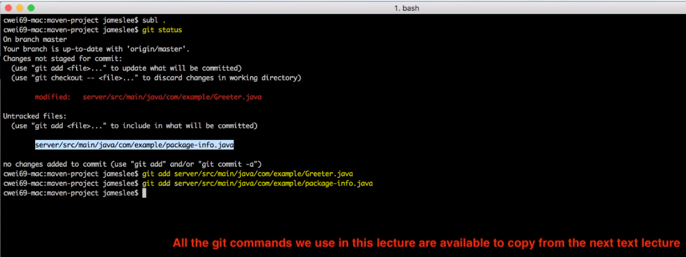

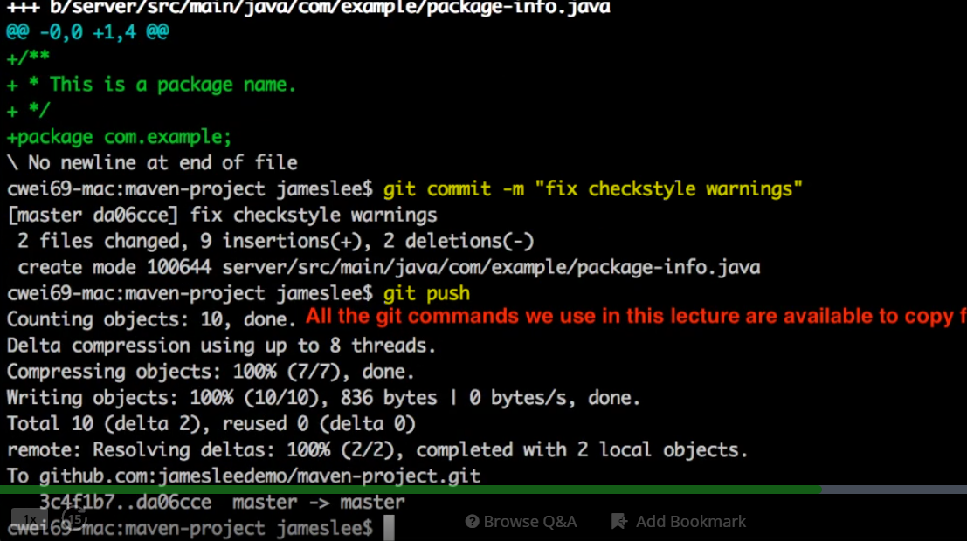

After pushing to github, it automatically triggers the build as we setup to create build for evert minutes. Lets wait for new build triggers

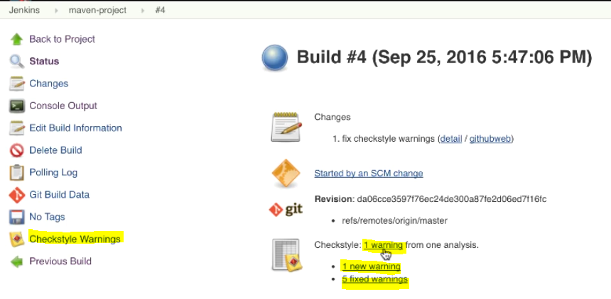

Fix the warning by adding new line in the file.

Commit & push the code to github

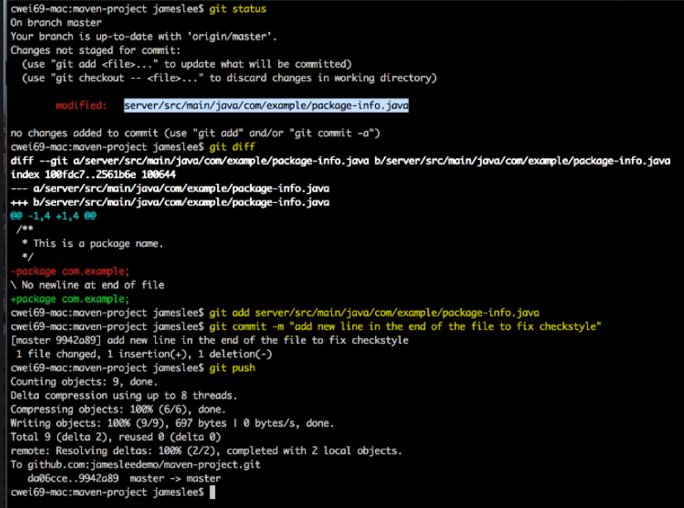

Lets go back to Jenkins and wait for the build to trigger and click on the build to see the results. You can see the Checkstyle Trend

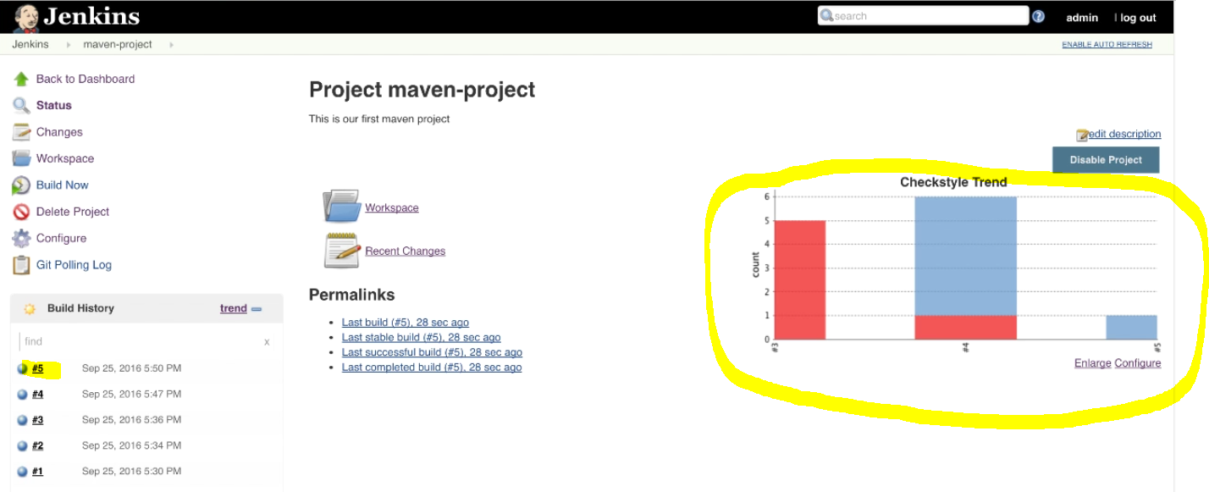

In this demo we use the Checkstyle plugin to do the static analysis of the code quality of a maven project.

PMD, FindBugs are most widely used Java programs.

Text Direction: Code Quality and Code Coverage Metrics Report

Section 3, Lecture 22

#### Git commands:

Show the working tree status:

git status

Add file contents to the index:

git add <file path>

Record changes to the repository:

git commit -m <commit message>

Record changes to the repository:

git commit -m <commit message>

Update remote refs along with associated objects:

git push

#### PMD Jenkins plugin:

https://wiki.jenkins-ci.org/display/JENKINS/PMD+Plugin

#### Findbugs Jenkins Plugin:

https://wiki.jenkins-ci.org/display/JENKINS/FindBugs+Plugin

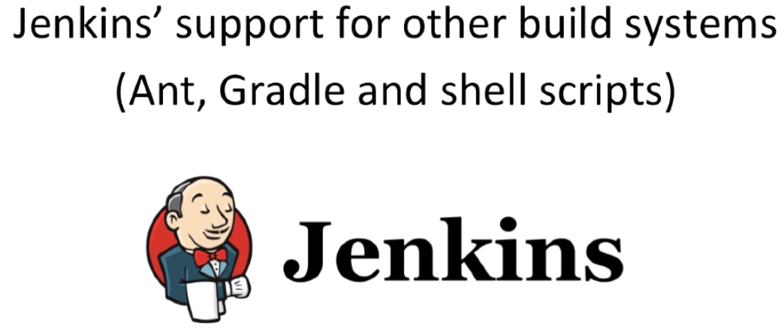

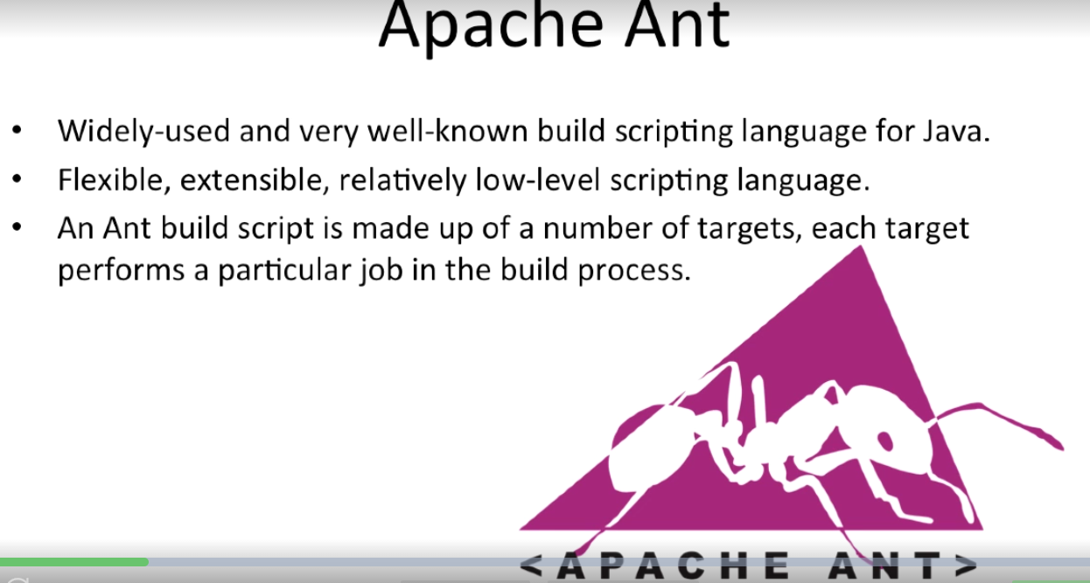

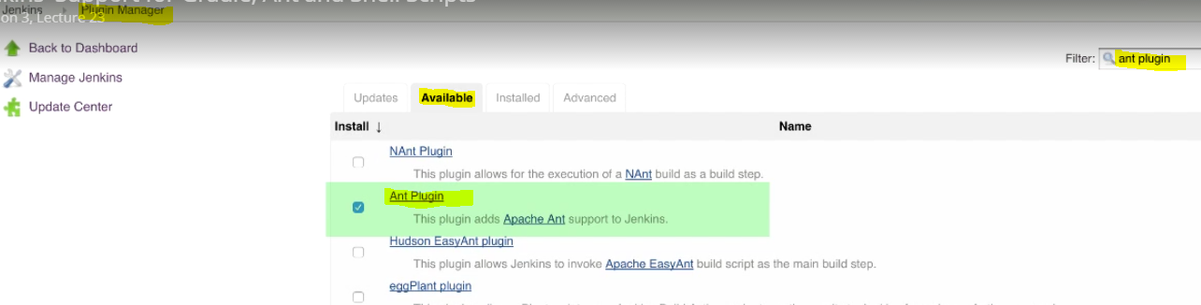

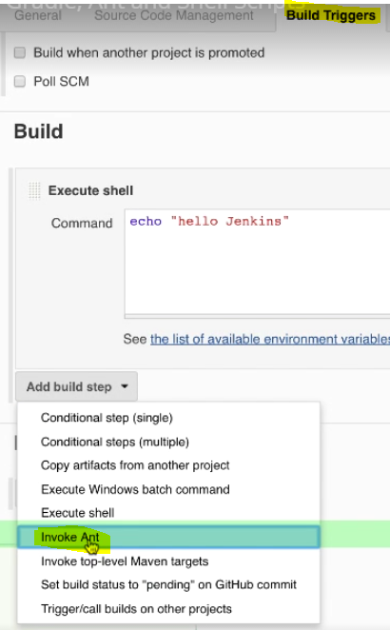

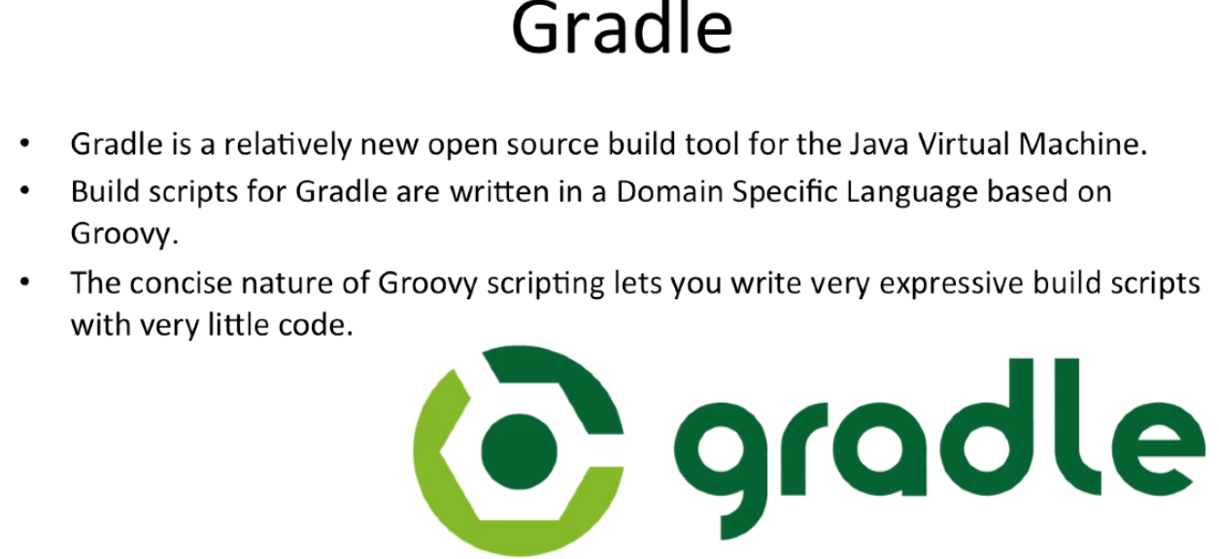

Install gradle plugin and configure the build

Shell Scripting:

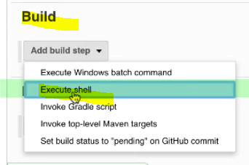

Text Direction: Jenkins' Support for Gradle, Ant and Shell Scripts

Section 3, Lecture 24

#### Apache Ant:

http://ant.apache.org/

#### Ant Targets:

http://ant.apache.org/manual/targets.html

#### Gradle:

https://docs.gradle.org/current/dsl/index.html

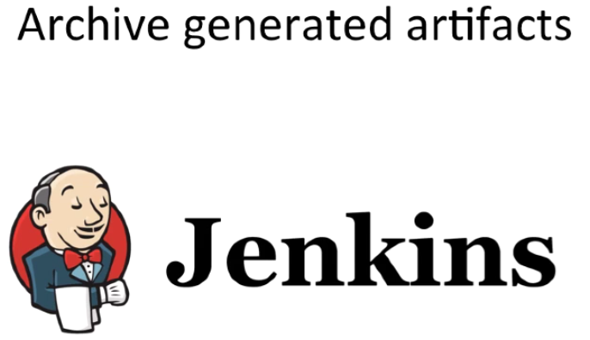

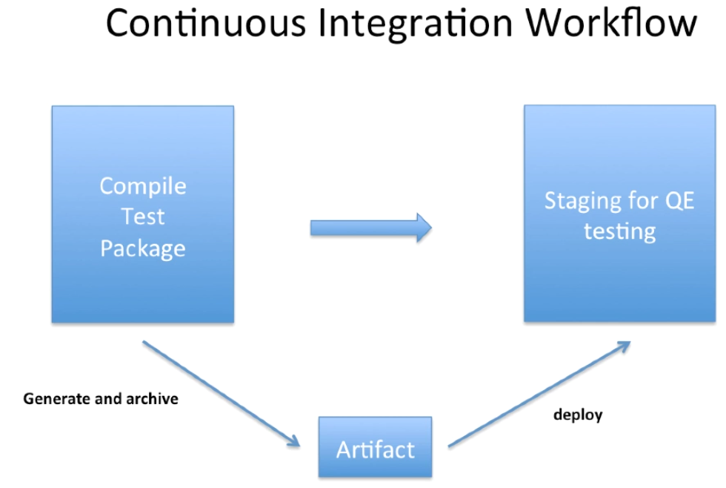

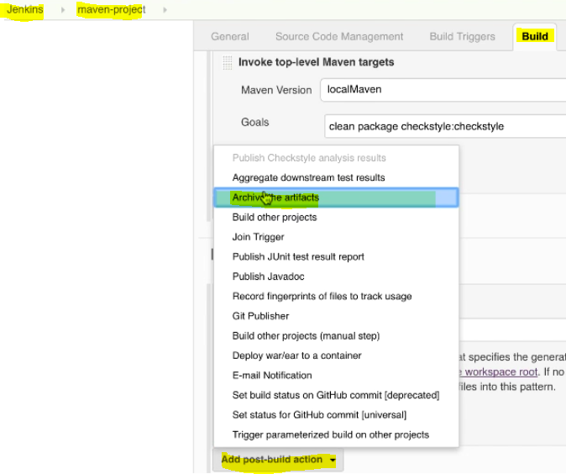

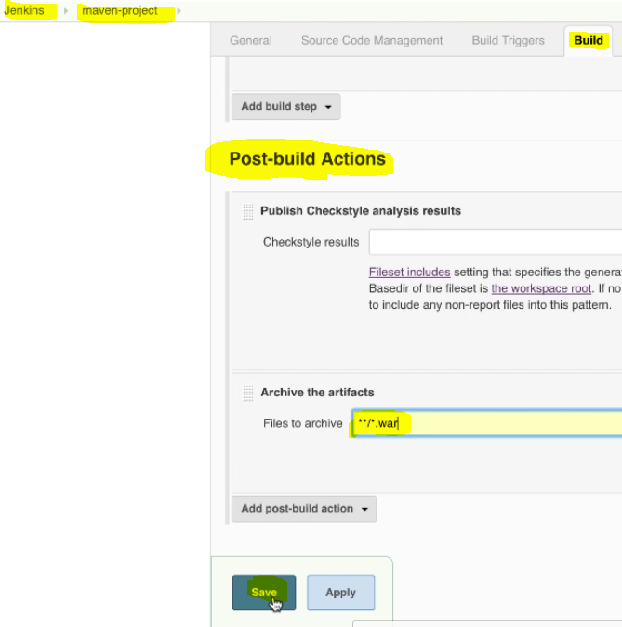

Click on “Build Now”

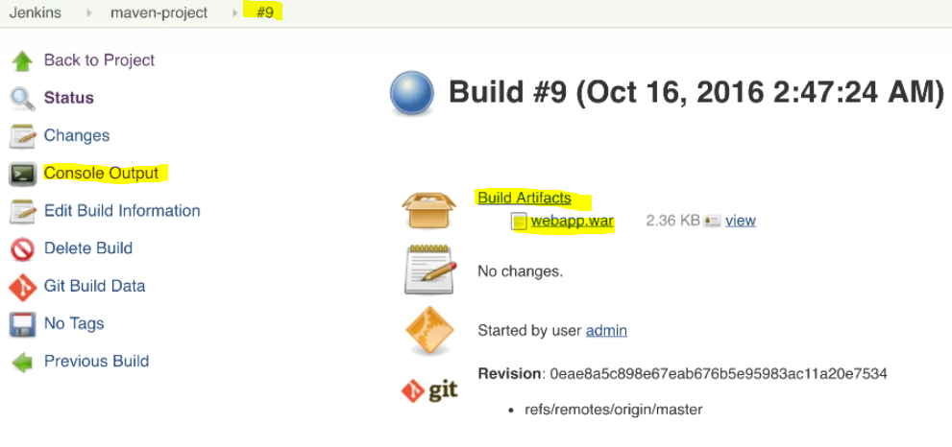

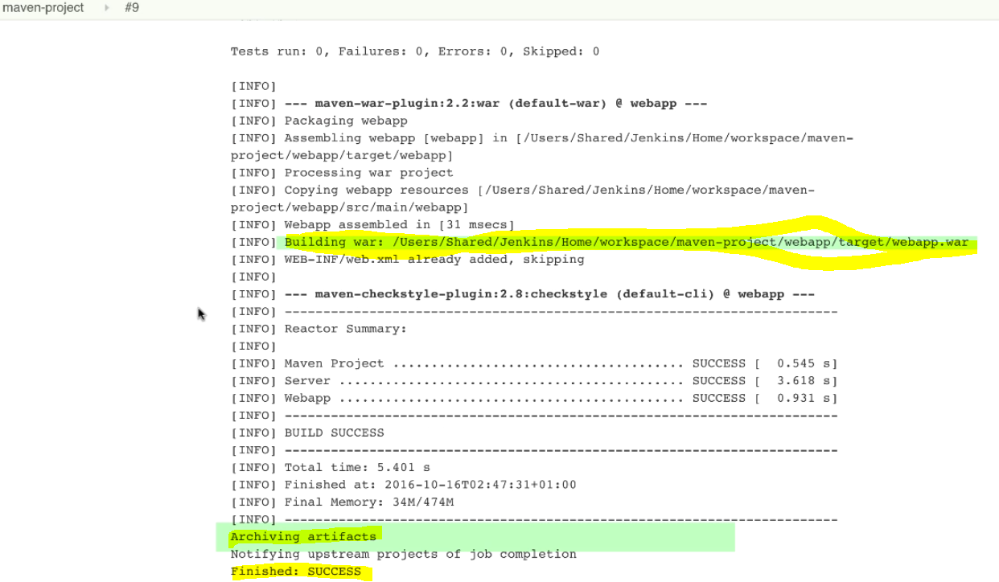

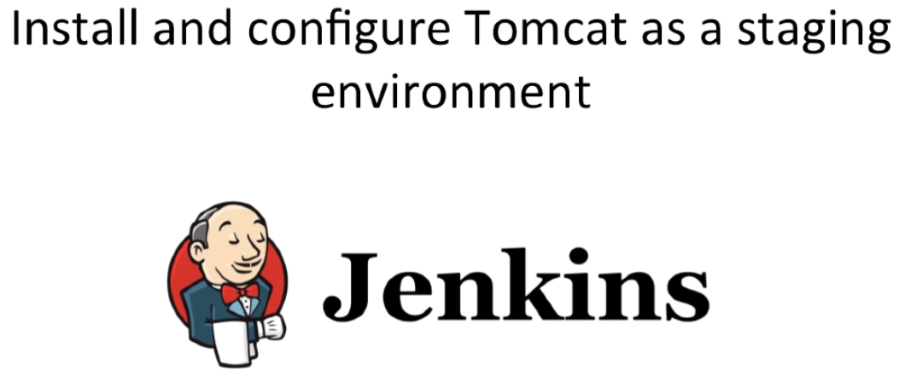

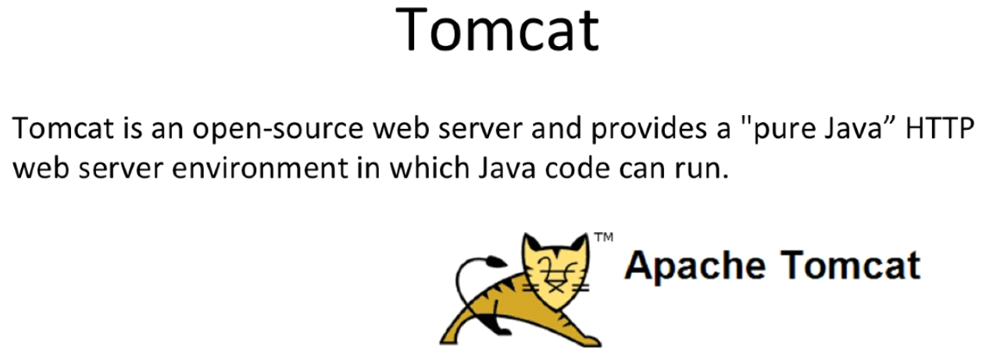

Google the Tomcat (version 8) and Install.

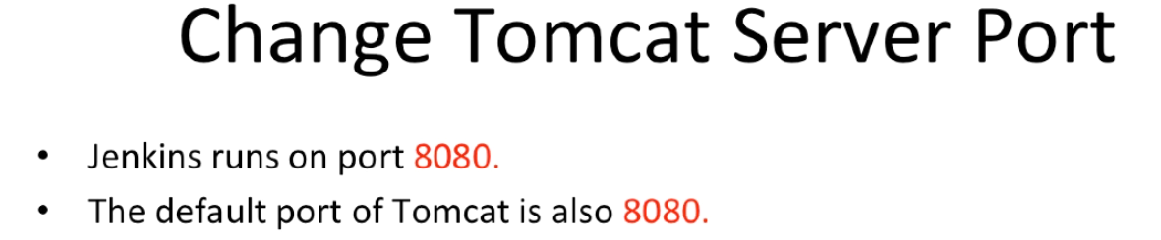

Bot Jenkins & Tomcat default ports are 8080.

There is port conflict between Tomcat & Jenkins. Hence we need to change the port for Tomcat port 8080 to 8090. These configuration need to be done in conf/server.xml in apache-tomcat folder.

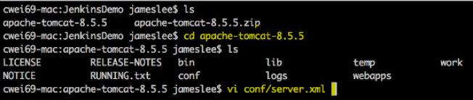

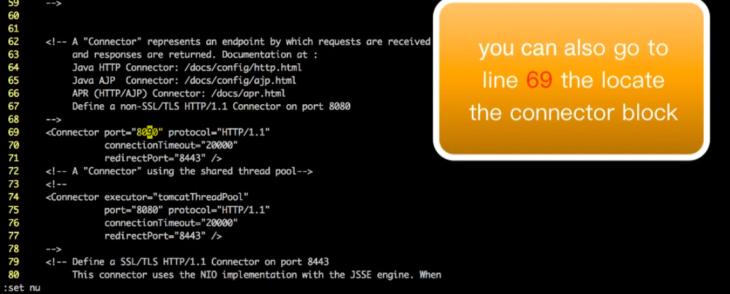

Once you updated the server.xml we need to spin up the tomcat server

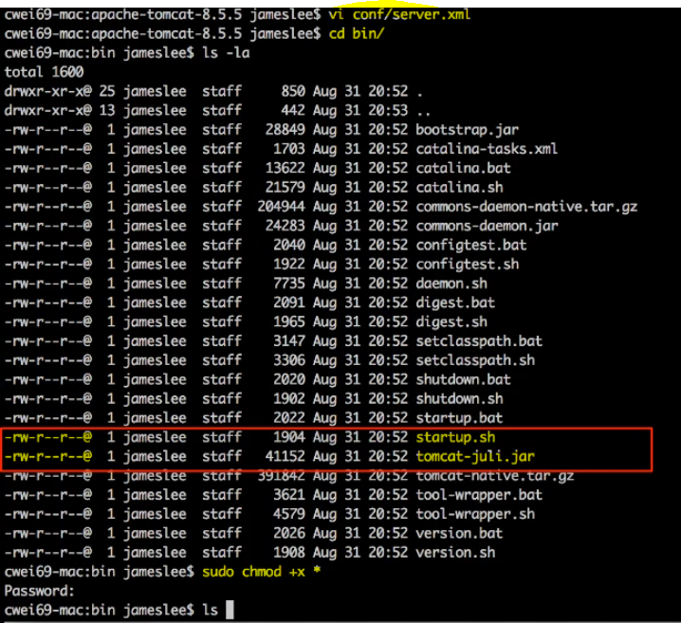

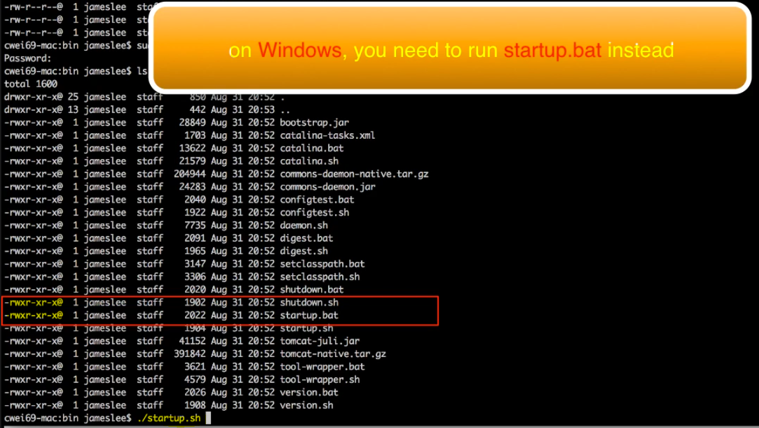

Once ./startup.sh script ran the tomcat port changed to 8090.

Test this on the browser.

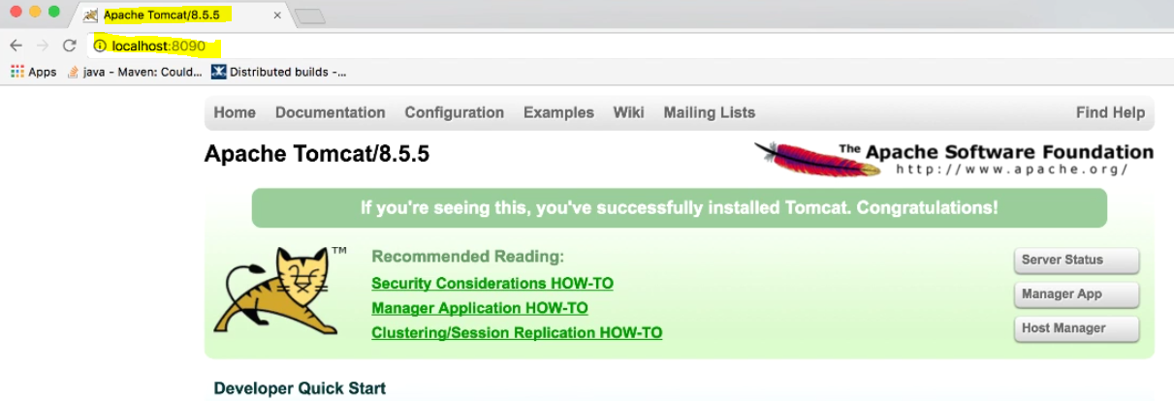

Tomcat run on the role based users. Change the roles in tomcat-users.xml

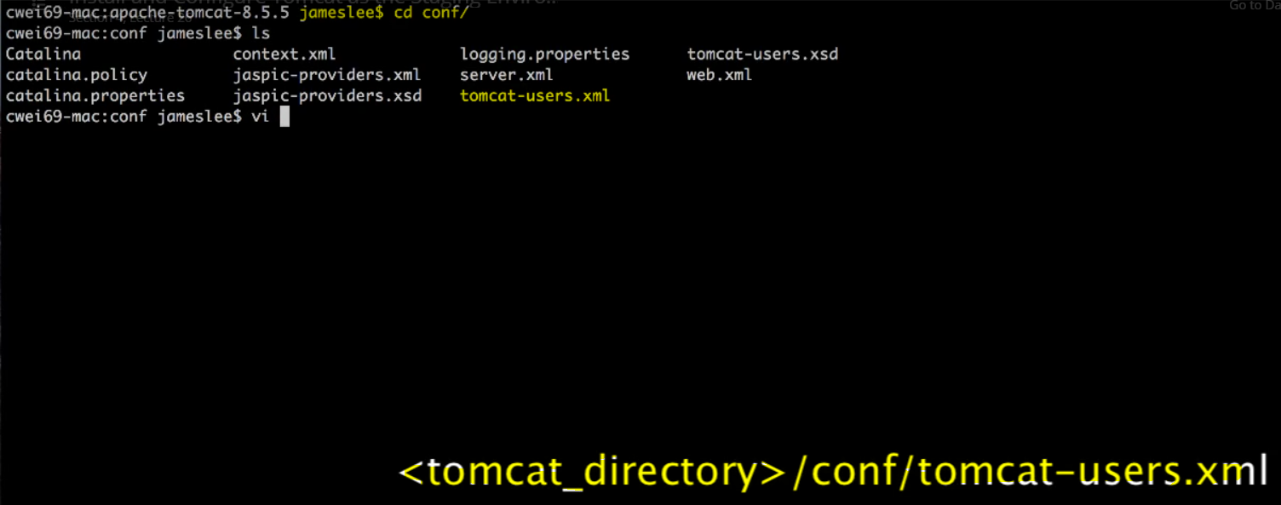

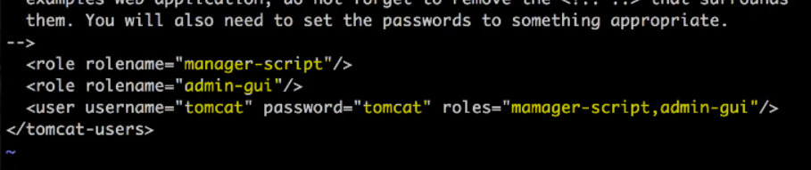

Once updated the roles, restart the tomcat server

